Information about the RICH1 LAMS
Introduction
This document is designed to provide a reference for the continued development and operation of the LHCb RICH1 Laser Alignment Monitoring System (LAMS). This system is designed to produce an independent relative stability measurement of the RICH1 spherical mirrors. It uses lasers reflected off each mirror quadrant to monitor the mechanical stability of the mirrors. This document assumes a reasonably high level of understanding of the RICH1 mechanics.
Motivation
The LAMS system is designed to make a relative measurement of the angle of the spherical mirror quadrants independently of the main detector readout system. This provides a valuable cross check, a trigger to recalibrate and a way of monitoring the mirror stability even when there is no data produced by the HPDs/DAQ.
Optical Layout
Laser light is supplied to the four LAMS systems by four fibres. The fibres are terminated with focalisers which have to be set to approximately 2m. It is very likely that these have to be reset every time the LAMS systems are removed.
The beam form the laser is split by a 50/50 beam splitter, with one, the ‘monitoring’ beam, passing straight through the splitter and monitoring the spherical mirror and falling on a camera on the bracket on the far side of the vessel. The other beam, the ‘reference’ beam, is sent directly to the camera and provides a measurement of the relative stability of the two optical benches. The camera is a radiation hard Charge Injection Device (CID), purchased form Thermo Fischer Scientific. The laser spots are focussed directly onto the chip, rather than using a lens. The four systems are mounted as pairs for the top and the bottom, with the camera sharing the opposite bench with the other systems laser and beam splitter.
When the laser is turned to higher intensities it is possible to see a double reference beam as the laser is reflected off the front and back surface of the beam splitter. This effect disappears as the laser is turned down to its operational level, but can be used to positively identify the spots during alignment.
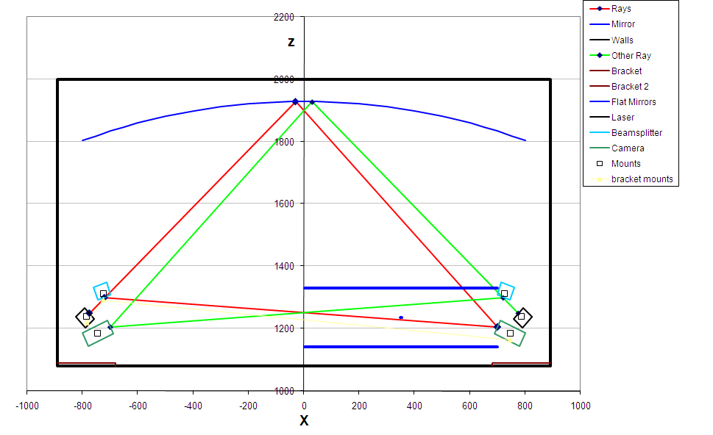

Mechanics
The optical components are mounted onto brackets, attached to the front wall of the gas enclosure. The brackets consist of three parts, a back plate, side plate and optical bench. The back plate is attached flat to the gas enclosure and will remain permanently fixed. It has two dowels to which the side plate can be accurately reattached. The optical bench is attached to the side plate at an angle that places the optical components in a plane with the centre of curvature.
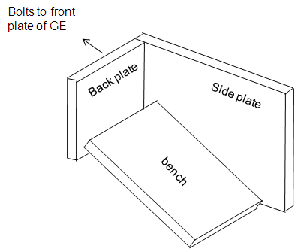
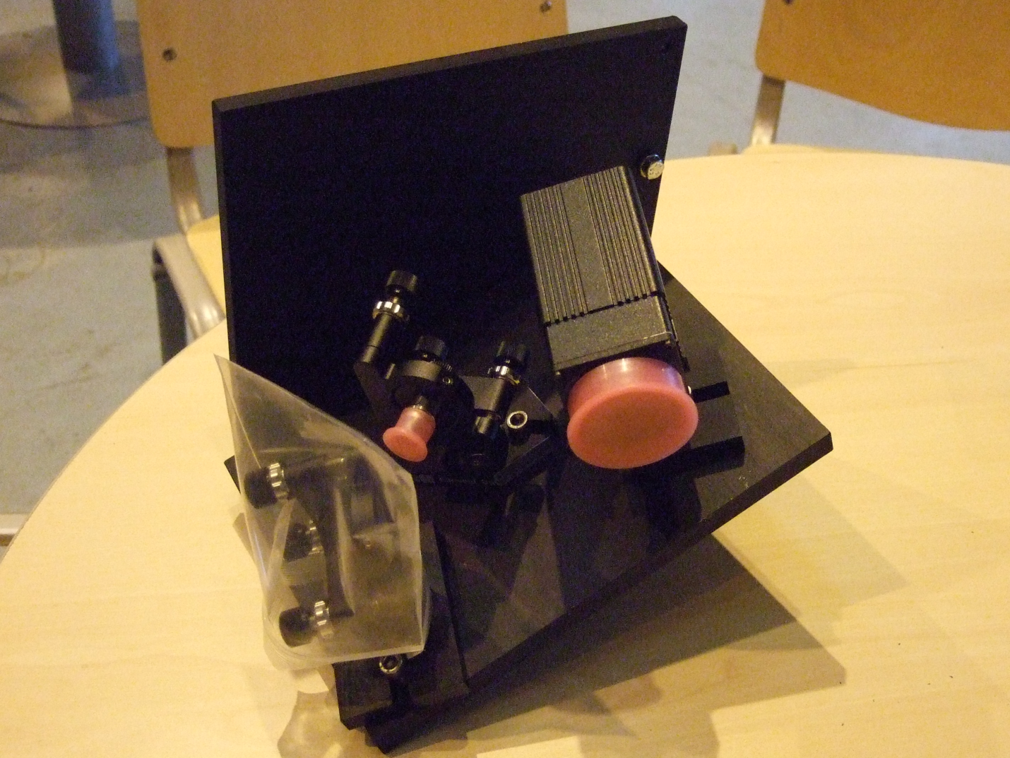
This picture shows the removed bench and side plate assembly with the optical components in place.
An important detail to note is that the lower system is upside down with respect to the upper system. This is to make the mechanics interchangeable and reduce the complexity of manufacture.
Current Arrangement
From the initial installation the spots are positions as followed. This needs to be redone after each reinstallation. It is recommended that images with high laser intensity are captured to definitively identify the reference and monitoring spots.
The following are in the orientations set by the jpg images produced.
A-Down (1) reference=lower monitoring=higher
A-Up(2) reference=lower monitoring=higher
C-Up(3) reference=lower monitoring=higher
C-Down(4) reference=higher monitoring=lower

Note that intensity isn’t a good determinant of the origin of the spot as the setting of the focus is rather arbitrary and so sometimes the reference is brighter and sometimes the monitoring is brighter.
If the origin of the spot is not known then it is possible that the shape of the spot could be used, as the monitoring beam seems to be ‘squashed’ for some reason. This is not well understood and so should be treated carefully.
C-Down
This camera seems to have a fault and if the intensity is too high seems to saturate and flare. A replacement is available for when the RICH box is open.
System Read Out
The cameras each have a readout box located on the balcony. These are read out by an analogue video line that runs to the D2 counting room, where and IP-Video server converts them into jpeg images and sends them via the LHCb network.

