The MICE experiment
Rob Edgecock
Rutherford Appleton Laboratory,
Chilton, Didcot,
Oxon, OX11 0QX.

Introduction
The ability to cool the muons is one of the most important requirements for a Neutrino Factory, otherwise the efficiency of capture in the first muon accelerator is very poor. All existing accelerator cooling techniques either do not work for muons or simply take too long. As a result, a new technique has been derived, ionization cooling [1]. In this the muons are passed through an absorber in which they lose both longitudinal and transverse momentum via ionization energy loss. The lost longitudinal momentum is then restored using radio-frequency cavities following the absorber, giving a net reduction in transverse momentum and transverse cooling. In practice, as shown in Figure 1, the cooling is applied in a series of cooling cells, each consisting of a thickness of absorber and enough RF-voltage to restore the energy lost in the absorber.
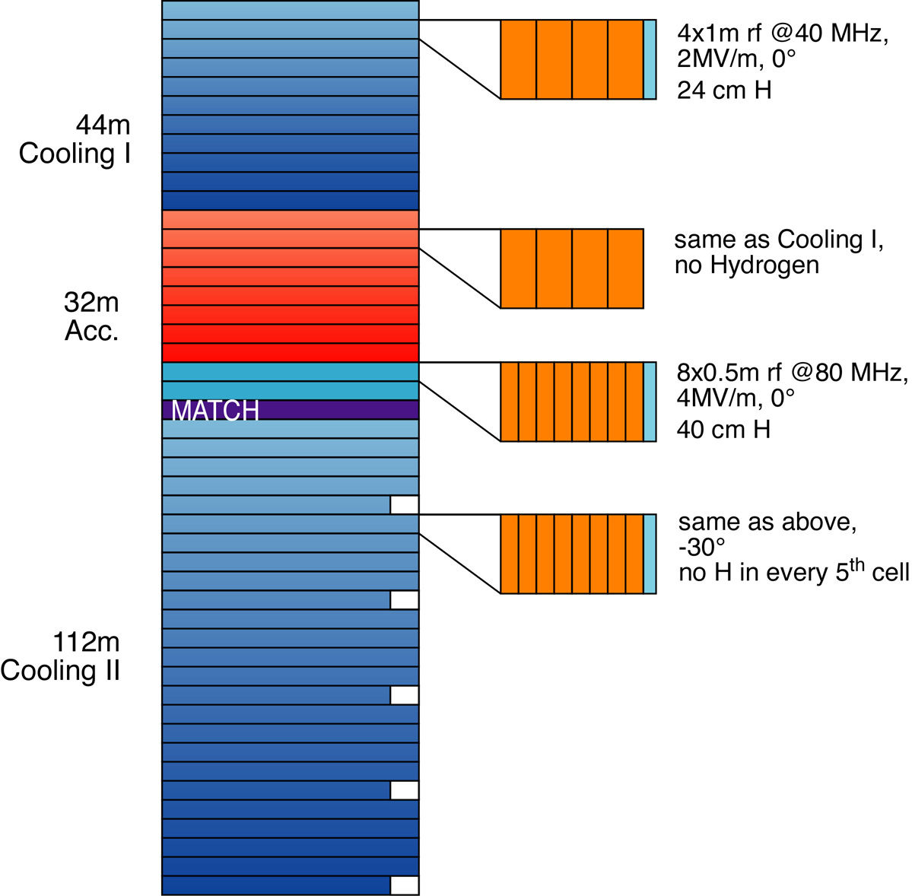

Figure 1: Layout of the CERN 44/88MHz cooling channel showing a number of the cooling cells in detail.
However, as well as cooling coming from the energy loss, there is also heating coming from multiple scattering of the muons. The net cooling is a delicate balance between these contributions, the change in normalized transverse emittance ε_{⊥,N} as a function of position z being given by
$$\frac{{dε}_{,N}}{\text{dz}}=−\frac{ε_{N}}{β^{2}E}\frac{\text{dE}}{\text{dz}}+\frac{β_{}(\text{13}\text{.}6{\text{MeV}}/c)^{2}}{2β^{3}{\text{Em}}_{μ}L_{R}}$$
where β and E are the muon’s velocity and energy, respectively, β┴ is the beam betatron function and L_{R} is the radiation length of the absorber. To keep the second, heating, term as small as possible requires a small β┴ and a large L_{R}. The former requires a highly divergent beam, created using super-conducting magnets, while for the latter the best compromise between energy loss and radiation length is liquid hydrogen. The resulting cooling cell is a complex structure, as shown in Figure 2.

Figure 2: Two SFOFO cooling cells from US Study2 [2].
Due to the complexity of the cooling cell and the fact that ionization cooling is not been demonstrated experimentally, a series of R&D projects are required to show that a cell can be built and will cool. The MuScat experiment [3] is measuring the multiple scattering distribution of muons in the correct momentum range and the MuCool project [1] is showing that a cooling cell can be built and the components will work together. The MICE experiment will show that it will cool and will investigate the cooling process in detail.

The MICE Experiment
The experiment is shown conceptually in Figure 3. The components are described in more detail below, but basically it consists of the two SFOFO cooling cells shown in Figure 2 surrounded by instrumentation to measure the parameters of muons entering and leaving the cells. The current plan is use muons with a range of momenta around 200MeV/c and produce a 6D emittance reduction of around 10%. This corresponds to an energy loss of about 12 MeV and would require a thickness of about 45cm of liquid hydrogen and enough RF voltage to restore the lost energy in the cooling cell. In addition, the instrumentation sections of the experiment must be able to make a significant measurement of this emittance reduction and hence have a total resolution, statistical plus systematic, of 1% or less.

The MICE collaboration consists of about 150 physicists and engineers from 36 institutes in Europe, the US and Japan. It is currently preparing a proposal to be submitted to the Rutherford Appleton Laboratory for the experiment to take place there.
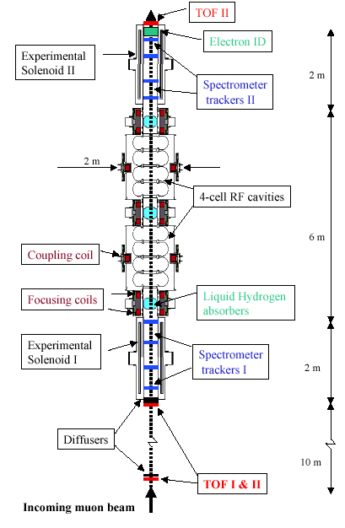
Figure 3: The schematic layout of the MICE Experment.

Muon beam
It is not possible to measure the emittance of the muons for MICE with the required precision using collective emittance measurement techniques as the best such measurement precision is about 10%. As a result, MICE will use a single particle beam, with no more than one muon passing through the detector every 10ns or so. This will allow all the required parameters of each muon to be determined.

To supply the muon beam for MICE, an existing beam line at RAL, the HEP test beam, is being modified to provide a clean beam with the required intensity. Two main changes are planned: (1) a new target and pion capture mechanism to increase the flux of muons and (2) a super-conducting decay solenoid to allow the rejection of most of the proton, pion and positron backgrounds to the muons. In addition, much new infrastructure is being added to the experimental hall to satisfy the requirements of MICE. The new beam line and the layout of MICE in the hall are shown in Figure 4.

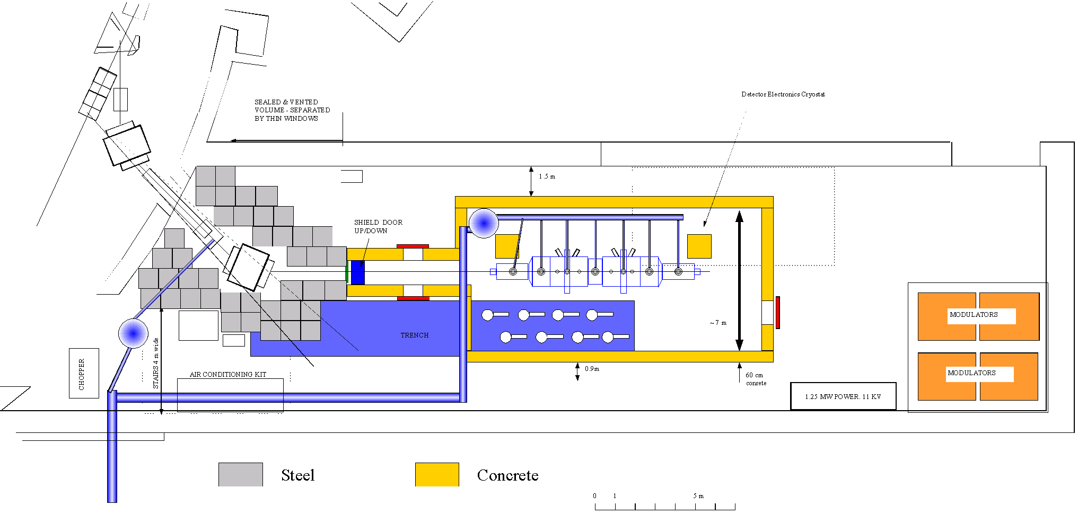

Figure 4: Layout of the new muon beam and MICE in the HEP test beam at RAL.

Instrumentation
MICE needs to measure the 6D parameters of each of all the particles passing through it and eliminate any backgrounds to the level of 0.1% or less. It thus has two types of instrumentation: one for measuring the particle parameters and the second for identifying the type of particle.

Five of the particle parameters are measured using tracking detectors placed inside super-conducting solenoids placed on either side the cooling cells. There are two candidates for these detectors: scintillating fibre chambers or Time Projection chambers using GEMs (TPGs), with the former being the current baseline. The final design of both these detectors will be strongly affected by an important source of background: dark current and X-rays from the RF-cavities. As the level of these will not be known until a real cavity is built, the current designs assume a pessimistic background rate.

The scintillating fibre tracker (FT) will consist of four or five detectors in each spectrometer section, each detector incorporating three double planes of offset fibres at 120 degrees to each other, as shown in Figure 5. This will give one space point per detector, with a very high and uniform efficiency. It is planned to read the fibres out using Visible Light Photon Counters [4]. These are avalanche photo-diodes with a very small band gap, so they have an excellent quantum efficiency. However, due to this small band gap they have to be run at cryogenic temperatures, ~9K, to reduce the noise.

Figure 5: The arrangement of the three double fibre planes in a scintillating fibre detector.
The alternative tracker, the TPG, will consist of a single chamber in each spectrometer section. These chambers will be standard TPCs, except for four components:
1) To keep the number of tracks drifting through the chamber at any one time down and hence maintain the pattern recognition performance, it is necessary to have a fast drift velocity. To achieve this, a drift voltage of 50k volts will be required, which could be a major safety hazard close to the liquid hydrogen absorbers.
2) It is planned to use a light gas, consisting mainly of helium, to reduce multiple scattering.
3) The electron avalanche will be created using Gas Electron Multipliers (GEMS) [5].
4) The TPGs will have 800k pads for readout, but to keep the cost down, rather than reading out each pad, they will be readout in u, v and x strips, as for the FT.

The main advantage of the TPG is it will give many points per muon track, about 120, compared to the 5 from the FT. This will make pattern recognition easier. However, backgrounds from the RF may be a problem due to the long TPG gate, 15ms.

The sixth muon parameter, time, will be measured using a very fast scintillator system, with a time resolution of about 50ps. This system will also be used for identification of the in-coming particle using time-of-flight and to provide a trigger. Identification of out-going electrons from muon decay in MICE will be made with an electron identifier placed in the rear of the experiment. There are two possibilities for this: a threshold Cherenkov detector or a sampling calorimeter and it is possible that both will be used.

Cooling cells
As already mentioned, two cooling cells will be used based on the US Study 2 design [2], as shown in Figure 2. Each will contain a four cell 201MHz RF cavity surrounded by large super-conducting coupling coils. There will be three absorbers, two at each end of the cooling cells, to provide shielding of the instrumentation sections from the dark current from the RF, and one in the center. The absorbers will be closely integrated with pairs of super-conducting focus coils.

Absorbers
The most important absorber for use by MICE is liquid hydrogen and the experiment is being designed around this. One of the main issues with using this absorber is safety and the absorber windows and hydrogen system are being designed in close collaboration with the relevant safety committees. In order to minimize the amount of material in the way of the beam, various window designs are beings studied which have more material at the edges than in the middle. A number of torispherical windows have been built and tested at Fermilab (see Figure 6).
Figure 6: Liquid hydrogen absorber window built for safety tests in the US.
In addition to liquid hydrogen, it is also planned to use other absorbers in MICE. In particular, a solid absorber (beryllium, aluminium or plastic) will be used during the setting up period and possibly liquid helium or lithium hydride for cooling studies.

RF cavities
As already mentioned, MICE will use two four cell cavities running at 201.25MHz. These will need to provide an accelerating voltage of more than 20MV on peak. In addition, to reduce the backgrounds they will produce, careful conditioning and possible treatment of the cavity surface will be necessary. To obtain the required accelerating field, it is planned to close the cavities and two types of window will be tested on a single cell prototype, a thin beryllium foil or a grid (see Figure 7). To provide the RF power, it is hoped to recuperate existing power components to create two amplifier chains, each of 4MW, from CERN, RAL or Fermilab. This will provide the required 23MV on crest. It is hoped to start construction of the single cell prototype in the near future.

Super-conducting magnets
As shown in Figure 8, MICE will have three basic types of magnet, all super-conducting:

Spectrometer solenoids: These surround each of the instrumentation sections and are used for the momentum measurement of the muons. They actually each contain five coils: the main solenoid, correction coils at each end of this and two additional coils on the end of the spectrometer towards the cooling cells. These are used to match the solenoid field to the field in the cooling cells.

Focus coils: these are pairs of coils surrounding each of the absorbers and closely integrated with them. The fields in the pairs of coils are reversed, creating significant stresses on the support structure. The integrated focus coils and absorber unit is probably the most complex in MICE (see Figure 9).

Coupling coils: these are the large coils, >1.2m diameter, surrounding the RF-cavities. They are necessary to maintain a focusing field through the cavity sections.

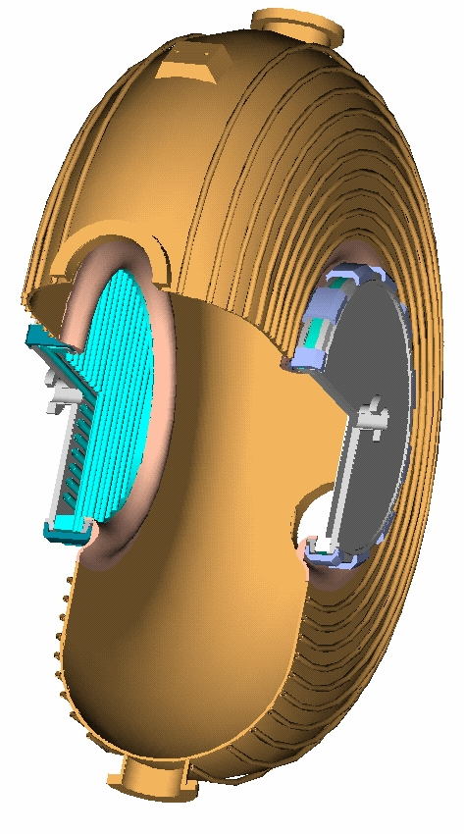

Figure 7: Design for a single cell prototype cavity for MICE, allowing both a thin foil window and a grid to be tested.
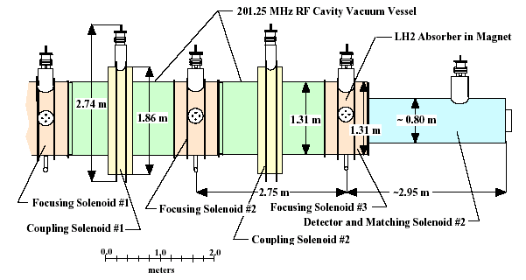
Figure 8: The MICE magnet system.

Figure 9: The integrated focus coils and liquid hydrogen absorber unit.

Performance
A Geant 4 [6] simulation of MICE is currently being written and will be used to study the performance of the whole experiment. For the moment, the MICE performance has been assessed from two separate simulations, one looking at the instrumentation and the other at the cooling cells. The first of these is a home-built Monte Carlo which uses four planes of scintillating fibre detectors, with 0.5mm thick fibres, in a uniform 5T magnetic field. The statistical error on the emittance reduction obtained by this with only 1000 muons is shown in Figure 10 as a function of the length of the solenoidal field or alternatively on the inverse of the momentum. This is for the case of no cooling and perfect electron and pion identification, so there are no backgrounds. Note that the resolution achieved is better than one would naively expect from this number of muons due to the strong correlation between the emittance in and the emittance out.

Due to the different kinematics, the effect of introducing backgrounds is to produce a dramatic reduction in the resolution of the emittance reduction. The simulations suggest that to have a minimal effect the pion and electron contamination must be kept below 0.1%. This leads to the requirement for excellent particle identification in MICE.

The cooling performance of MICE has been studied using ICOOL [7] and the results are summarised in Figure 11. This shows the rms transverse, longitudinal and 6D emittance along the length of MICE and the net change in the emittance. There is a 11% emittance reduction in each transverse plane and a 11% increase in the longitudinal emittance, giving a net reduction of 11% in the 6D emittance. Note that the longitudinal emittance growth was expected to be 6% rather than 11%, the difference arising because the magnetic fields were not properly matched when these studies were done. This was fixed in later studies. The last plot shows the percentage muon loss.

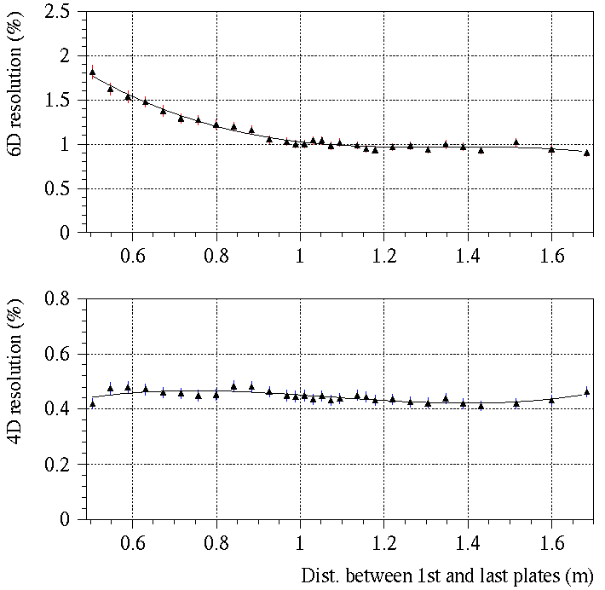

Figure 10: Resolution on the 6D and 4D emittance reduction achievable by MICE with 1000 muons, without cooling and with no backgrounds, as a function of the solenoid length.

MICE schedule and cost
As a Technical Design Report for the Neutrino Factory cannot be completed until the results of MICE are known, the aim is to do this as quickly as possible. In particular, it is important that cooling has been demonstrated by about the time that the LHC starts. This defines the end point for MICE. The starting point is affected by two main things: approval by the Rutherford Appleton Laboratory and obtaining funding. It is hoped to obtain the former in spring 2003 and that the latter will quickly follow. MICE will then take place in the six stages shown in table 1, with completion in 2008.

 | Milestone | Start date
1  2  3  4  5  6 | Characterization of muon beam  Commissioning of first spectrometer  Commissioning of both spectrometers  Measurements with one absorber  Measurements with two absorbers and one RF cavity  Measurements with the full version of MICE | Q3 2004  Q3 2005  Q1 2006  Q2 2006  Q4 2006  Q2 2007

Table 1: Milestones for MICE
The current estimate for the cost of MICE is 25.2MEuro, consisting of 13.9MEuro for the cooling section, 7.5MEuro for the spectrometer section and 3.8MEuro for ancillary items. The preliminary allocation of the responsibilities for providing the components of MICE leads to 34% of this coming from the US, 4% from Japan and remaining 62% from Europe, with the UK contributing 33%. This is for the full cost of the experiment assuming everything is new. However, it is expected that a number of components will refurbished, bringing substantial savings and a cost of 19.2MEuro.
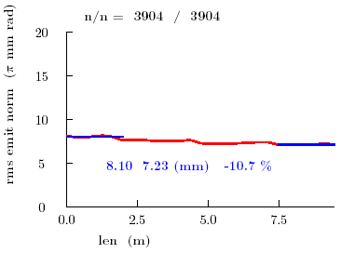
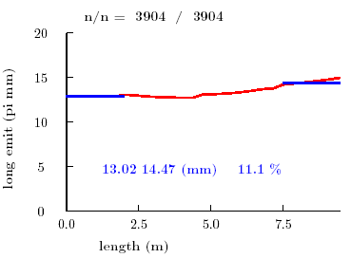
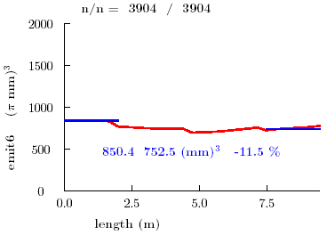
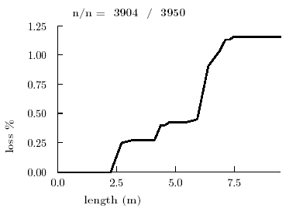

Figure 11: Performance of the MICE cooling cells.

Conclusions
The MICE experiment is an essential component of the R&D taking place for a Neutrino Factory. It will demonstrate that the process of ionization cooling can be used to cool the muons. The MICE Collaboration is currently preparing a proposal that will be submitted to the Rutherford Appleton Laboratory in the UK at the beginning of January 2003. Much of the MICE design is being finalized in preparation for this. It is hoped to receive approval in spring 2003 and to start construction of MICE late in 2003 or at the start of 2004. Although there is still some R&D to be done, it looks feasible to build the current MICE design and simulations suggest that it will work as required.

MICE will be constructed and tested in the muon beam in approximately six stages, starting with only the tracking detectors in 2005 and finishing with the complete MICE in 2007. It is hoped that all data taking and analysis will be finished before the end of 2008.

Further collaborators are always welcome!

Bibliography
[1] MuCool Collaboration, Fermilab Proposal P904 (1998)
[2] US Muon Collaboration, BNL-52623 (2001)
[3] The MuScat Collaboration, RAL-TR-2002-022 (2002) 33
[4] A.Bross et al, FERMILAB-Pub-97/015 (1997)
[5] S. Bachmann et al, CERN-EP/2000-151 (2000)
[6] See http://cern.ch/geant4
[7] See http://pubweb.bnl.gov/people/fernow/icool/readme.htm

