Status and prospects of the HARP experiment
M. Ellis, on behalf of the HARP collaboration
RAL, Chilton, Didcot, Oxon., OX11 0QX, UK.

Abstract. The Hadron Production (HARP) experiment is described. The data-taking programme was performed during 2001 and 2002 at the CERN PS. The performance of the detector and plans for analysis are reviewed.

Introduction
The purpose of the Hadron Production (HARP) experiment is to make precise measurements of secondary hadron production over the full solid angle on thin and thick nuclear targets by beams of protons and pions in the momentum range 3 to 15 GeV/c.

There are two main motivations; to acquire adequate knowledge of pion yields necessary for an optimal design of the proton driver and target station of a neutrino factory and to make a substantial improvement to the calculation of the atmospheric neutrino flux necessary for interpretation of the evidence for neutrino oscillations from the study of atmospheric neutrinos. In addition, special measurements have been made with targets supplied by the MiniBooNE and K2K collaborations.

- The HARP Experiment
The HARP experiment (see Fig 1.) comprises a large-acceptance charged-particle magnetic spectrometer of conventional design using the T9 tagged charged-particle beam.
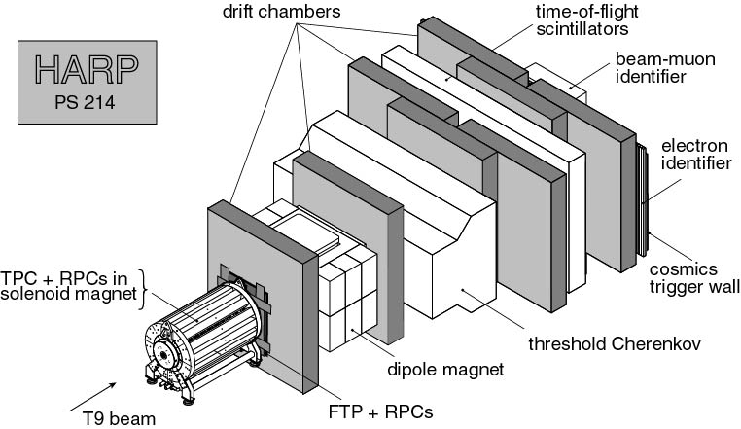

Figure 1: The HARP experimental setup
The crucial detector of low energy secondary particles was a TPC which surrounded the target and was placed inside a solenoid magnet. The TPC provided tracking of large angle particles and particle identification through dE/dx. The TPC was surrounded by RPC chambers which provide time of flight measurement for high P_{T} tracks. Drift Chambers from the NOMAD experiment and a Dipole Magnet comprised the forward spectrometer. In this region particle identification is achieved with a threshold Cerenkov detector, Time of Flight wall and Calorimeters.

The incoming beam was tracked by 4 MWPC chambers and identified through two threshold Cerenkov detectors and Time of Flight.

The experiment was approved by the SPSC on 17th February 2000 as PS214 for data-taking in the CERN PS East Area (see Fig. 2). A technical run was made in October 2000 and the data taking with solid targets commenced in 2001. The data taking concluded in September 2002.
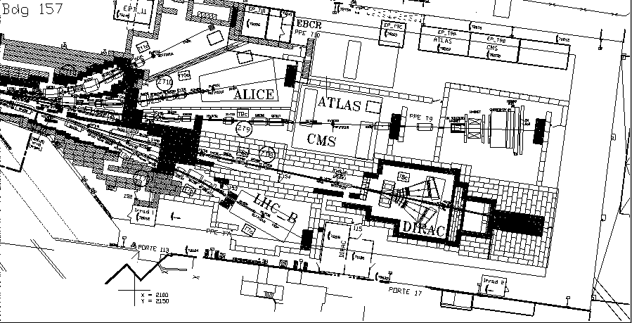

Figure 2: The CERN PS East Hall

- Beam and Targets
For each target, data was taken with the beam at ±3 ±5 ±8 ±12 and ±15 GeV/c.

The solid target programme initially consisted of thin targets which were 2% of an interaction length and thick targets which were 100% of an interaction length. Following the identification of some problems in the 2001 data-taking, 5% targets were produced and used in the 2002 run. The solid targets measured were
Be, C, Al, Cu, Sn, Ta and Pb. In addition there were several special targets used for alignment and the measurement of systematic effects.

During the 2002 run, measurements were also made with cryogenic targets filled with H₂, D₂, N₂ and O₂.

Measurements were also made with targets supplied by the MiniBooNE and K2K collaborations.

The appearance of HARP during the 2001 run is shown in Fig. 3, the inset shows the target holder and target when withdrawn from the TPC.

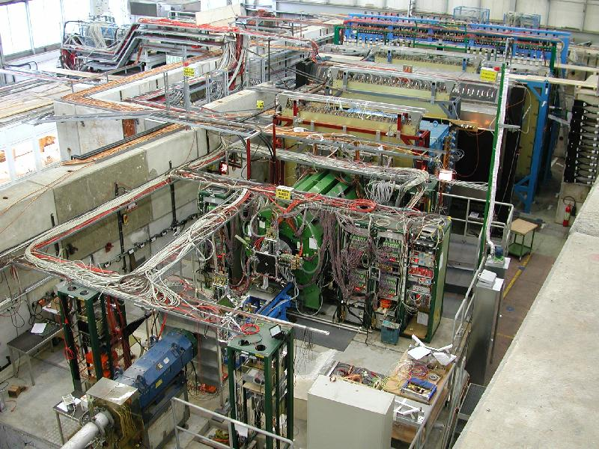

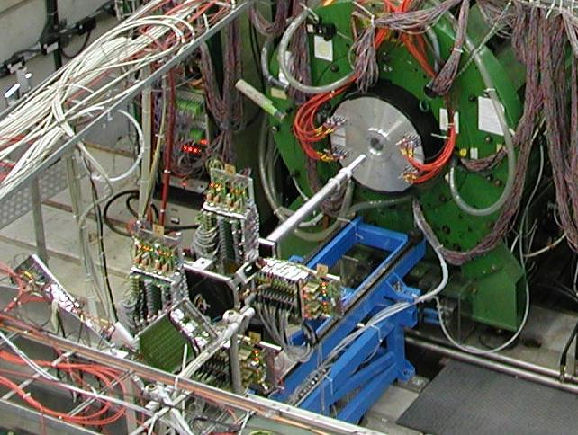

Figure 3: The HARP Experiment during the 2001 run.

- Data-taking in 2001 and 2002
During the 2001 data-taking run, approximately one third of the solid target programme was completed. A study of the data taken showed a problem with the thin target settings. For this data a beam particle which did not interact in the target would produce electrons and photons in the MeV range as a result of passage through material in the experiment. These photons and electrons could cause a trigger to be formed and as a result between one half and two thirds of the thin target data recorded was actually of non-interacting beam particles.

During the 2002 run, the 2% targets were replaced with 5% targets in order to enhance the fraction of good interactions recorded with respect to non-interacting particles.

The cryogenic target measurements were made in July 2002 and measurements of the MiniBooNE and K2K targets, with the appropriate beam settings, were made in August 2002.

Data-taking concluded with the measurement of water with an incoming beam of +1.5 GeV/c. This setting was not originally planned and may prove useful for understanding the results of the LSND experiment.

- Software Processes
The stringent time schedule of HARP has required the adoption of software engineering practices and standards. The first software release coincided with the start of the technical run in October 2000. Since then, new versions have been produced, consistently adding functionality in a coherent manner.

Modern software-engineering procedures have been adopted and commercial software products employed. A set of “User Requirements” were defined and then transformed into a set of software requirements. An architectural design was developed based on an Object-Oriented analysis and design. A release procedure was defined, including the definition of unit and system testing. The HARP software has continued to be developed, tested and released according to this formula since the very first release in 2000.

The software architecture employed by HARP is shown in Fig. 4.

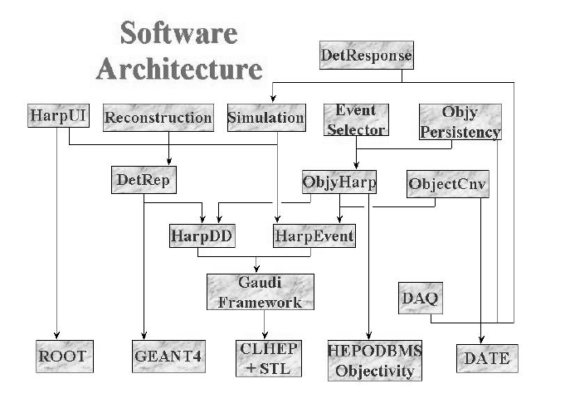
Figure 4: The HARP Software Architecture

The software components shown in Fig. 4 provide the following functionality:
- HarpEvent is the component implementing the HARP transient event model.
- HarpDD is the component implementing the HARP detector geometry and materials data as well as the calibration and alignment of the detectors.
- DetRep is based on the GEANT4 solid modelling and provides the geometrical representation of the detector components suitable for use by the physics applications
- ObjyHarp implements the HARP persistent event model, based on the Objectivity database and mirrors the transient event model.
- ObjectCnv is the component implementing the unpacking of raw data and the construction of transient C++ objects used by the physics applications.
- ObjyPersistency implements the adaptor to use the Objectivity database which decouples the physics applications from the I/O solution at compile time.
- EventSelector provides the functionality for implementing event selection and data navigation.
- Simulation is based on GEANT4 and implements the HARP Monte Carlo.
- DetResponse implements the specific digitisation of the HARP detectors
- Reconstruction is the component implementing the construction of objects representing the reconstruction of raw data through clusterisation, hit recognition, pattern recognition, track fitting and particle identification. All tracking detectors are fitted using a Kalman Filter.
- HarpUI provides the event display, based on ROOT, which can be used both online and offline.

- Performance
The beam instrumentation very capably determined the identification and point of impact of the beam particles on the target. The identification through Time of Flight of beam particles is shown in Fig. 5. Electrons identified by the Cerenkov detectors have been removed from the distribution.
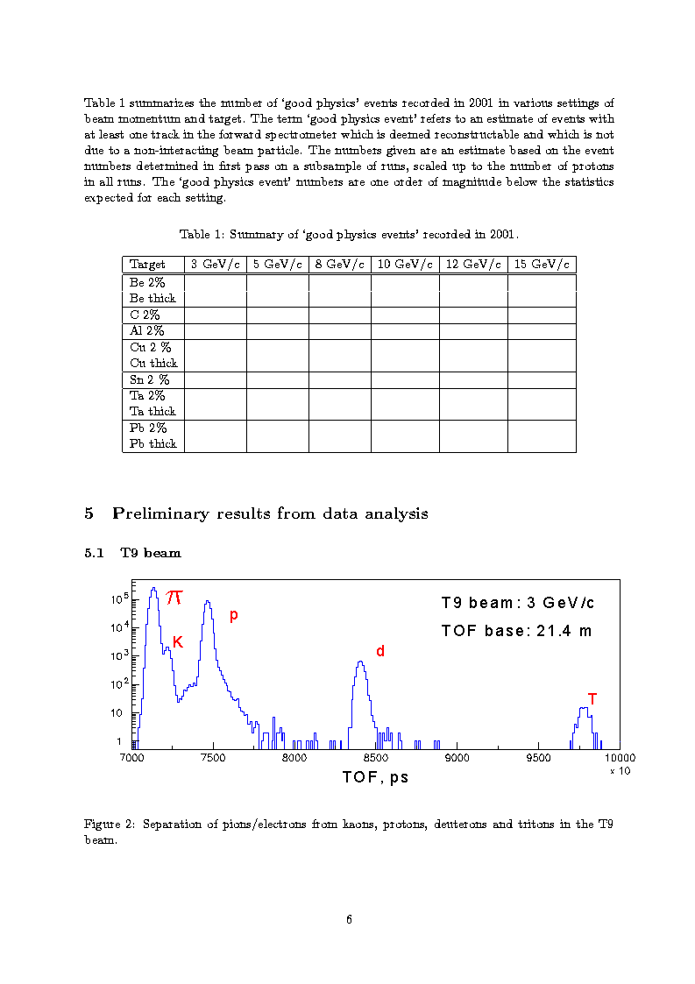

Figure 5: TOF distribution for beam particles.

The TPC readout electronics had a considerable cross-talk within the multi-layer motherboard for about half of the ~4000 channels. This cross talk alters the charge-sharing between neighbouring pads and hence the resolution in space and charge. A calibration effort to map the cross-talk pattern has been made and work is in progress to develop an algorithm to correct the cross-talk in the offline software. The output of the event display showing the TPC region and a reconstructed event from the 2001 data is shown in Fig 6.
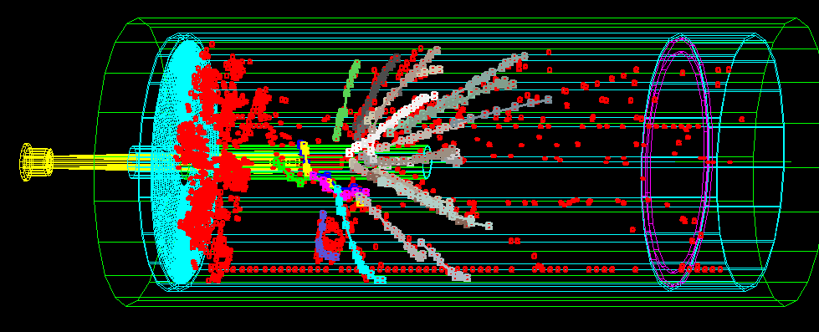

Figure 6: A reconstructed event from the 2001 data in the TPC.

The NOMAD Drift Chambers, which form the tracker in the forward spectrometer, were originally designed and built for use in a neutrino experiment. These chambers have shown a variation in efficiency, and in particular less than optimal performance of the first module when it is subjected to an intense, collimated beam of non-interacting particles. Work is ongoing to produce optimized algorithms to enhance the pattern recognition efficiency in the forward region. The output of the event display for the forward region for an event from the 2001 data is shown in Fig. 7.
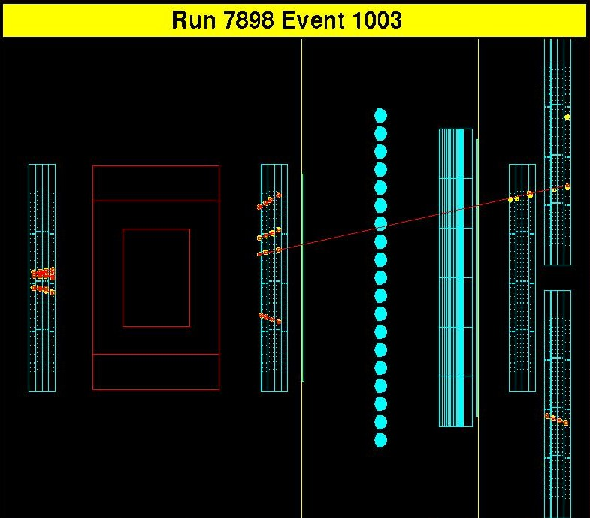

Figure 7: A reconstructed event from the 2001 data in the NOMAD Drift Chambers.

The Cerenkov detector was found to suffer from a gas leakage during commissioning. The support structure was re-welded and the inner surfaces treated with epoxy. The leak rate was thus reduced to an acceptable limit. The number of photo-electrons reconstructed in the Cerenkov as a function of the momentum for beam particles is shown in Fig. 8 which includes a good fit to the pion mass.
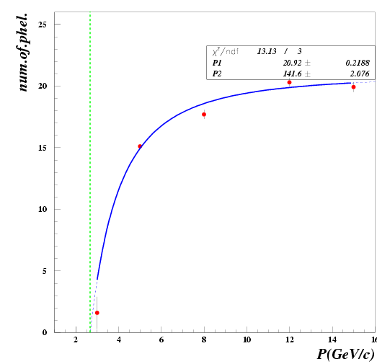

Figure 8: Reconstructed photo- electrons in the Cerenkov versus beam momentum

The clear separation of protons from pions in the TOF wall is shown in Fig. 9.
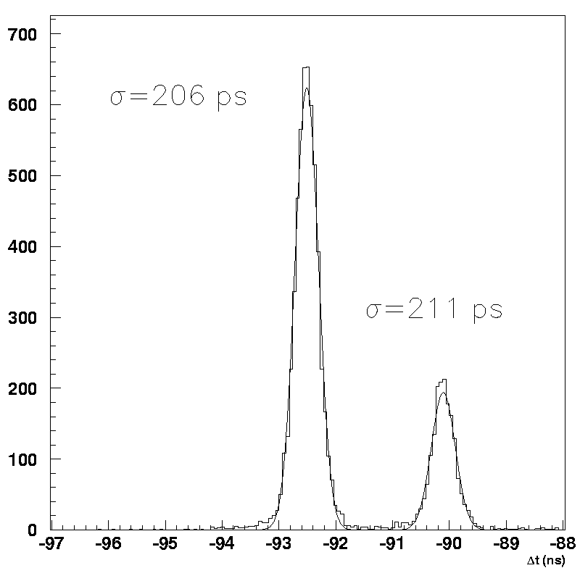

Figure 9: Proton Pion separation in the Time of Flight wall.

The Calorimeter, consisting of Electromagnetic, Hadronic and Muon identification modules, can clearly separate electrons and protons as shown in Fig. 10

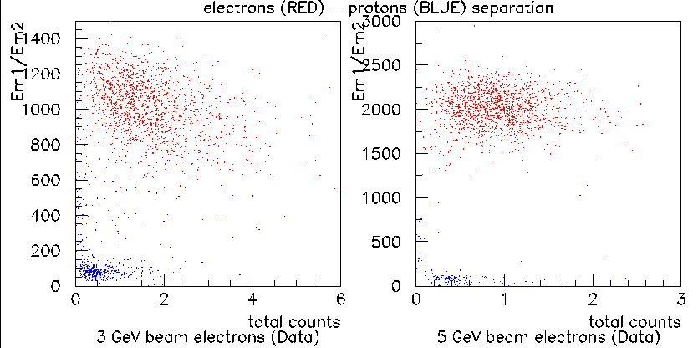

Figure 10: Electron Proton separation in the Calorimeter.

- Prospects and Conclusions
Since the completion of data-taking, analysis groups have been formed, separating into the “Large Angle” region corresponding to the TPC and RPC detectors and the “Small Angle” region corresponding to the forward spectrometer.

Work is in progress to determine an accurate calibration and alignment of the whole experiment, understand the quality of the data taken and generate sufficiently accurate Monte Carlo to further develop and rigorously test the reconstruction and analysis software.

Despite the very short time scale from approval, through construction and data-taking and a number of technical challenges, the HARP collaboration have managed to collect a large quantity of data over and above the originally planned programme and expect preliminary results from analysis in mid 2003.

