FLC_PHY2 Front end chip

DATASHEET

Table of content
Table of content 2
Table of figures 3
Figures 3
Tables 3
Equation 4
General description 5
One channel description 7
Charge preamplifier 7
Shapers 11
Track and hold 11
Output buffer 13
Multiplexer description 13
Pin definition 15
Characteristics & measurement 17
DC Levels 17
Crosstalk 18
Noise 19
Transient 22
Linearity 24
Linearity measurement – Cf=3pF 25
Linearity measurement – Cf=1.6pF 26
Linearity measurement – Cf=0.8pF 27
Linearity measurement – Cf=0.4pF 28
Linearity measurement – Cf=0.2pF 29
Pedestal dispersion 30
ANNEX 1 – FLC_PHY2 pinout, bias and current 31
ANNEX 2 – FLC_PHY2 versus FLC_PHY1 pinout 32
ANNEX 3 - Preamp schematic 33
ANNEX 4 – shaper gain 1 schematic 34
ANNEX 5 – Shaper gain 10 schematic 35
ANNEX 6 – Shapers OPAMP schematic 36
ANNEX 7 – Widlar schematic 37

Table of figures

Figures

Figure 1 General block schema of FLC_PHY2 5
Figure 2 - Block schema of one channel 7
Figure 3 - Schema of charge preamplifier 8
Figure 4 - first stage of charge preamplifier 9
Figure 5 - preamplifier resistor feedback 10
Figure 6 - CRRC shaper schematic 11
Figure 7- Block diagram of the track and hold 12
Figure 8 - Block diagram of the shift register 14
Figure 9 - Chronogram of the multiplexed readout 14
Figure 10 - ENC=f(Cd) with Cf=1.6pF 19
Figure 11 - Output noise vs preamp gain 20
Figure 12 - output noise versus feedback capacitance 21
Figure 13 - Output noise vs Input PMOS current bias 21
Figure 14 - Output gain 1 versus feedback capacitance 22
Figure 15 - Measured feedback capa versus theoretic capa 23
Figure 16 - Widlar & Common collector transient for comparison 23
Figure 17 - Linearity - Cf=3pF 25
Figure 18 - Linearity - Cf=1.6pF 26
Figure 19 - Linearity - Cf=0.8pF 27
Figure 20 - Linearity - Cf=0.4pF 28
Figure 21 - Linearity - Cf=0.2pF 29
Figure 22 - Pedestal measurement on Gain 1 output 30
Figure 23 - Pedestal measurement on gain 10 output 30

Tables

Table 1- Compensation capacitance values 9
Table 2 - Gain versus feedback capacitance switch configuration 10
Table 3 - follower switch SW description 12
Table 4 - measured vs simulated DC levels 17
Table 5 - Crosstalk measurement 18
Table 6 - ENC vs Cd, Cf=1.6pF 19
Table 7 - Noise versus shut down stages 20
Table 8 - Measured gains and peaking times 22
Table 9 - Characterization Cf=3pF 25
Table 10 - Characterization Cf=1.6pF 26
Table 11 - Characterization Cf=0.8pF 27
Table 12 - Characterization Cf=0.4pF 28
Table 13 - Characterization Cf=0.2pF 29
Table 14 - Pedestal measurement results 30

Equation

Equation 1 - Shaper transfer function 11

General description
The FLC_PHY2 Front-end chip is an 18-channel charge input front end circuit. It provides a shaped signal proportional to the input charge.
Buffer
OUT G=1
Channel 0
Shaper
G=1
T&Hold
IN 0
Shaper
G=10
T&Hold
4
Gain select
Channel 1
Shaper
G=1
T&Hold
IN 1
Shaper
G=10
T&Hold
Channel 17
preamp
Shaper
G=1
T&Hold
IN 17
Shaper
G=10
T&Hold
Buffer
OUT G=10
preamp
preamp

Figure 1 General block schema of FLC_PHY2

Each channel is made of a variable-gain charge preamplifier followed by two parallel shaping filter of different gain (1 and 10) using a CRRC structure. Each of these shaper are followed by a track & hold device driving two single multiplexed output (one for the unit gain and one for the gain 10).
The bias of each stage is common for every channel.
Figure 1 is a simplified schema block of the whole chip.

One channel description

Amp
OPA
OPA
MUX out Gain=1
MUX out Gain=10
Input

Figure 2 - Block schema of one channel
Figure 2 shows a simplified block schema of one channel. The first stage is made of a multi-gain charge preamplifier. Four switchable feedback capacitance allow to tune the gain within 16 gains. After the preamplifier, the circuit is doubled to optimise dynamic range. Two shapers with different gains (1 and 10) allows to reduce noise. Hence there is two shaped signal available. Choosing one or the other may depend on the magnitude of the signal. A track and hold device allowing multiplexing follows each of the shaper.
Each functional block will be described in detail below.

Charge preamplifier

25
25
1
1
0.2pF
0.4pF
0.8pF
1.6pF
1pF
2pF
4pF
4pF

Figure 3 - Schema of charge preamplifier
The first stage of that preamplifier is a common source transistor biased by a current source made of two NMOS transistor connected as a current mirror.
It is recommended to flow at least 500µA in the input PMOS to reduce series noise by increasing the PMOS gm. That means Vbiasi_pa should be connected to the Vdd with a resistor smaller than 10kΩ (typ. 6.7kΩ for Ids=500µA or 3.3 kΩ for Ids=1mA).A compromise have to be done at this point by the designer between consumption and noise. Vbiasi_pa is the current source of the input PMOS and the bipolar cascode. The current flowing in the input PMOS can be calculated by subtracting the cascode current (provided by the Vbiasm_pa current source) to the input current source.
The noise can be reduced a little bit more by increasing the PMOS bulk voltage (pin Vdda). It is recommended to bias that bulk 2V higher than the high supply rail (Figure 4).

IN
Vbiasi_pa
Vdda

Figure 4 - first stage of charge preamplifier

The second stage is a common base bipolar transistor (NPN) in a cascode structure. The Vb pin allows to tune the input PMOS Vds. The Vbiasm_pa bias the bipolar transistor with a DC current.
After the second stage are the compensation capacitors that allows to slow the preamplifier down in case of oscillation, if the impedance on the input is not enough capacitive. The value of the compensation capacitance are given in Table 1.

Capacitance | Value
Switch 1 | 4pF
Switch 2 | 4pF
Switch 3 | 2pF
Switch 4 | 1pF
Table 1- Compensation capacitance values

The third stage is a follower (common drain PMOS) biased by a current source (Vbiaso_pa).
The feedback capacitor is tuneable. 4 switched capacitors allows to choose within 16 gain. The different gain are listed in Table 2.

Switch configuration |  |  |  | Feedback  Capacitance | Gain
Capa SW0=1.6pF | Capa SW1=0.8pF | Capa SW2=0.4pF | Capa SW3=0.2pF | Feedback  Capacitance | Gain
OFF | OFF | OFF | OFF | 0pF | N/A
OFF | OFF | OFF | ON | 0.2pF | 5V/pC
OFF | OFF | ON | OFF | 0.4pF | 2.5V/pC
OFF | OFF | ON | ON | 0.6pF | 1.67V/pC
OFF | ON | OFF | OFF | 0.8pF | 1.25V/pC
OFF | ON | OFF | ON | 1pF | 1V/pC
OFF | ON | ON | OFF | 1.2pF | 830mV/pC
OFF | ON | ON | ON | 1.4pF | 714mV/pC
ON | OFF | OFF | OFF | 1.6pF | 625mV/pC
ON | OFF | OFF | ON | 1.8pF | 555mV/pC
ON | OFF | ON | OFF | 2pF | 500mV/pC
ON | OFF | ON | ON | 2.2pF | 455mV/pC
ON | ON | OFF | OFF | 2.4pF | 416mV/pC
ON | ON | OFF | ON | 2.6pF | 385mV/pC
ON | ON | ON | OFF | 2.8pF | 357mV/pC
ON | ON | ON | ON | 3pF | 333mV/pC

Table 2 - Gain versus feedback capacitance switch configuration

The resistor feedback is made of two unbalanced current mirror and a resistor (Figure 3).That makes the resistor virtually bigger.
The output transistor of the mirror is 25 times bigger than the input one, that means the current in the input line is 25 times lower. Considering there is two stage, the input current is 625 smaller than the output one which is flowing in the feedback resistor. The resistor seen at the input of the preamp is then virtually 625 bigger than its real value (36kΩ*625=22.5MΩ, Figure 5).

Preamp out
Preamp in
I
I/25
I/625
25
25
1
1
36kΩ

Figure 5 - preamplifier resistor feedback

Shapers

Shapers are CRRC active filters that use operational amplifiers (Figure 6). The differential input of an operational amplifier allows to reduce the pedestal dispersion of shapers due to a DC loop feedback.
The DC reference allows to tune the output DC level. The transfer function of shapers is given on Equation 1.

C1
R1
C2
R2
-
+
IN
DC ref
OUT

Figure 6 - CRRC shaper schematic

$\begin{aligned}H(p)=−\frac{R_{2}}{R_{1}}⋅\frac{R_{1}C_{1}p}{\left(1+R_{1}C_{1}p\right)\left(1+R_{2}C_{2}p\right)} \\ \end{aligned}$
Equation 1 - Shaper transfer function

Track and hold

The track and hold allows to memorize an analogue value in a capacitance using a CMOS switch driven by the hold signal (pin H). That hold signal have to be synchronized with the peaking time of the shaper to ensure a maximum dynamic range and offset swing. The analogue value can then be red through the read CMOS switch. A follower forbids the charge of the capacitance to go away through the readout electronic. The value is then conserved during the reading. It is possible to choose between two different follower architecture. The first one is a simple common collector as on FLC_PHY1 chip. The second one use a differential structure (Widlar) to optimise pedestal dispersion. The pin SW permits to choose between common collector or Widlar structure (Table 3).

SW=1(Vdd) | SW=0(Vss)
Common collector | Widlar structure
Table 3 - follower switch SW description
The read switch is driven by a D latch cascaded as a shift register. That system allows to read sequentially the analogue value of the 2*18 channels with the multiplexed output. The first 18 read values are respectively the 18 gain-1 analogue value, while these channels are read, the gain-10 output is in a high impedance state. The 18 next read values are the 18 gain-10 analogue values while these channels are read, the gain-1 output is in a high impedance state. A block diagram of the track and hold is shown on Figure 7.

Reset
CMOS switch
CMOS switch
To Multiplexed output buffer
D latch
Clock
Reset
D
Q
From shaper
Hold
Clock
To D of channel N+1
From Q of channel N-1
Widlar
follower
IN
OUT
Follower selec. switch

Figure 7- Block diagram of the track and hold

Output buffer

The output buffer is made of an OTA with a unit feedback on the negative input. The bias_buf pin is to bias the input differential peer of the OTA. 100 µA DC current is needed to bias that first stage. A 47 kΩ resistor to Vdd allows to obtain that current.

Multiplexer description

The multiplexer allows to serialize the 2*18 outputs. This is made by enabling the read of the track and hold (see Figure 7) of each channel sequentially one after another. The read of each channel is controlled by the output of a D-latch. To read sequentially outputs, it is needed to provide a “1” at the input of the shift register (pin R), which is the D of the channel 0 of Gain 1 output. After a rising clock, the channel 0 of gain 1 output is enable (i.e. readable on the output). The shift register input have then to be set to “0” before the next rising clock to avoid having several “1” propagating in the shift register, therefore several channel available at the output at the same moment. After a rising clock, the channel 0 will be disabled and the channel 1 will be enable as the output of the channel 1 D-latch will be “1”. The shift register will then shift the enabled output up to the 17th channel of the gain 1 output. The next rising clock will then enable channel 0 of gain 10 output, and so on.When the 17th channel of gain 10 output will be enabled, the output register (pin Q_R) will be up. That output allows to control that the shift register propagate properly the enabling value and permits to cascade several chip. The block diagram of the shift register is on Figure 8.The chronogram is available on Figure 9.
Depending on measurement, next version may include parallel output sequence for gain 1 and gain 10 to ensure full logical compatibility with FLC_PHY1.
CLK
D
RST
SR_{IN}
G1
READ₀
G1
READ₁
G1
READ₂
G1
READ₁₆
G1
READ₁₇
D
D
D
D
CLK
D
RST
SR_{OUT}
D
D
D
D
G10
READ₀
G10
READ₁
G10
READ₂
G10
READ₁₆
G10
READ₁₇

Figure 8 - Block diagram of the shift register

RST
CLK
SR_{IN}
OUT 1
SR_{OUT}
G1
Ch.0
G1
Ch.1
G1
Ch.2
G1
Ch.3
Hold
0
1
2
3
34
35
36
OUT 10
G10
Ch.16
G10
Ch.17

Figure 9 - Chronogram of the multiplexed readout

Pin definition
Ibm_pa
Rst_R
Ibo_sh10
SW
Ibi_wid
Ib_cc
Ibo_wid
Vddd
OUT_g10
Vdd_ota+diode
SW_C2
SW_C3
Vss_ota
SW_C0
SW3
Ib_ota
SW2
SW_C1
Vdda
In 0
Ibi_pa
Vb_pa + Vbf
Vss_pa
If_pa
Ibo_pa
Ibo_sh1
Ibi_sh1
H
D_R
Vss_setH
Ibi_sh10
In 16
Ck_R
In 1
In 2
In 3
In 4
In 5
In 6
In 7
In 8
Vss
In 9
In 10
In 11
In 12
In 15
In 14
In 13
SW0
In 17
Vdd_pa
SW1
Vss_pa
Vss_sh1
Vref_sh1
Q_R
Vdd_sh1
OUT_g1
Vss_sh10
Vref1_sh10
Vdd_sh10
Vref2_sh10
Vdd_setH
1
2
3
4
5
6
7
8
10
9
11
12
13
14
15
16
17
18
19
20
21
24
22
23
31
30
29
28
27
26
25
40
39
38
32
37
36
35
34
33
47
46
45
44
43
42
41
51
50
49
48
56
57
58
59
60
61
62
63
64
55
54
53
52
FLC_PHY2
TQFP 64 package

Pin number | Pin name | definition
64, 1 – 8, 10 – 18 | In 0 – in 17 | 18 charge inputs
9, 22, 23, 28, 41, 51, 60 | Vss | Low supply (substrate bias)
19, 26, 31, 32, 40, 42 | Vdd | High supply
63 | Vdda | Input transistor bulk bias
20,21, 34, 35 | SW1, SW2, SW3, SW4 | CMOS preamp feedback capacitor switch  SW0 : 1.6 pF SW1 : 0.8 pF  SW2 : 0.4 pF SW3 : 0.2 pF
36 – 39 | SW_C0, SW_C1, SW_C2, SW_C3 | CMOS preamp compensation capacitor switch  SW_C0 : 4pF SW_C1 : 4pF  SW_C2 : 2pF SW_C3 : 1pF
47 | SW | Widlar or common collector buffer switch
50 | Rst_R | CMOS shift register reset
53 | Ck_R | CMOS shift register clock
54 | H | CMOS Hold command
52 | D_R | CMOS shift register input
25 | Q_R | CMOS shift register output
27 | OUT_g1 | Gain 1 multiplexed output
43 | OUT_g10 | Gain 10 multiplexed output
24 | Vref_sh1 | Gain 1 shaper voltage reference for differential
29 | Vref1_sh10 | Gain 10 shaper voltage reference for differential
30 | Vref2_sh10 | Gain 10 shaper voltage reference for anti-saturation
62 | Ibi_pa | Preamplifier input stage current bias
58 | Ibm_pa | Preamplifier middle-stage current bias
57 | Ibm_pa | Preamplifier out-stage current bias
61 | Vb_pa+Vbf | Base cascode transistor voltage bias and feedback resistor cascode transistor voltage bias
59 | If_pa | Feedback preamplifier leakage current bias (should be around 100nA)
56 | Ibi_sh1 | Current bias of gain 1 shaper input stage
55 | Ibo_sh1 | Current bias of gain 1 shaper output stage
49 | Ibi_sh10 | Current bias of gain 10 shaper input stage
48 | Ibo_sh10 | Current bias of gain 10 shaper output stage
46 | Ibi_wid | Current bias of widlar buffer input stage
44 | Ibo_wid | Current bias of widlar buffer output stage
45 | Ib_cc | Current bias of common collector buffer
33 | Ib_OTA | Current bias of OTA output buffer

Characteristics & measurement

DC Levels

Following DC levels have been measured and simulated on FLC_PHY2 chip :

Block | Bias name | Simulation result | Measurement | Current yield
Preamplifier | Ibi_pa | -3.3V | -3.3V | 1mA
Preamplifier | Ibm_pa | -1.37V | -1.6V | 70uA
Preamplifier | Ibo_pa | -1.28V | -1.6V | 100uA
Preamplifier | If_pa | -0.7V | -0.9V | 100nA
Preamplifier | Vb_pa | -3.8V | -3.8V | None – voltage ref.
Shaper 1 | Ibi_sh1 | -3.7V | -3.8V | 50uA
Shaper 1 | Ibo_sh1 | -3.7V | -3.8V | 50uA
Shaper 1 | Vref_sh1 | -3.8V | -3.8V | None – voltage ref.
Shaper 10 | Ibi_sh10 | -3.7V | -3.8V | 50uA
Shaper 10 | Ibo_sh10 | -3.7V | -3.8V | 50uA
Shaper 10 | Vref1_sh10 | -3.8V | -3.8V | None – voltage ref.
Shaper 10 | Vref2_sh10 | -2V | -2V | None – voltage ref.
Track&hold | Ib_cc | -1.4V | -1.5V | 50uA
Track&hold | Ibi_wid | -3.7V | -3.8V | 50uA
Track&hold | Ibo_wid | -3.7V | -3.7V | 50uA
OTA | Ib_ota | -3.7V | -4V | 50uA
Table 4 - measured vs simulated DC levels

Crosstalk
Channel 7 | 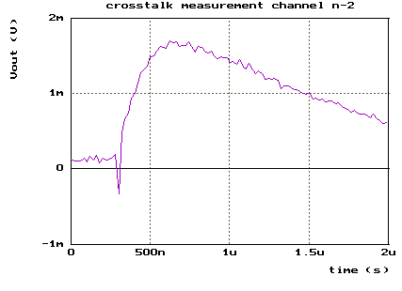 | Signal magnitude @ peaking time :  1.364mV (1.48‰ of signal)
Channel 8 | 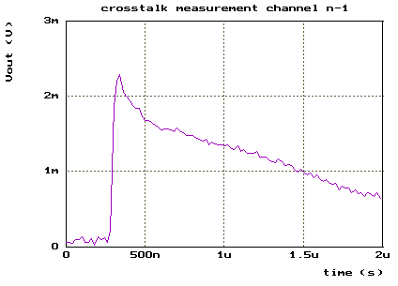 | Signal magnitude @ peaking time :  1.568mV (1.69‰ of signal)
Channel 9 | 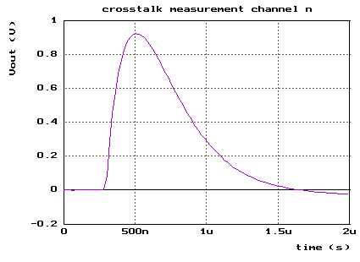 | HIT CHANNEL  Injected charge : 5pC  Signal magnitude @ peaking time :  924.7mV (100% of signal)
Channel 10 | 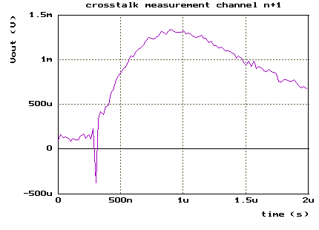 | Signal magnitude @ peaking time :  705μV (0. 762‰ of signal)
Channel 11 | 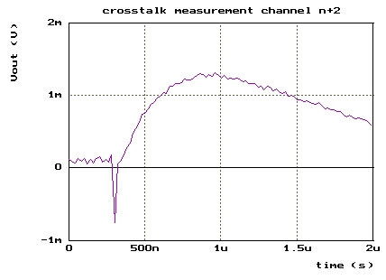 | Signal magnitude @ peaking time :  639μV (0.691‰ of signal)
Table 5 - Crosstalk measurement
The measured crosstalk is well beyond application expectation as shown on Table 5. Average crosstalk is below 1‰ in the 4 nearest channel around hit channel.

Noise
As FLC_PHY2 does not include testpoint after preamplifier, it is more difficult to analyze noise. The only signal that can be monitored is the multiplexed output. It is thus not possible to sweep peaking time shaping to fit ENC measurement and extract serial noise.
Noise measurement made so far are below expectations. In order to compare noise with FLC_PHY1, the 1.6pF feedback capacitor will be selected for noise measurement. A 500uA input bias is set up.
ENC is calculated for different detector capacitors C_{d}. Results are available in Table 6.

C_{d} (pF) | ENC (e⁻)
0 | 3273
10 | 3496
18 | 3725
33 | 4250
68 | 5188
Table 6 - ENC vs Cd, Cf=1.6pF

Figure 10 - ENC=f(Cd) with Cf=1.6pF

By fitting ENC=f(Cd) serial noise is estimated around 2.42 nV/sqrt(Hz) with a parasitic capacitance of 112.77 pF. That estimation is physically impossible thus obtain such a big parasitic capacitance is not possible (parasitic capacitance should be around 15 pF). That means there is a wrong approximation in the calculation.

The end of that chapter will deal with measurement made to figure out why the noise is so high.
Theory assume that preamplifier is the major noise source, next stages are supposed to be not noisy. First work will be to slice off different stage to isolate noise sources.
First measurement shows up that the noise sounds to come from shaper rather than preamplifier. All stage of a channel have been shut down one after another. RMS noise have then be measured at the output of the whole channel. Results are presented in Table 7.

Stage down | Measurement of | Output RMS noise
OTA | Board buffer | 67.7 μV
Common collector | OTA+board buffer | 72.12 μV
Shaper 1 | OTA+board buf. + T&H | 77 μV
Preamp | OTA+board buf. + T&H + shaper | 184.88 μV
 | Whole line | 187.93 μV
Table 7 - Noise versus shut down stages

It sounds like major noise source comes from the shaper stage. Some further measurements have been made with gain 10 shaper. Results are around twice better.
These bad results may come from very high resistor (33k and 100k) in the shaper. It will be necessary to analyze more in detail these noise results to improve results of next iteration.
Some parameter of the preamp have then be swept to try to minimize noise and improve knowledge of that noise. A commenter avec Christophe
Figure 11 - Output noise vs preamp gain
Figure 12 - output noise versus feedback capacitance

Figure 13 - Output noise vs Input PMOS current bias

Transient
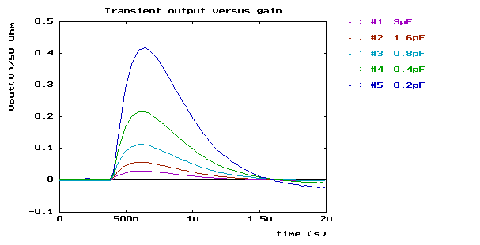
Figure 14 - Output gain 1 versus feedback capacitance
Shape of the output signal, gain and peaking time will be studied In this chapter. The aim is to determine that peaking time is constant when changing gain or buffer, etc. Peaking time versus magnitude will not be figured out as it is implicit in the linearity study.
As shown on Figure 14, the peaking time seems not to change when the gain is changing. Table 8 gives more details about peaking time for every gain. The dispersion of peaking time is small enough according to the shape of the output signal (Figure 14 ) to assume that it is not changing versus preamplifier gain.
Theoretic Feedback capa | Theoretic gain | Measured gain | Peaking time  Meas.
0.2pF | 5V/pC | 5.61 V/pC | 217.84 ns
0.4pF | 2.5V/pC | 2.85 V/pC | 217.37 ns
0.6pF | 1.67V/pC | 1.92 V/pC | 215.39 ns
0.8pF | 1.25V/pC | 1.45 V/pC | 214.7 ns
1pF | 1V/pC | 1.17 V/pC | 214.7 ns
1.2pF | 830mV/pC | 973 mV/pC | 212.92 ns
1.4pF | 714mV/pC | 832 mV/pC | 212.46 ns
1.6pF | 625mV/pC | 735 mV/pC | 212.77 ns
1.8pF | 555mV/pC | 656 mV/pC | 213.47 ns
2pF | 500mV/pC | 593 mV/pC | 214.21 ns
2.2pF | 455mV/pC | 543 mV/pC | 216.44 ns
2.4pF | 416mV/pC | 490 mV/pC | 215.45 ns
2.6pF | 385mV/pC | 457 mV/pC | 216.61 ns
2.8pF | 357mV/pC | 424 mV/pC | 216.76 ns
3pF | 333mV/pC | 395 mV/pC | 215.45 ns
Table 8 - Measured gains and peaking times
As gain is conditioned by feedback capacitance and assuming that MMIC capacitance has around 20% precision, we shall assume that gain will have a 20% precision. Measurement made on gain is shown on Figure 15. Measured capacitance are smaller than expected capacitance.
Figure 15 - Measured feedback capa versus theoretic capa
To ensure full compatibility with read-out part wathever the final choice on the buffer will be, peaking time has to be constant between Widlar structure and common collector buffer. Figure 16 shows that shape are exactly the same. There is a little gain modification that will be quantified in the linearity part but this is not critical for compatibility.
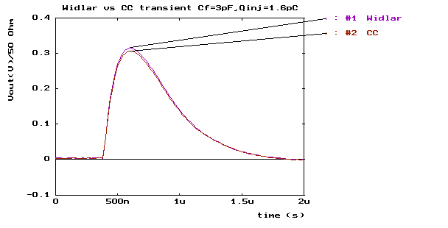
Figure 16 - Widlar & Common collector transient for comparison

Linearity
Linearity has been measured for 5 different gains. An outlook of performance is available in the 5 characterisation sheet below. Linearity have been measured for both common collector and Widlar structure track and hold buffer. Results show up that Widlar structure is better in term of voltage swing. Linearity is only fraction of percent whatever the gain or the buffer is. Linearity results are beyond expectations. All curves have been taken with a 50 Ohm load. That means voltages are divided by 2 in every figure or table.

Linearity measurement – Cf=3pF

Switch configuration

Switch 0 | Switch 1 | Switch 2 | Switch 3
ON | ON | ON | ON

Measurement results

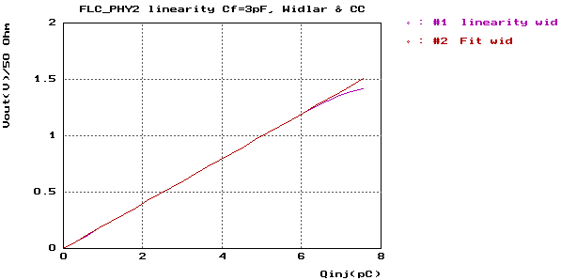 | 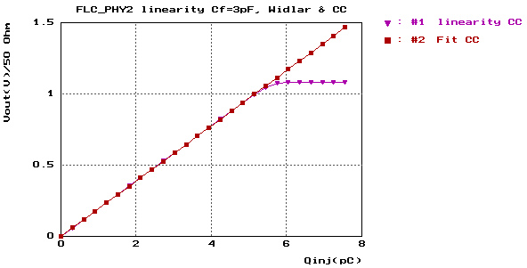
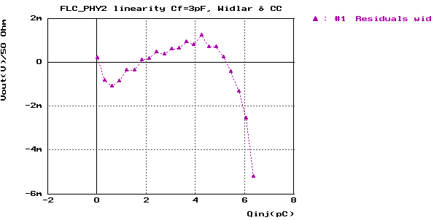 | 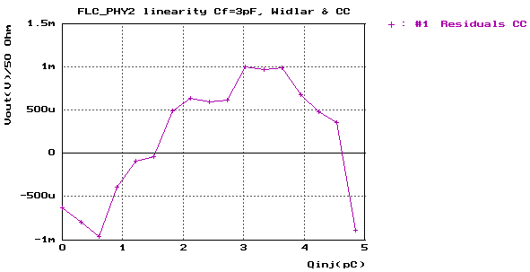
Figure 17 - Linearity - Cf=3pF

Buffer Structure | Widlar | Common collector
Qin max | 6.34 pC | 4.83 pC
Vout max | 1.26 V (over 50 Ω) | 0.94 V (over 50 Ω)
Gain | 199.2 mV/pC | 193 mV/pC
Feedback cap | 2.51 pF | 2.59pF
Non-linearity | 3.9‰ | 2.1‰
Table 9 - Characterization Cf=3pF

Linearity measurement – Cf=1.6pF

Switch configuration

Switch 0 | Switch 1 | Switch 2 | Switch 3
ON | OFF | OFF | OFF

Measurement results

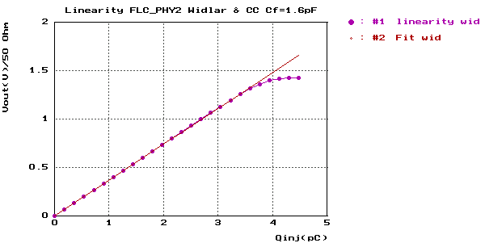 | 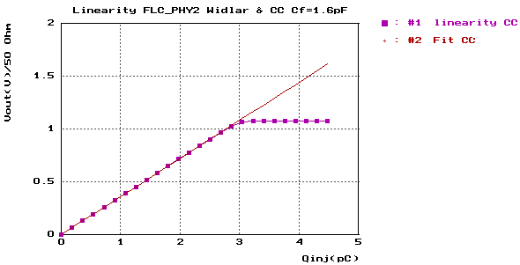
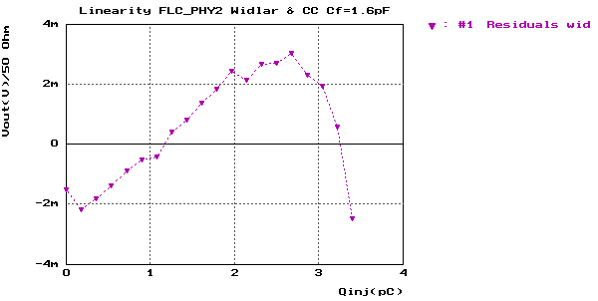 | 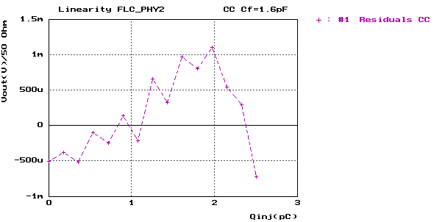
Figure 18 - Linearity - Cf=1.6pF

Buffer Structure | Widlar | Common collector
Qin max | 3.4 pC | 2.5 pC
Vout max | 1.26 V (over 50 Ω) | 0.9 V (over 50 Ω)
Gain | 370 mV/pC | 358 mV/pC
Feedback cap | 1.35 pF | 1.4 pF
Non-linearity | 3.9‰ | 1.7‰
Table 10 - Characterization Cf=1.6pF

Linearity measurement – Cf=0.8pF

Switch configuration

Switch 0 | Switch 1 | Switch 2 | Switch 3
OFF | ON | OFF | OFF

Measurement results

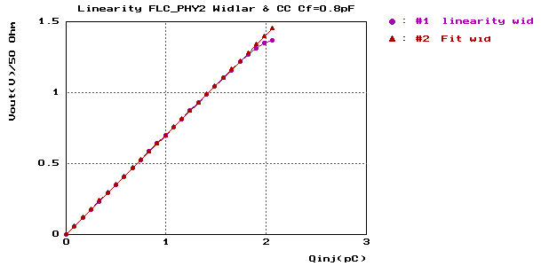 | 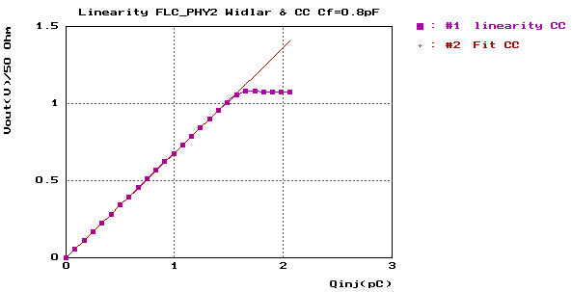
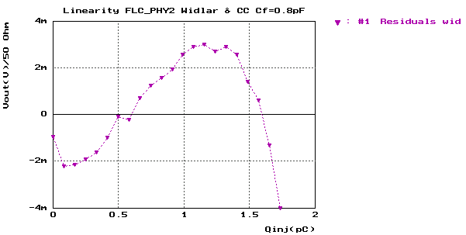 | 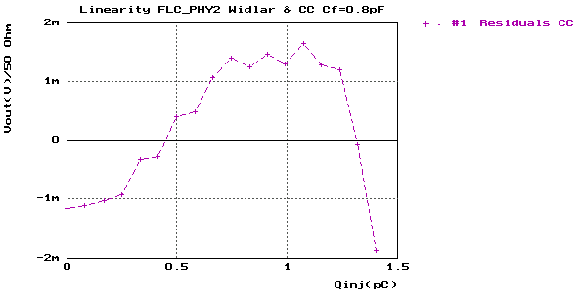
Figure 19 - Linearity - Cf=0.8pF

Buffer Structure | Widlar | Common collector
Qin max | 1.73 pC | 1.4 pC
Vout max | 1.22 V (over 50 Ω) | 0.95 V (over 50 Ω)
Gain | 702 mV/pC | 681 mV/pC
Feedback cap | 0.71 pF | 0.73 pF
Non-linearity | 4.1‰ | 3.2‰
Table 11 - Characterization Cf=0.8pF

Linearity measurement – Cf=0.4pF

Switch configuration

Switch 0 | Switch 1 | Switch 2 | Switch 3
OFF | OFF | ON | OFF

Measurement results

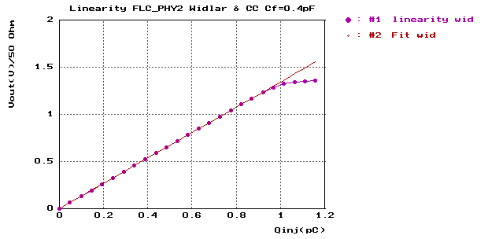 | 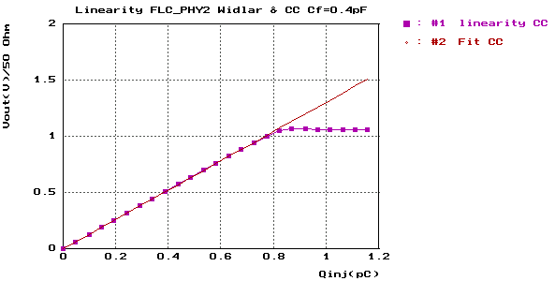
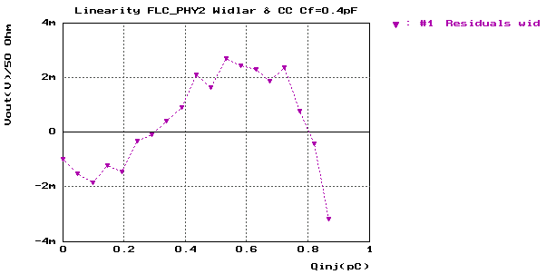 | 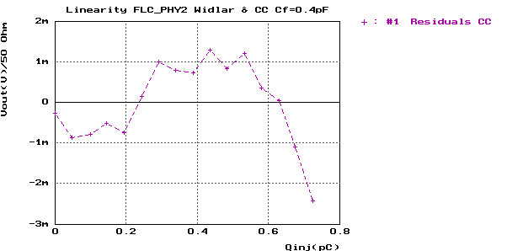
Figure 20 - Linearity - Cf=0.4pF

Buffer Structure | Widlar | Common collector
Qin max | 0.87 pC | 0.72 pC
Vout max | 1.17 V (over 50 Ω) | 0.94 V (over 50 Ω)
Gain | 1350 mV/pC | 1310 mV/pC
Feedback cap | 0.37 pF | 0.38 pF
Non-linearity | 3.4‰ | 3.3‰
Table 12 - Characterization Cf=0.4pF

Linearity measurement – Cf=0.2pF

Switch configuration

Switch 0 | Switch 1 | Switch 2 | Switch 3
OFF | OFF | OFF | ON

Measurement results

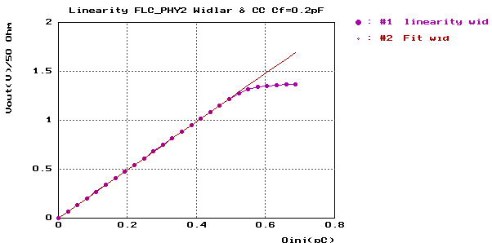 | 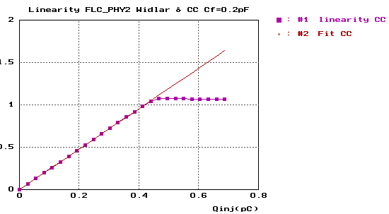
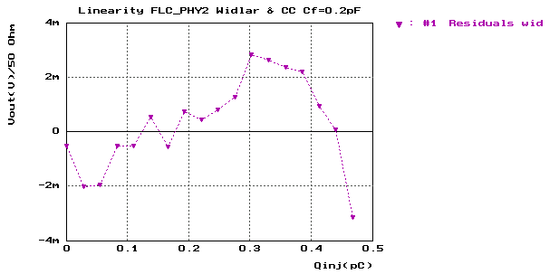 | 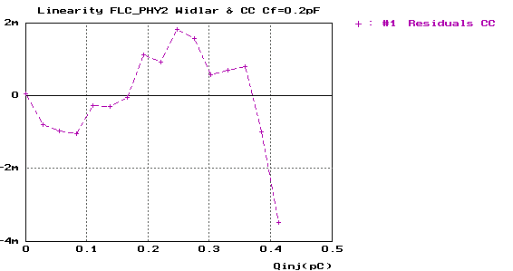
Figure 21 - Linearity - Cf=0.2pF

Buffer Structure | Widlar | Common collector
Qin max | 0.47 pC | 0.41 pC
Vout max | 1.15 V (over 50 Ω) | 0.98 V (over 50 Ω)
Gain | 2460 mV/pC | 2390 mV/pC
Feedback cap | 0.203 pF | 0.21 pF
Non-linearity | 4.3‰ | 5.1‰
Table 13 - Characterization Cf=0.2pF

Pedestal dispersion
Pedestal measurement have been made on both track-and-hold buffer structures (Common collector and Widlar, Figure 7). As a differential structure, we expected Widlar buffer to be significantly better than Common collector. Measurement of unit gain is shown on Figure 22.Measurement of Gain 10 is shown on Figure 23. Meassurement of pedestal dispersion is in Table 14.

DC (V) | DC (V)

Figure 22 - Pedestal measurement on Gain 1 output
DC (V) | DC (V)

Figure 23 - Pedestal measurement on gain 10 output
 | Common collector | Widlar structure
Gain 1
  7,8 mV
  0,9 mV
Gain 10 | 16,9 mV
  1,1 mV

Table 14 - Pedestal measurement results

ANNEX 1 – FLC_PHY2 pinout, bias and current

ANNEX 2 – FLC_PHY2 versus FLC_PHY1 pinout

ANNEX 3 - Preamp schematic

ANNEX 4 – shaper gain 1 schematic

ANNEX 5 – Shaper gain 10 schematic

ANNEX 6 – Shapers OPAMP schematic

ANNEX 7 – Widlar schematic

