CNRS | ICL
Centre National de la Recherche Scientifique | Imperial College of London – Blackett Laboratory
 | 



ICL – LAL EXCHANGES
for DAQ SPECS

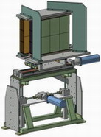

Code : xxxxx.doc
Issue : 2
Date : 09.23.04

Laboratoire de l’Accélérateur Linéaire
Campus Universitaire d’Orsay - Bâtiment 200
91898 ORSAY cedex - FRANCE
CHANGE RECORD

Issue/Rev | Date | Section affected | Reason/ remarks
1 | 06.30.04 | All sections | Creation
2 | 09.23.04 | All sections | Update

Authors: | Date | Signature
JEHANNO Didier | 09.23.04
Approved by:
BOUQUET Bernard | 09.23.04

Table of contents

1 AIM OF THE DOCUMENT 4
2 VOCABULARY 5
3 POINT 1 6
4 POINT 2 6
5 POINT 3 6
6 POINT 4 6
7 POINT 5 7
8 POINT 6 7
9 POINT 7 7

AIM OF THE DOCUMENT

This document , called "ICL – LAL EXCHANGES for DAQ SPECS", describes the questions/answers between LAL Laboratory and Imperial College of London, represented by Paul D. DAUNCEY of the Blackett Lab., about the DAQ interface.

The beginning of the exchanges starts with the document listed below (discussed on 06.29.2004 by P.D. DAUNCEY and B.BOUQUET at the CERN) :

" DAQ Interface" ref. ECALArchitecture2_DAQ.ppt 06.25.2004, rev. 2

Revisions (Steps) of THIS document
Beginning of exchanges

06/25/2004
DAQ Interface
ECALArchitecture2_DAQ.ppt
06/30/2004
ICL – LAL EXCHANGES for DAQ SPECS

etc...

STEP | Imperial College of London |  |  | LAL answer
STEP | NAME | TITLE | DATE | DATE | Revision of THIS document
1 | P.D. DAUNCEY | Dr. | 06.30.2004 | 07.01.2004 | 1
2 | P.D. DAUNCEY | Dr. | 07.01.2004 | 09.23.2004 | 2

VOCABULARY

System Overview

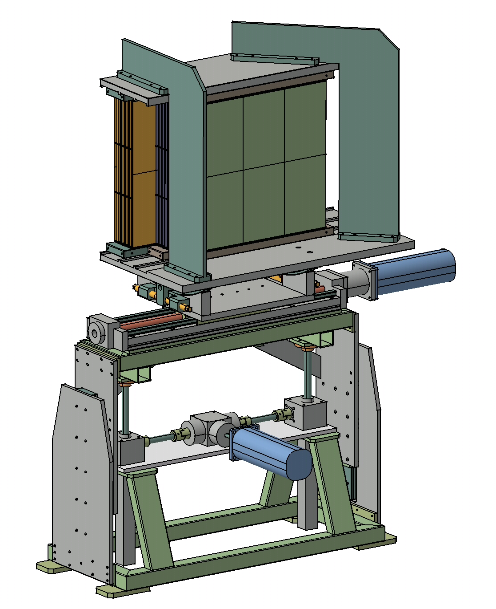
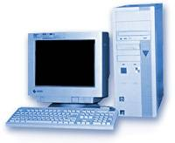
ECAL
MoX
MoY
STAND
TT
DAQ
HESTA

MIB
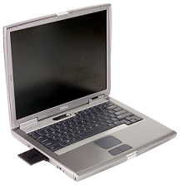

422HI
422L
232L

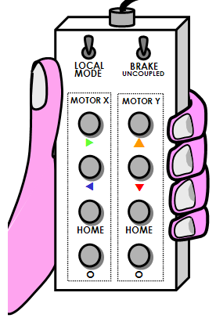
LCO

LAN

Ethernet

HESTA content

Graphical Interface
Socket
Socket Interface
TCP/UDP

422HI
Indexer Interface
IP
LAN
ASCII Indexer Protocol
Ethernet

Term | Signification
ECAL | Electromagnetic Calorimeter
MoX | Motor X-axis (translation table)
MoY | Motor Y-axis (vertical move)
MIB | Motor Indexer Box
TT | Translation Table (THOMSON)
LCO | Local Console
422HI | RS422 Hardware Interface
422L | RS422 Line between MIB and 422HI
232L | RS232 Line between 422HI and HESTA
HESTA | HMI for ECAL STAnd
HMI | Human-Machine Interface
DAQ | Data AcQuisition system, provided by ICL
LAN | Local Area Netwok

POINT 1

ICL | 06/30/2004  The cable length of 30m may not be sufficient at all beam lines, but this is not a limitation of the RS422 signal and so can be increased if necessary.
LAL | 09/14/2004  The RS422 line will use RS485 devices, operated as full-duplex point-to-point circuits. Hence, the maximum length of the line should not exceed 4000ft @100kbps. Also, as the data rate is going to be more likely 9600 bauds, this distance can be increased.  Anyway, if you know the maximum distance, let inform us. We will make the appropriate cable which will be suitable for all beams.

POINT 2

ICL | 06/30/2004  The DAQ system will be in Linux so you using Windows will involve some work to port the code (mainly sockets). Hence, if you can use Linux, then it would be easier. However, the work for the porting should not be too hard assuming you have Visual C++ on the Windows machine.
LAL | 09/14/2004  The HESTA software will be written in C++ with Microsoft Visual C++ tool. The laptop provided by the LAL will run under Windows XP.

POINT 3

ICL | 06/30/2004  The stand will never need to be moved during a run. Hence, the DAQ will treat the whole system as passive, i.e. it will not move the stages. It therefore only needs to be able to do a read-only read of the data from the system.
LAL | 09/14/2004  OK. No move during the experiment’s run. DAQ sees the datas as “Read-only”.

POINT 4

ICL | 06/30/2004  There is no drift of the stages so, if the stages are not moved, the readings will be constant. Because of this, a read at run start (and also run end) is sufficient. Therefore, the data will _not_ be treated as slow controls monitoring data which need to be read every e.g. 1 minute.
LAL | 09/14/2004  During the run, some event may appear, like indexer fault, motor over-current, etc…

POINT 5

ICL | 06/30/2004  The interface to the DAQ is therefore as a simple server; the DAQ will request the data when needed and the system laptop will respond. The format will be a DAQ "record" sent via a socket to the laptop; the laptop then reads the stage data, adds them to the record by inserting a C++ object, and finally sends back the record to the DAQ. The DAQ will provide the framework and you will need to write the code within this to read the data into the C++ objects (and also probably the C++ object classes themselves).
ICL | 01/07/2004  I am not sure what you mean here. We have to get the data from the laptop controlling the stages to the general DAQ, which is definitely in C++ and will be structured to send and receive records through sockets.  How you handle the interface within the laptop is mainly up to you. For example, you could set it up so anytime anything is changed, the new values (for position, etc) are written in ASCII to a simple file on the laptop disk. The DAQ program running on the laptop could then read this file and copy the numbers into the record before returning it. This makes the two programs (the one you use for control and the DAQ one) effectively independent of each other. As I said, I was assuming we would write most (or in this case, effectively all) the DAQ program part of this. There are probably lots of other ways to structure this and it is mainly your choice. However, we still need _some_ DAQ program running on the laptop or else the data can't be integrated into the general DAQ system.  The only way I can see around having a DAQ-specific program on the laptop is for you to do something like copy the ASCII file from the laptop to some other (DAQ) PC using scp or similar whenever it is updated. Then the program which reads the data and puts them in the DAQ record runs on the other PC, not the laptop. The problem with this is that is it harder to be sure the file on the disk is the latest; if the network goes down, then as far as the DAQ is concerned there is nothing wrong, although the file may no longer have the right values. With the first method, then the socket communication will fail if the network goes down, so the DAQ knows not to write bad values to the records.
LAL | 09/14/2004  OK. The socket mechanism will be implemented by LAL. At a first glance, we do not intend to split our software : the socket mechanism will be native (no dedicated DAQ software using ASCII file) and thus will be part of our scope of supply.  Some requests :  - Dealing with the mode of connection, we propose TCP (connected mode). Do you agree ?  - Can you sent to us the C code you have already implemented for sockets ?  - Have you written a DAQ simulation that notably reproduces the socket functionalities so that we can test our software here in the LAL ?

POINT 6

ICL | 06/30/2004  The actual data listed as proposed seem fine. Generally, there should be no values written into these records which might change with calibration or alignment, i.e. the basic values in integer units should be read out. The data should also be as complete as possible; data volume for this system will be totally insignficant so basically include every possible byte which can be read out.
LAL | 09/14/2004  OK. We agree to the fact that “The data should also be as complete as possible » .

POINT 7

ICL | 06/30/2004  The rest of the control, etc, code for the laptop can then be written any way you like as long as it doesn't clash with the DAQ socket program when both are running. All the movement and readback commands as listed can be defined as you like.
LAL | 09/14/2004  OK

