FLC_PHY3 Front end chip
DATASHEET

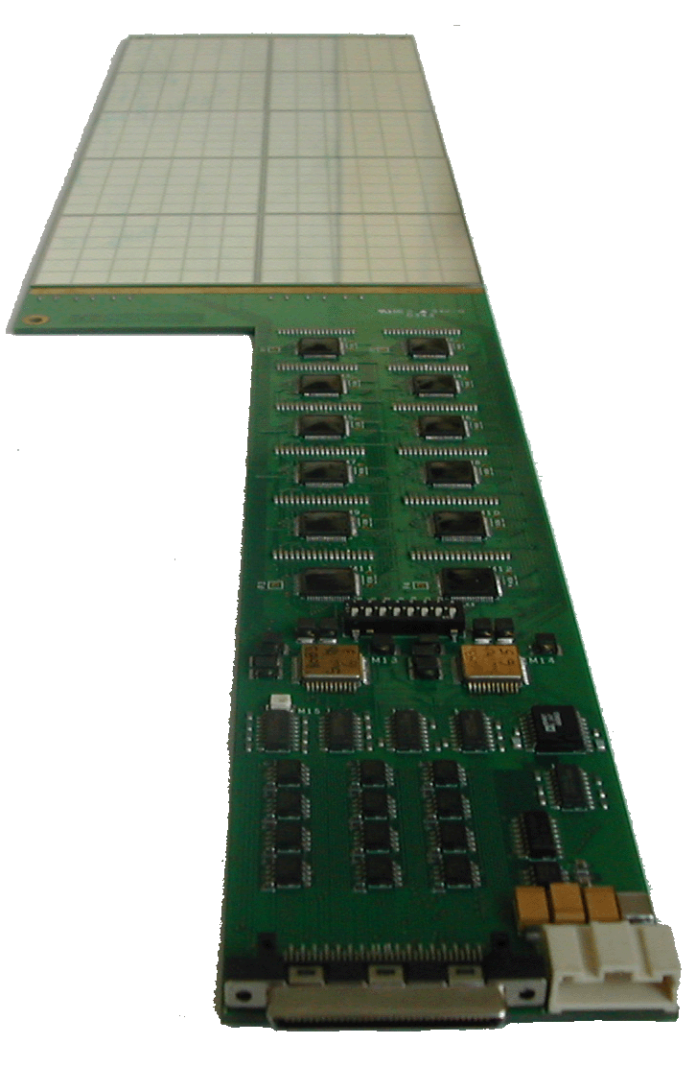

Table of content

1. Table of content 2
2. Table of figures 3
3. General description 4
4. One channel description 5
4.1. Charge preamplifier 5
4.2. Shapers 8
4.3. Track and hold 8
4.4. Output buffer 10
4.5. Multiplexer description 10
5. Pin definition 12
6. Characteristics & measurement 14
6.1. DC Levels 14
6.2. Transient 15
6.2.1. Output signal shape 15
6.2.2. Output signal dispersion 15
6.2.3. Preamplifier gain measurement 16
6.3. Linearity 17
6.3.1. Linearity measurement – Cf=3pF 18
6.3.2. Linearity measurement – Cf=1.6pF 19
6.3.3. Linearity measurement – Cf=0.8pF 20
6.3.4. Linearity measurement – Cf=0.4pF 21
6.3.5. Linearity measurement – Cf=0.2pF 22
6.4. Crosstalk 23
6.5. Noise 26
6.5.1. Gain 1 26
6.5.2. Gain 10 27
6.5.3. Charge Preamplifier 29
6.6. Pedestal dispersion 30

Table of figures

Figure 1 General block schema of FLC_PHY3 4
Figure 2 - Block schema of one channel 5
Figure 3 - Schema of charge preamplifier 6
Figure 4 - preamplifier resistor feedback 8
Figure 5 - CRRC shaper schematic 8
Figure 6- Block diagram of the channel N track and hold 9
Figure 7 - Block diagram of the shift register 11
Figure 8 - Chronogram of the multiplexed readout 11
Figure 9 - Transient of gain 1 and gain 10 shapers output 15
Figure 10 - Transient of gain 1 shaper output vs feedback capacitance 15
Figure 11 – Preamplifier measured feedback capacitance vs theoretic capacitance 17
Figure 12 - Linearity - Cf=3pF 18
Figure 13 - Linearity - Cf=1.6pF 19
Figure 14 - Linearity - Cf=0.8pF 20
Figure 15 - Linearity - Cf=0.4pF 21
Figure 16 - Linearity - Cf=0.2pF 22
Figure 17 - Output noise versus input capacitance - gain 1 26
Figure 18 - Equivalent input noise charge versus input capacitance - gain 1 27
Figure 19 - Output noise versus input capacitance - gain 10 28
Figure 20 - Equivalent input noise charge versus input capacitance – Gain 10 28
Figure 21 - FLC_PHY3 preamp ENC (e⁻) vs Tp (s) 29
Figure 22 - Pedestal measurement on Gain 1 output 31
Figure 23 - Pedestal measurement on gain 10 output 31

Table 1- Compensation capacitance values 7
Table 2 - Gain versus feedback capacitance switch configuration 7
Table 3 - follower switch SW description 9
Table 4 - measured vs simulated DC levels 14
Table 5 - Gain and peaking time dispersion 16
Table 6 - Theoretic vs measured preamplifier gain 16
Table 7 - Characterization Cf=3pF 18
Table 8 - Characterization Cf=1.6pF 19
Table 9 - Characterization Cf=0.8pF 20
Table 10 - Characterization Cf=0.4pF 21
Table 11 - Characterization Cf=0.2pF 22
Table 12 – Gain 1 Crosstalk measurement 24
Table 13 – Gain 10 Crosstalk measurement 25
Table 14 - Pedestal measurement 30

Equation 1 - Shaper transfer function 8

General description
The FLC_PHY3 Front-end chip is an 18-channel charge input front end circuit. It provides a shaped signal proportional to the input charge.
Gain select
MUX ctrl

4

T&Hold
preamp
Shaper
G=1
IN 0

T&Hold
Channel 0
Shaper
G=10

T&Hold
preamp
Shaper
G=1
IN 1

T&Hold
Channel 1
Shaper
G=10

preamp
T&Hold
Shaper
G=1
IN 17

T&Hold
Channel 17
Shaper
G=10

Figure 1 General block schema of FLC_PHY3
Buffer

OUT

Each channel is made of a variable-gain charge preamplifier followed by two parallel shaping filter of different gain (1 and 10) using a CRRC structure. Each of these shaper are followed by a track & hold device driving a single multiplexed output.
The bias of each stage is common for every channel.

One channel description

Amp
OPA
OPA
MUX out Gain=1
MUX out Gain=10
Input

Figure 2 - Block schema of one channel
Figure 2 shows a simplified block schema of one channel. The first stage is made of a multi-gain charge preamplifier. Four switchable feedback capacitance allow to tune the gain within 16 gains. After the preamplifier, the circuit is doubled to optimise dynamic range. Two shapers with different gains (1 and 10) allows to reduce noise. Hence there is two shaped signal available. Choosing one or the other may depend on the magnitude of the signal. A track and hold device allowing multiplexing follows each of the shaper.
Each functional block will be described in detail below.

Charge preamplifier

25
25
1
1
0.2pF
0.4pF
0.8pF
1.6pF
1pF
2pF
4pF

Figure 3 - Schema of charge preamplifier
The first stage of that preamplifier is a common source transistor biased by a current source made of two NMOS transistor connected as a current mirror.
It is recommended to let flow at least 500µA in the input PMOS to reduce series noise by increasing the PMOS gm. That means Vbiasi_pa should be connected to the Vdd with a resistor smaller than 10kΩ (typ. 6.7kΩ for Ids=500µA or 3.3 kΩ for Ids=1mA).A compromise have to be done at this point by the designer between consumption and noise. Vbiasi_pa is the current source of the input PMOS and the bipolar cascode. The current flowing in the input PMOS can be calculated by subtracting the cascode current (provided by the Vbiasm_pa current source) to the input current source.
The second stage is a common base bipolar transistor (NPN) in a cascode structure. The Vb pin allows to tune the input PMOS Vds. The Vbiasm_pa bias the bipolar transistor with a DC current.
After the second stage are the compensation capacitors that allows to slow the preamplifier down in case of oscillation, if the impedance on the input is not enough capacitive. The value of the compensation capacitance are given in Table 1.

Capacitance | Value
Switch 1 | 4pF
Switch 2 | 2pF
Switch 3 | 1pF
Table 1- Compensation capacitance values

The third stage is a follower (common drain PMOS) biased by a current source (Vbiaso_pa).
The feedback capacitor is tuneable. 4 switched capacitors allows to choose within 16 gain. The different gain are listed in Table 2.
Switch configuration |  |  |  | Feedback  Capacitance | Gain
Capa SW0=1.6pF | Capa SW1=0.8pF | Capa SW2=0.4pF | Capa SW3=0.2pF | Feedback  Capacitance | Gain
OFF | OFF | OFF | OFF | 0pF | N/A
OFF | OFF | OFF | ON | 0.2pF | 5V/pC
OFF | OFF | ON | OFF | 0.4pF | 2.5V/pC
OFF | OFF | ON | ON | 0.6pF | 1.67V/pC
OFF | ON | OFF | OFF | 0.8pF | 1.25V/pC
OFF | ON | OFF | ON | 1pF | 1V/pC
OFF | ON | ON | OFF | 1.2pF | 830mV/pC
OFF | ON | ON | ON | 1.4pF | 714mV/pC
ON | OFF | OFF | OFF | 1.6pF | 625mV/pC
ON | OFF | OFF | ON | 1.8pF | 555mV/pC
ON | OFF | ON | OFF | 2pF | 500mV/pC
ON | OFF | ON | ON | 2.2pF | 455mV/pC
ON | ON | OFF | OFF | 2.4pF | 416mV/pC
ON | ON | OFF | ON | 2.6pF | 385mV/pC
ON | ON | ON | OFF | 2.8pF | 357mV/pC
ON | ON | ON | ON | 3pF | 333mV/pC

Table 2 - Gain versus feedback capacitance switch configuration

The resistor feedback is made of two unbalanced current mirror and a resistor (Figure 3).That makes the resistor virtually bigger.
The output transistor of the mirror is 25 times bigger than the input one, that means the current in the input line is 25 times lower. Considering there is two stage, the input current is 625 smaller than the output one which is flowing in the feedback resistor. The resistor seen at the input of the preamp is then virtually 625 bigger than its real value (36kΩ*625=22.5MΩ, Figure 4).

Preamp out
Preamp in
I
I/25
I/625
25
25
1
1
36kΩ

Figure 4 - preamplifier resistor feedback

Shapers

Shapers are CRRC active filters that use operational amplifiers (Figure 5). The differential input of an operational amplifier allows to reduce the pedestal dispersion of shapers due to a DC loop feedback.
The DC reference allows to tune the output DC level. The transfer function of shapers is given on Equation 1. A decoupling capacitor have been added to reduce the shaper noise that was abnormally high in FLC_PHY2 version.

C1
R1
C2
R2
-
+
IN
DC ref
OUT

Figure 5 - CRRC shaper schematic
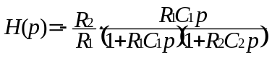
Equation 1 - Shaper transfer function

Track and hold
The track and hold allows to memorize an analogue value in a capacitance using a CMOS switch driven by the hold signal (pin H). That hold signal have to be synchronized with the peaking time of the shaper to ensure a maximum dynamic range and offset swing. The analogue value can then be red through the read CMOS switch. A follower forbids the charge of the capacitance to go away through the readout electronic. The value is then conserved during the reading. It is possible to choose between two different follower architecture. The first one is a simple common collector as on FLC_PHY1 chip. The second one use a differential structure (Widlar) to optimise pedestal dispersion. The pin SW permits to choose between common collector or Widlar structure (Table 3).

SW=1(Vdd) | SW=0(Vss)
Common collector | Widlar structure
Table 3 - follower switch SW description
The read switch is driven by a D latch cascaded as a shift register. That system allows to read sequentially the analogue value of the 18 channels of the selected gain with the multiplexed output.. A block diagram of the track and hold is shown on Figure 6.

Reset
CMOS switch
CMOS switch
To Multiplexed output buffer
D latch
Clock
Reset
D
Q
From shaper
Hold
Clock
To D of channel N+1
From Q of channel N-1
Widlar
follower
IN
OUT
Follower selec. switch

Figure 6- Block diagram of the channel N track and hold

Output buffer

The output buffer is made of an OTA with a unit feedback on the negative input. The bias_buf pin is to bias the input differential peer of the OTA. 100 µA DC current is needed to bias that first stage. A 47 kΩ resistor to Vdd allows to obtain that current.

Multiplexer description

There has been major modifications of the multiplexer between FLC_PHY2 and FLC_PHY3.
The two outputs of FLC_PHY2 (G1 and G10) are now mixed up in a single output (OUTPUT G1/G10). The choice of the gain can be made with an asynchronous gain selection switch.
The two shift registers (one for gain 1, one for gain 10) have the same digital control. That is to say they both will have the same behaviour to the same stimuli. In other words the two shift registers will always be in the same state (Figure 7).
In normal use, that involves the same channel will be active for gain 1 and gain 10 at a given time (see chronogram in Figure 8).
According to that symetry, the choice of the gain at the output will be done for a given channel. For example if the channel 2 is active for gain 1, channel 2 is active for gain 10 too. The choice of the gain will then be done for channel 2.
To keep the pin to pin compatibility with both FLC_PHY1 and FLC_PHY2, there is only one shift register output even if there is now two shift register. The Gain one shift register has been chosen to have an output. There is therefore now output for gain 10 shift register.
CLK
D
RST
SR_{IN}
G1
READ₀
G1
READ₁
G1
READ₂
G1
READ₁₆
G1
READ₁₇
D
D
D
D
CLK
D
RST
SR_{OUT}
D
D
D
D
G10
READ₀
G10
READ₁
G10
READ₂
G10
READ₁₆
G10
READ₁₇

Figure 7 - Block diagram of the shift register
RST
CLK
SR_{IN}
Gain_SW
SR_{OUT}
G1
Ch.0
G1
Ch.1
G10
Ch.2
G10
Ch.3
Hold
0
1
2
3
16
17
18
OUT
G10
Ch.16
G1
Ch.17

Figure 8 - Chronogram of the multiplexed readout

Pin definition
Ibm_pa
Rst_R
Ibo_sh10
SW
Ibi_wid
Ib_cc
Ibo_wid
Vddd
SW_gain
Vdd_ota+diode
SW_C2
SW_C3
Vss_ota
Out_preamp
SW3
Ib_ota
SW2
SW_C1
Vdd_pa
In 0
Ibi_pa
Vb_pa + Vbf
Vss_pa
If_pa
Ibo_pa
Ibo_sh1
Ibi_sh1
H
D_R
Vss_setH
Ibi_sh10
In 16
Ck_R
In 1
In 2
In 3
In 4
In 5
In 6
In 7
In 8
Vss
In 9
In 10
In 11
In 12
In 15
In 14
In 13
SW0
In 17
Vdd_pa
SW1
Vss_pa
Vss_sh1
Vref_sh1
Q_R
Vdd_sh1
OUT_g1
Vss_sh10
Vref1_sh10
Vdd_sh10
Vref2_sh10
Vdd_setH
1
2
3
4
5
6
7
8
10
9
11
12
13
14
15
16
17
18
19
20
21
24
22
23
31
30
29
28
27
26
25
40
39
38
32
37
36
35
34
33
47
46
45
44
43
42
41
51
50
49
48
56
57
58
59
60
61
62
63
64
55
54
53
52
FLC_PHY3
TQFP 64 package

Pin number | Pin name | definition
64,1-8,10-18 | In 0 – in 17 | 18 charge inputs
9,22,23,28, 41,51,60 | Vss | Low supply (substrate bias)
19,26,31, 32,40,42,63 | Vdd | High supply
20,21,34,35 | SW1,SW2,SW3, SW4 | CMOS preamp feedback capacitor switch  SW0 : 1.6 pF SW1 : 0.8 pF  SW2 : 0.4 pF SW3 : 0.2 pF
37 – 39 | SW_C1, SW_C2, SW_C3 | CMOS preamp compensation capacitor switch  SW_C1 : 4pF  SW_C2 : 2pF SW_C3 : 1pF
47 | SW | Widlar or common collector buffer switch
50 | Rst_R | CMOS shift registers reset
53 | Ck_R | CMOS shift registers clock
54 | H | CMOS Hold command
52 | D_R | CMOS Gain 1 and Gain 10 shift registers input
25 | Q_R | CMOS Gain 1 shift register output
27 | OUT_g1 | Gain 1 multiplexed output
43 | SW_gain | Gain 1 – gain 10 selection switch
24 | Vref_sh1 | Gain 1 shaper voltage reference for differential
29 | Vref1_sh10 | Gain 10 shaper voltage reference for differential
30 | Vref2_sh10 | Gain 10 shaper voltage reference for anti-saturation
62 | Ibi_pa | Preamplifier input stage current bias
58 | Ibm_pa | Preamplifier middle-stage current bias
57 | Ibm_pa | Preamplifier out-stage current bias
61 | Vb_pa+Vbf | Base cascode transistor voltage bias and feedback resistor cascode transistor voltage bias
59 | If_pa | Feedback preamplifier leakage current bias (should be around 100nA)
56 | Ibi_sh1 | Current bias of gain 1 shaper input stage
55 | Ibo_sh1 | Current bias of gain 1 shaper output stage
49 | Ibi_sh10 | Current bias of gain 10 shaper input stage
48 | Ibo_sh10 | Current bias of gain 10 shaper output stage
46 | Ibi_wid | Current bias of widlar buffer input stage
44 | Ibo_wid | Current bias of widlar buffer output stage
45 | Ib_cc | Current bias of common collector buffer
33 | Ib_OTA | Current bias of OTA output buffer
36 | Out_preamp | Channel 17 preamp output

Characteristics & measurement

DC Levels

Following DC levels have been measured and simulated on FLC_PHY3 chip :

Block | Bias name | Simulation result | Measurement | Current yield
Preamplifier | Ibi_pa | -3.3V | -3.2V | 1mA
Preamplifier | Ibm_pa | -1.37V | -1.4V | 70uA
Preamplifier | Ibo_pa | -1.28V | -1.3V | 100uA
Preamplifier | If_pa | -0.7V | -0.7V | 100nA
Preamplifier | Vb_pa | -3.5V | -3.5V | None – voltage ref.
Shaper 1 | Ibi_sh1 | -3.7V | -3.7V | 50uA
Shaper 1 | Ibo_sh1 | -3.7V | -3.7V | 50uA
Shaper 1 | Vref_sh1 | -3.8V | -3.7V | None – voltage ref.
Shaper 10 | Ibi_sh10 | -3.7V | -3.7V | 50uA
Shaper 10 | Ibo_sh10 | -3.7V | -3.7V | 50uA
Shaper 10 | Vref1_sh10 | -3.8V | -3.7V | None – voltage ref.
Shaper 10 | Vref2_sh10 | -2V | -2V | None – voltage ref.
Track&hold | Ib_cc | -1.4V | -1.5V | 50uA
Track&hold | Ibi_wid | -3.7V | -3.7V | 50uA
Track&hold | Ibo_wid | -3.7V | -3.7V | 50uA
OTA | Ib_ota | -3.7V | -3.9V | 50uA
Table 4 - measured vs simulated DC levels
Consumption of the whole chip is 150mW. That makes a 8.2mW dissipation per channel. It is easy to reduce that consumption by reducing input transistor bias current depending on noise yield and input capacitance. Setting a 200uA input current makes the consumption fall down to 4mW per channel.

Transient

Output signal shape
The output signal shape has been monitored to check the response of the CRRC filter (Figure 9).
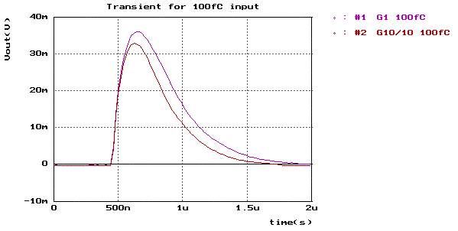
Figure 9 - Transient of gain 1 and gain 10 shapers output
The same measurement has been made with several preamp feedback capacitance (Figure 10). The gain variation is qualitatively validated.
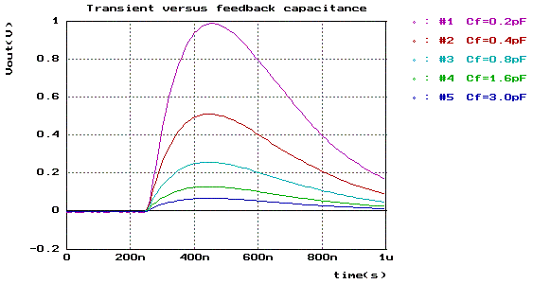
Figure 10 - Transient of gain 1 shaper output vs feedback capacitance

Output signal dispersion
The output signal has been measured on all channels. Statistic calculation has been done to estimate the peaking time and magnitude dispersion. Results are reported in Table 5.
 | Gain 1 |  | Gain 10
Channel | Mag. (mV) | Tp (ns) | Mag. (mV) | Tp (ns)
1 | 35 | 191 | 320 | 173
2 | 35,1 | 192 | 314 | 174
3 | 35,1 | 189 | 316 | 172
4 | 35,1 | 189 | 322 | 177
5 | 33,9 | 188 | 307 | 175
6 | 33,2 | 187 | 302 | 176
7 | 34,5 | 186 | 308 | 172
8 | 34,6 | 190 | 312 | 175
9 | 33,9 | 188 | 307 | 176
10 | 35,4 | 186 | 319 | 174
11 | 35,5 | 189 | 319 | 171
12 | 33 | 186 | 297 | 171
13 | 33,9 | 187 | 313 | 174
14 | 35,2 | 188 | 320 | 171
15 | 35 | 191 | 312 | 169
16 | 34 | 189 | 312 | 174
17 | 37,3 | 190 | 341 | 172
18 | 35,2 | 190 | 316 | 174
mean. | 34,717 | 188,667 | 314,278 | 173,333
Std dev. | 0,990 | 1,815 | 9,398 | 2,114
std dev/mean | 2,85% | 0,96% | 2,99% | 1,22%
Table 5 - Gain and peaking time dispersion

Preamplifier gain measurement
Preamplifier gains has been measured depending on feedback capacitance with an input charge of 100fC. Results are presented in Table 6.

Theoretic gain | theoretic Cf | Vout preamp | Meas. Gain | Meas. Cf
- | 0 | - | - | -
5 | 0,2 | 0,4934 | 4,934 | 0,2027
2,5 | 0,4 | 0,2658 | 2,658 | 0,3762
1,67 | 0,6 | 0,1822 | 1,822 | 0,5488
1,25 | 0,8 | 0,13898 | 1,3898 | 0,7195
1 | 1 | 0,11052 | 1,1052 | 0,9048
0,83 | 1,2 | 0,09334 | 0,9334 | 1,0714
0,71 | 1,4 | 0,07936 | 0,7936 | 1,2601
0,625 | 1,6 | 0,06784 | 0,6784 | 1,4741
0,56 | 1,8 | 0,06034 | 0,6034 | 1,6573
0,5 | 2 | 0,05526 | 0,5526 | 1,8096
0,45 | 2,2 | 0,0502 | 0,502 | 1,9920
0,42 | 2,4 | 0,04628 | 0,4628 | 2,1608
0,38 | 2,6 | 0,0428 | 0,428 | 2,3364
0,36 | 2,8 | 0,03966 | 0,3966 | 2,5214
0,33 | 3 | 0,03698 | 0,3698 | 2,7042
Unit : V/pC | Unit : pF | Unit : V | Unit : V/pC | Unit : pF
Table 6 - Theoretic vs measured preamplifier gain

Results presented in Table 6 allow to compare measured feedback capacitance with theoretic capacitance. That comparison is done in Figure 11.
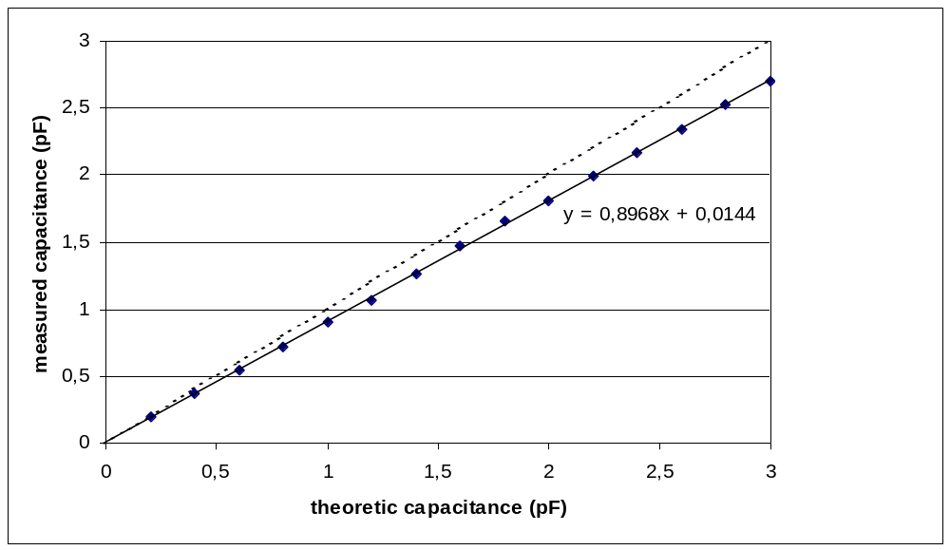
Figure 11 – Preamplifier measured feedback capacitance vs theoretic capacitance
Measured capacitance are smaller than expected (-10.32%). Parasitic capacitance between output and input is around 14fF.

Linearity
Linearity has been measured on both shaper gain 1 and gain 10. Several preamp gain configuration has been tested. FLC_PHY3 provides a 135 factor between highest and lowest channel gain. Considering a 6.72 fC MIP, Full range is from 6.6 MIP (highest gain) to 900 MIP (lowest gain). Linearity is around a few per thousand.
Max input and output signal, linearity measurement and gain calculation are detailed for a few preamp gain below.

Linearity measurement – Cf=3pF

Switch configuration

Switch 0 | Switch 1 | Switch 2 | Switch 3
ON | ON | ON | ON

Measurement results

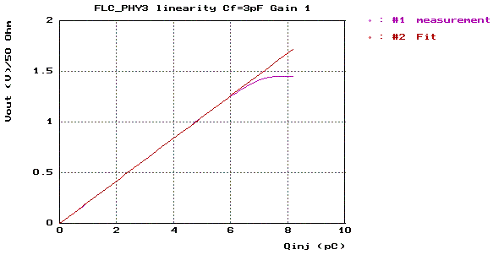 | 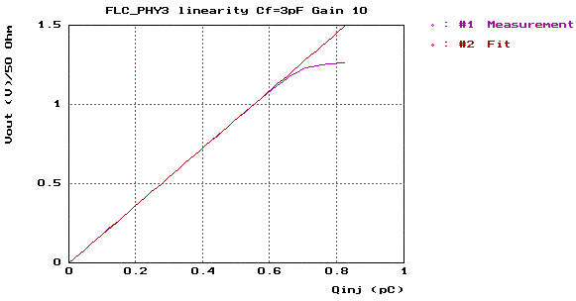
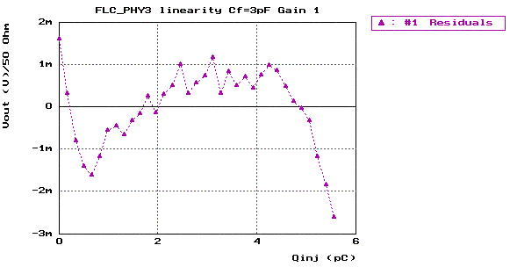 | 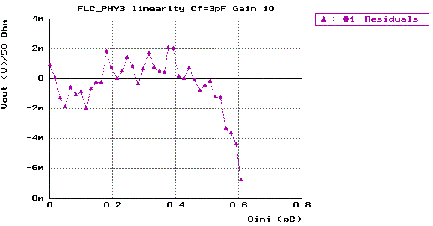
Figure 12 - Linearity - Cf=3pF

Shaper gain | 1 | 10
Qin max | 6.04 pC | 0.605 pC
Vout max | 1.26 V (over 50 Ω) | 1.09V (over 50 Ω)
Gain | 211 mV/pC | 1820 mV/pC
Feedback cap | 2.36 pF | 2.74pF
Non-linearity | 1.6‰ | 3.7‰
Table 7 - Characterization Cf=3pF

Linearity measurement – Cf=1.6pF

Switch configuration

Switch 0 | Switch 1 | Switch 2 | Switch 3
ON | OFF | OFF | OFF

Measurement results

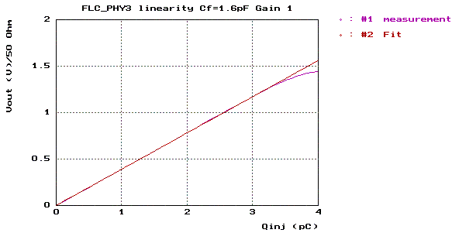 | 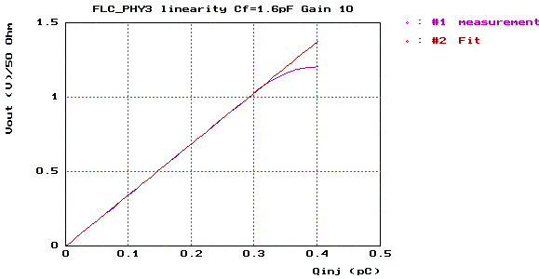
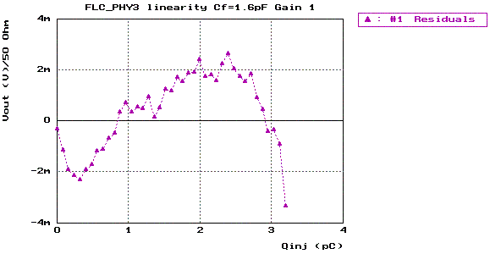 | 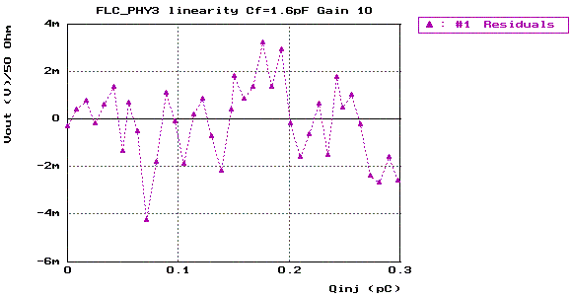
Figure 13 - Linearity - Cf=1.6pF

Shaper gain | 1 | 10
Qin max | 3.27 pC | 0.33 pC
Vout max | 1.27 V (over 50 Ω) | 1.12 V (over 50 Ω)
Gain | 391 mV/pC | 3.44 V/pC
Feedback cap | 1.27 pF | 1.45 pF
Non-linearity | 3.2‰ | 3.6‰
Table 8 - Characterization Cf=1.6pF

Linearity measurement – Cf=0.8pF

Switch configuration

Switch 0 | Switch 1 | Switch 2 | Switch 3
OFF | ON | OFF | OFF

Measurement results

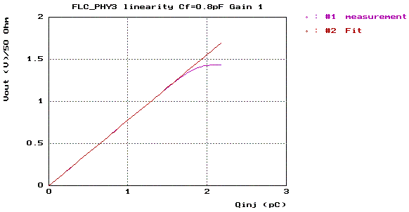 | 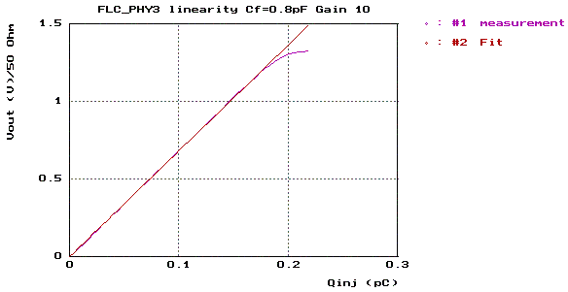
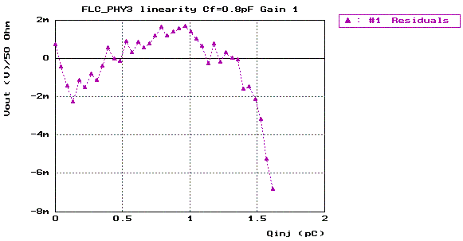 | 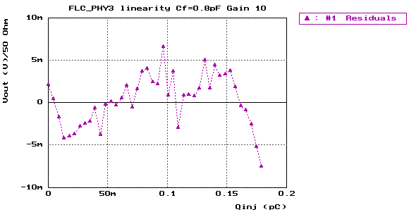
Figure 14 - Linearity - Cf=0.8pF

Shaper gain | 1 | 10
Qin max | 1.65 pC | 0.187 pC
Vout max | 1.28 V (over 50 Ω) | 1.26 V (over 50 Ω)
Gain | 778 mV/pC | 6.83 V/pC
Feedback cap | 0.64 pF | 0.73 pF
Non-linearity | 3.1‰ | 7.9‰
Table 9 - Characterization Cf=0.8pF

Linearity measurement – Cf=0.4pF

Switch configuration

Switch 0 | Switch 1 | Switch 2 | Switch 3
OFF | OFF | ON | OFF

Measurement results

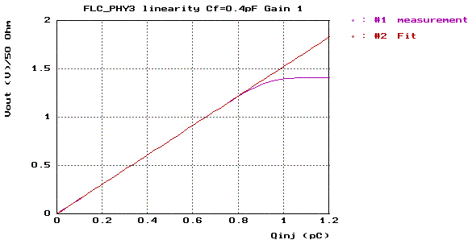 | 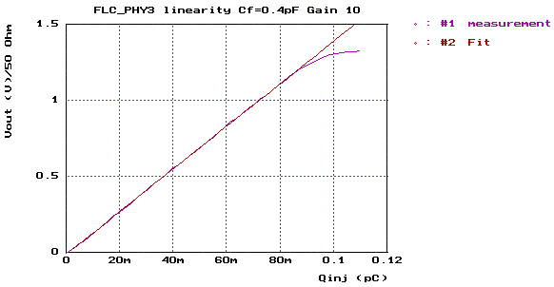
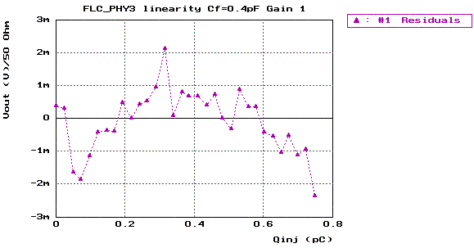 | 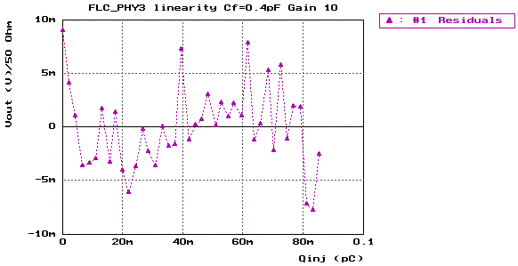
Figure 15 - Linearity - Cf=0.4pF

Gain shaper | 1 | 10
Qin max | 0.817 pC | 89.9 fC
Vout max | 1.24 V (over 50 Ω) | 1.23 V (over 50 Ω)
Gain | 1.53 V/pC | 14 V/pC
Feedback cap | 0.33 pF | 0.36 pF
Non-linearity | 2.4‰ | 8.1‰
Table 10 - Characterization Cf=0.4pF

Linearity measurement – Cf=0.2pF

Switch configuration

Switch 0 | Switch 1 | Switch 2 | Switch 3
OFF | OFF | OFF | ON

Measurement results

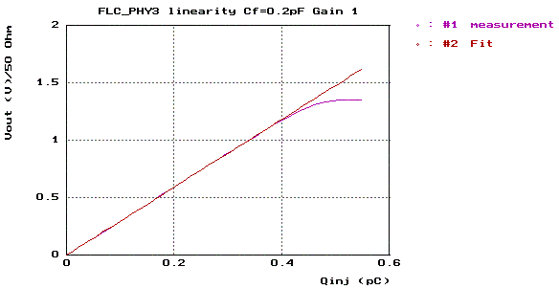 | 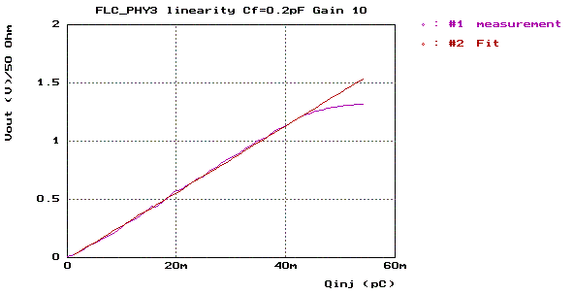
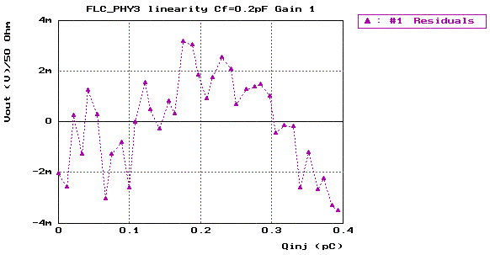 | 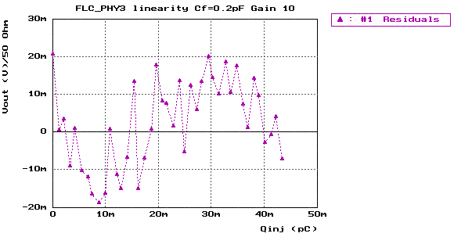
Figure 16 - Linearity - Cf=0.2pF

Shaper gain | 1 | 10
Qin max | 0.41 pC | 44.2 fC
Vout max | 1.19 V (over 50 Ω) | 1.24 V (over 50 Ω)
Gain | 2.96 V/pC | 28.6 V/pC
Feedback cap | 0.17 pF | 0.18 pF
Non-linearity | 3.4‰ | 16‰
Table 11 - Characterization Cf=0.2pF

Crosstalk

Crosstalk has been measured for Gain 1 and gain 10. Average crosstalk is below 1‰ in the 4 nearest channel around hit channel. A 3.4pC charge is injected in channel 4 for Gain 1 crosstalk measurement. A 0.34pC charge is injected in channel 4 for gain 10 crosstalk measurement.

Channel 2 | 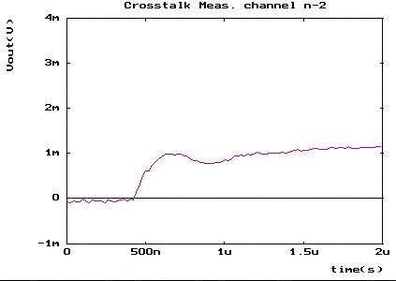 | Signal magnitude @ peaking time :  929μV (0.75‰ of signal)
Channel 3 | 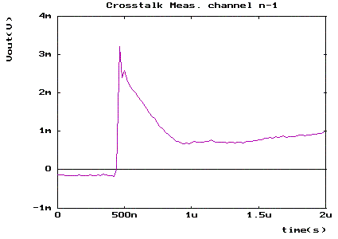 | Signal magnitude @ peaking time :  1.884mV (1.52‰ of signal)
Channel 4 | 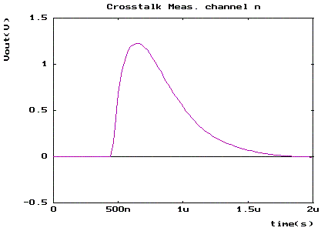 | HIT CHANNEL  Injected charge : 5pC  Signal magnitude @ peaking time :  1238.3mV (100% of signal)
Channel 5 | 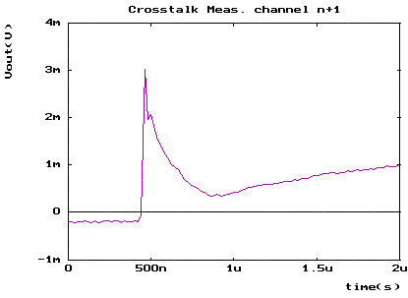 | Signal magnitude @ peaking time :  1.071mV (0. 86‰ of signal)
Channel 6 | 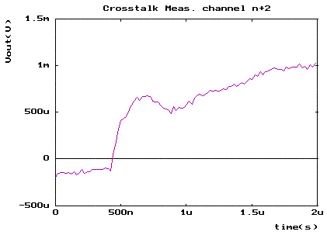 | Signal magnitude @ peaking time :  676μV (0.55‰ of signal)
Table 12 – Gain 1 Crosstalk measurement

Channel 2 | 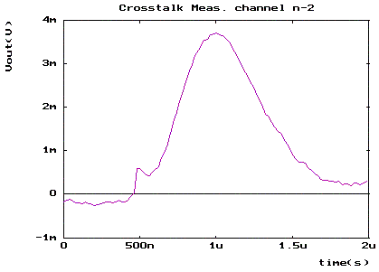 | Signal magnitude @ peaking time :  700μV (0.639‰ of signal)
Channel 3 | 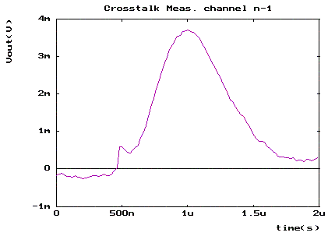 | Signal magnitude @ peaking time :  910μV (0.831‰ of signal)
Channel 4 | 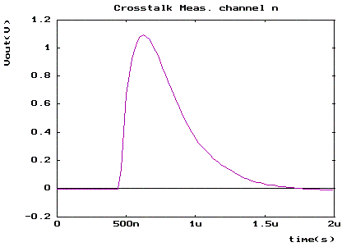 | HIT CHANNEL  Injected charge : 5pC  Signal magnitude @ peaking time :  1094mV (100% of signal)
Channel 5 | 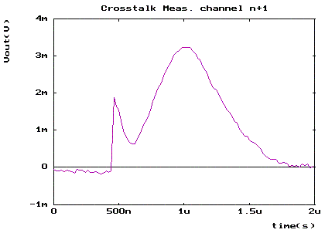 | Signal magnitude @ peaking time :  914μV (0. 84‰ of signal)
Channel 6 | 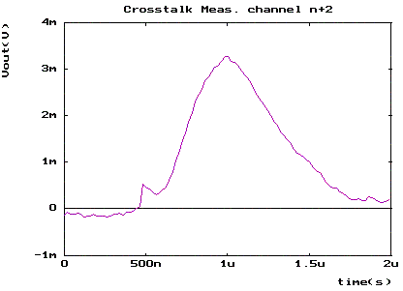 | Signal magnitude @ peaking time :  825μV (0.75‰ of signal)
Table 13 – Gain 10 Crosstalk measurement

Noise
Output noise and ENC (Equivalent noise charge) have been measured on a whole line with gain 1 and gain 10. A sweep of the input capacitance has been made. These noise measurements have been made with the § 6.1 DC levels.

Gain 1
Results of gain 1 are provided in Figure 17 and Figure 18.
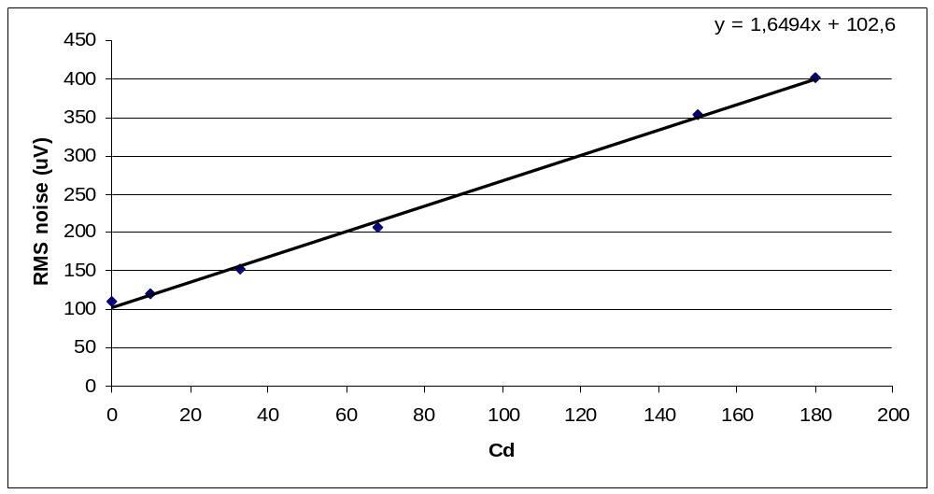
Figure 17 - Output noise versus input capacitance - gain 1

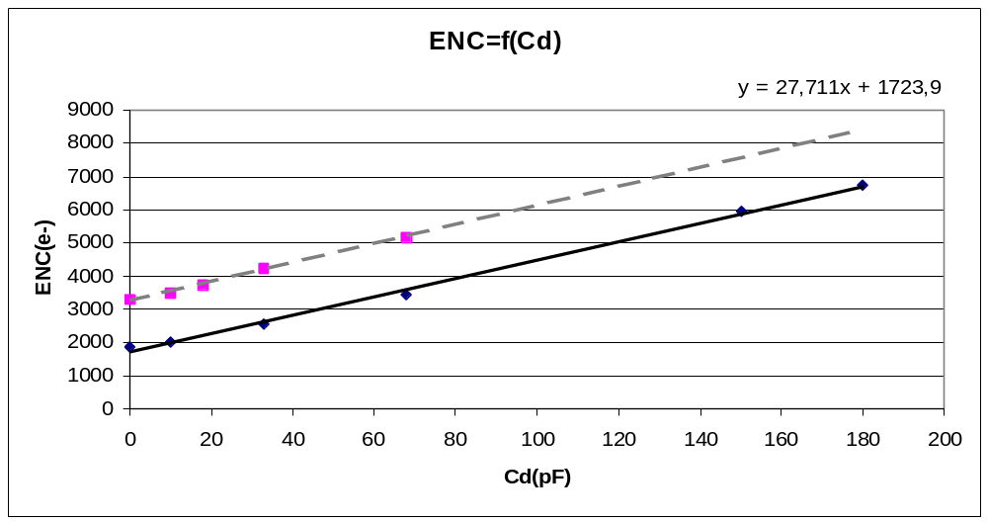
Figure 18 - Equivalent input noise charge versus input capacitance - gain 1

These results are better than FLC_PHY2 measurement due to the decoupling capacitance of the shaper DC reference. ENC is 1500 e⁻ better than FLC_PHY2 (dotted line in Figure 18).

Gain 10
Results of gain 1 are provided in Figure 19 and Figure 20.
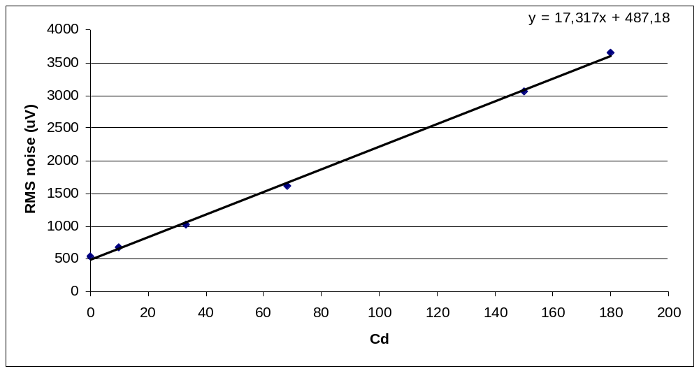
Figure 19 - Output noise versus input capacitance - gain 10
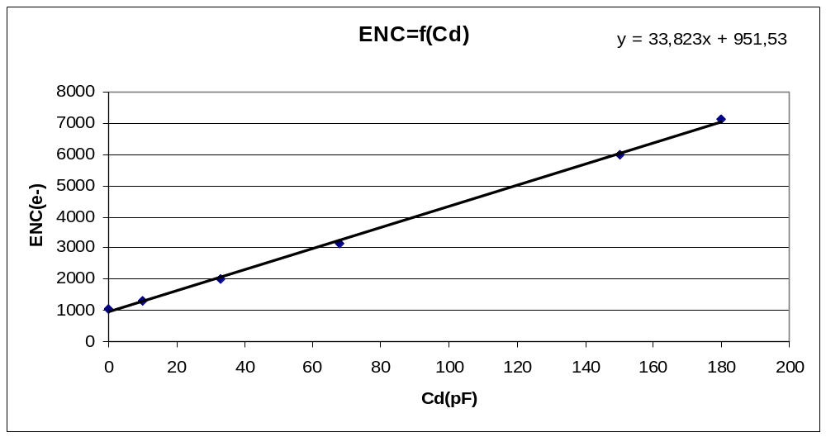
Figure 20 - Equivalent input noise charge versus input capacitance – Gain 10

Charge Preamplifier
FLC_PHY3 provide a direct preamp output on channel 18. That allows to measure preamp noise precisely. ENC curves have been drawn to find the serial noise of the preamplifier ( Parallel noise is neglected).
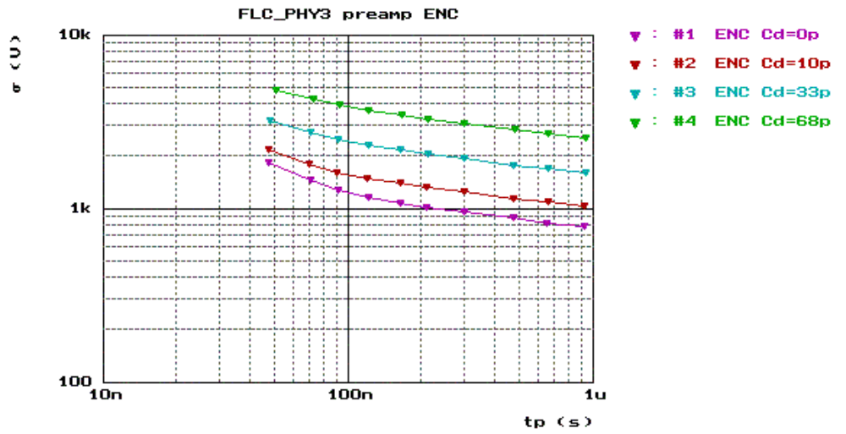
Figure 21 - FLC_PHY3 preamp ENC (e⁻) vs Tp (s)
A fit of these curves gives a serial noise of 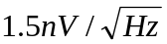 . Expectation was 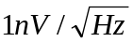.
There is an improvement here. FLC_PHY2 has a 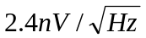 serial noise.

Pedestal dispersion
Pedestal dispersion has been measured on both gain using both track and hold follower (Widlar and common collector). Measurement and stats are in Table 14. Figure 22 and Figure 23 show graphically the pedestal measurement on gain 1 and gain 10 respectively.

 | Pedestal measurement (V)
 | Gain 1 |  | Gain 10
Channel | Com. Col | Widlar | Com. Col. | Wid.
1 | -2,7839 | -3,7017 | -2,8082 | -3,735
2 | -2,7872 | -3,6895 | -2,8163 | -3,731
3 | -2,7899 | -3,7042 | -2,7985 | -3,7316
4 | -2,7706 | -3,7023 | -2,8381 | -3,7252
5 | -2,7829 | -3,7032 | -2,8034 | -3,7237
6 | -2,781 | -3,6934 | -2,8012 | -3,7296
7 | -2,7679 | -3,7037 | -2,8048 | -3,7338
8 | -2,7688 | -3,7005 | -2,8146 | -3,7207
9 | -2,7745 | -3,7046 | -2,8241 | -3,748
10 | -2,7839 | -3,7036 | -2,7982 | -3,7238
11 | -2,7868 | -3,6955 | -2,8101 | -3,7355
12 | -2,761 | -3,7093 | -2,8131 | -3,7443
13 | -2,7913 | -3,7044 | -2,8227 | -3,7327
14 | -2,787 | -3,7067 | -2,8085 | -3,7215
15 | -2,7805 | -3,6953 | -2,8113 | -3,741
16 | -2,7846 | -3,7036 | -2,8357 | -3,7465
17 | -2,7906 | -3,7003 | -2,793 | -3,7227
18 | -2,7825 | -3,7005 | -2,8057 | -3,7237
Min. value (V) | -2,7913 | -3,7093 | -2,8381 | -3,748
Max. Value (V) | -2,761 | -3,6895 | -2,793 | -3,7207
Max -Min (mV) | 30,3 | 19,8 | 45,1 | 27,3
Mean (V) | -2,7808 | -3,7012 | -2,8115 | -3,7317
Std dev. (mV) | 8,72 | 4,95 | 12,30 | 8,76
Table 14 - Pedestal measurement

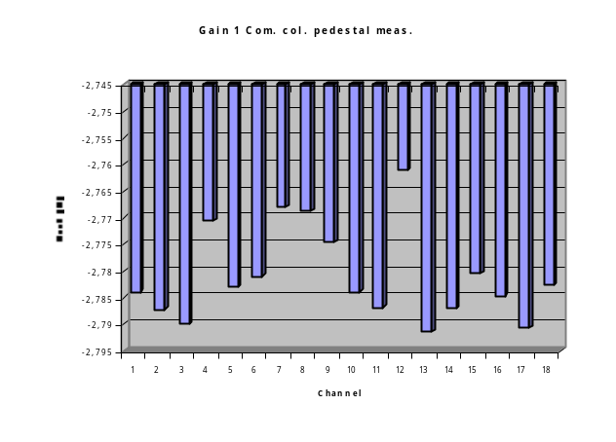 | 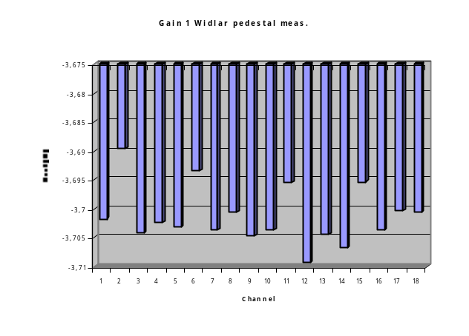
Figure 22 - Pedestal measurement on Gain 1 output

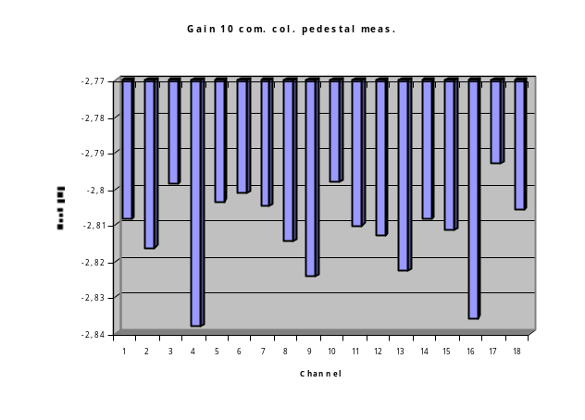 | 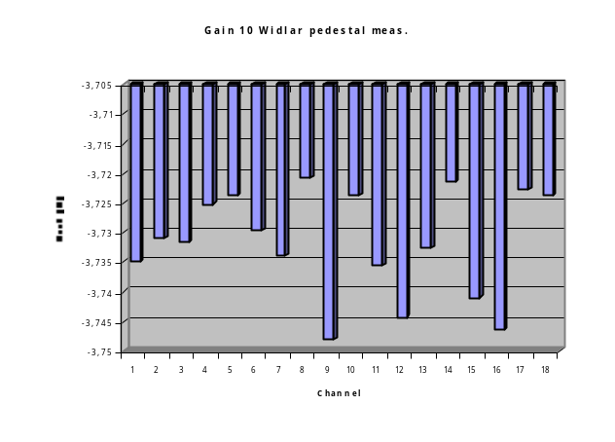

Figure 23 - Pedestal measurement on gain 10 output

