 | 
Imperial College London – Blackett Laboratory | Laboratoire de l'Accélérateur Linéaire

FLC :: ECAL
DAQ / HESTA Exchanges - Specs & Tests

Issue : 2.1
Date : 21.06.06

Laboratoire de l'Accélérateur Linéaire
Centre Scientifique d'Orsay - Bâtiment 200 - B.P. 34 - 91898 ORSAY

CHANGE RECORD

Issue | Date | Author | Verified | Reason/ remarks
1.0 | 12.04.05 | D. JEHANNO | P.D. DAUNCEY | Creation
2.0 | 20.04.05 | D. JEHANNO | P.D. DAUNCEY | Tests
2.1 | 21.06.06 | D. JEHANNO | P.D. DAUNCEY | Added 1 axis case §2 table part 2/

SUMMARY

1 PROTOCOL 4
2 DATAS SENT TO DAQ 5
3 P.D. DAUNCEY TESTS 7
4 LOG EVENTS 8
5 TEST : 19.04.05 9

PROTOCOL
START
ACTIVATED as CLIENT
DAQ
IP 155.198.211.74
PORT 1200
@ ICL ↓
START
ACTIVATED as SERVER
HESTA
IP 134.158.90.89
PORT 1200

the Client asks for a TCP connection to the Server
STEP A
Tx
STEP B
Rx
CLIENT Connect request

STEP C
Tx
STEP D
Rx
SERVER Connect response

the Client/Server connection is established

STEP 1
STEP 2
P
A
U
L
0
0
1
0
STEP 3
STEP 4
OK
KO
Z
Z
Z
Z
0x50,0x41,0x55,0x4C,
0x30,0x30,0x31,0x30
Asks for 10 UINT32
Sends 10 UINT32
0x5A,0x5A,0x5A,0x5A

Checksum (modulo 0x100000000)

header

Indexer X Status

Indexer X Values (1)

Indexer X Values (2)

Indexer X Values (3)

Indexer Y Status

Indexer Y Values (1)

Indexer Y Values (2)

Indexer Y Values (3)

ASCII
Tx
Rx
Tx
Rx

STEP 1’
STEP 2’
STEP 3’
STEP 4’
P
A
U
L
0
0
1
0
OK
KO
0x50,0x41,0x55,0x4C,
0x30,0x30,0x31,0x30

Asks for 10 UINT32
Sends 10 UINT32

Checksum (modulo 0x100000000)

header

Indexer X Status

Indexer X Values (1)

Indexer X Values (2)

Indexer X Values (3)

Indexer Y Status

Indexer Y Values (1)

Indexer Y Values (2)

Indexer Y Values (3)

ASCII
Z
Z
Z
Z
0x5A,0x5A,0x5A,0x5A

Tx
Rx
Tx
Rx

DATAS SENT TO DAQ

Part 1

BYTE 3 |  |  |  |  |  |  |  | BYTE 2 |  |  |  |  |  |  |  | BYTE 1 |  |  |  |  |  |  |  | BYTE 0 |  |  |  |  |  |  |  | COMMENTS
31 | 30 | 29 | 28 | 27 | 26 | 25 | 24 | 23 | 22 | 21 | 20 | 19 | 18 | 17 | 16 | 15 | 14 | 13 | 12 | 11 | 10 | 9 | 8 | 7 | 6 | 5 | 4 | 3 | 2 | 1 | 0 | LONG 0 : HEADER  IF ERROR : ‘ZZZZ’ (0x5A,0x5A,0x5A,0x5A)
0 | 1 | 0 | 1 | 0 | 1 | 0 | 1 | 0 | 0 | 0 | 0 | 1 | 0 | 1 | 0 | • | • | • | • | • | • | • | • | 0 | 0 | 0 | 0 | 0 | 0 | • | • | LONG 0 : HEADER  IF ERROR : ‘ZZZZ’ (0x5A,0x5A,0x5A,0x5A)
Magic Number : 0xAA |  |  |  |  |  |  |  | Size of Longs : 10 (0x0A) |  |  |  |  |  |  |  | Surveillance Counter :  Values : 1,2,3,…,255,1,2,3…  (incremented +1 each sending) |  |  |  |  |  |  |  | General Status  Bit 0 : Status PC Com OK  Bit 1 : Status Set OK  Bits 2..7 : spare |  |  |  |  |  |  |  | LONG 0 : HEADER  IF ERROR : ‘ZZZZ’ (0x5A,0x5A,0x5A,0x5A)
31 | 30 | 29 | 28 | 27 | 26 | 25 | 24 | 23 | 22 | 21 | 20 | 19 | 18 | 17 | 16 | 15 | 14 | 13 | 12 | 11 | 10 | 9 | 8 | 7 | 6 | 5 | 4 | 3 | 2 | 1 | 0 | LONG 1 : Indexer X Status
0 | 0 | 0 | 0 | 0 | 0 | 0 | 0 | 0 | 0 | 0 | 0 | 0 | 0 | • | • | • | • | • | • | • | • | • | • | • | • | • | • | • | • | • | • | LONG 1 : Indexer X Status
Bit 9 : Out Fault Bit 0 : Indexer Status OK  Bit 10 : Limit Plus Bit 1 : Motor is Moving  Bit 11 : Limit Minus Bit 2 : Composite Fault  Bit 12 : Local Mode On Bit 3 : Current Fault  Bit 13 : Console X Right Button On Bit 4 : Supply Fault  Bit 14 : Console X Left Button On Bit 5 : Ambiant Temp. Fault  Bit 15 : Console X Home Button On Bit 6 : Drive Fault  Bit 16 : Console X Set Home Button On Bit 7 : Config Fault  Bit 17 : User Lamp On Bit 8 : High Voltage Fault  Bits 18 to 31 : spare |  |  |  |  |  |  |  |  |  |  |  |  |  |  |  |  |  |  |  |  |  |  |  |  |  |  |  |  |  |  |  | LONG 1 : Indexer X Status
31 | 30 | 29 | 28 | 27 | 26 | 25 | 24 | 23 | 22 | 21 | 20 | 19 | 18 | 17 | 16 | 15 | 14 | 13 | 12 | 11 | 10 | 9 | 8 | 7 | 6 | 5 | 4 | 3 | 2 | 1 | 0 | LONG 2 : Indexer X Values (1)
0 | 1 | 0 | 0 | 0 | 1 | 1 | 0 | 0 | 1 | 1 | 0 | 0 | 1 | 0 | 0 | 0 | 0 | 0 | 0 | 0 | 0 | 1 | 0 | 0 | 0 | 0 | 1 | 0 | 0 | 1 | 0 | LONG 2 : Indexer X Values (1)
Motor Standby : 70% (0x46) |  |  |  |  |  |  |  | Motor Current : 100% (0x64) |  |  |  |  |  |  |  | Major Rev. : 2 (0x02) |  |  |  |  |  |  |  | Minor Rev. : 18 (0x12) |  |  |  |  |  |  |  | LONG 2 : Indexer X Values (1)
31 | 30 | 29 | 28 | 27 | 26 | 25 | 24 | 23 | 22 | 21 | 20 | 19 | 18 | 17 | 16 | 15 | 14 | 13 | 12 | 11 | 10 | 9 | 8 | 7 | 6 | 5 | 4 | 3 | 2 | 1 | 0 | LONG 3 : Indexer X Values (2)
0 | 0 | 1 | 0 | 1 | 0 | 0 | 0 | 0 | 0 | 0 | 1 | 0 | 1 | 0 | 0 | 0 | 0 | 0 | • | • | • | • | • | • | • | • | • | • | • | • | • | LONG 3 : Indexer X Values (2)
Motor Res. /100 : 40 (0x28) |  |  |  |  |  |  |  | Motor Vel. x100 : 20 (0x14) |  |  |  |  |  |  |  | Stand Position (X) [ 2500 (0x09C4) , 5500 (0x157C) ] |  |  |  |  |  |  |  |  |  |  |  |  |  |  |  | LONG 3 : Indexer X Values (2)
31 | 30 | 29 | 28 | 27 | 26 | 25 | 24 | 23 | 22 | 21 | 20 | 19 | 18 | 17 | 16 | 15 | 14 | 13 | 12 | 11 | 10 | 9 | 8 | 7 | 6 | 5 | 4 | 3 | 2 | 1 | 0 | LONG 4 : Indexer X Values (3)
0 | 0 | 0 | 0 | 0 | 0 | 0 | 0 | 0 | 0 | 0 | 0 | 0 | 0 | 0 | 0 | 0 | 0 | 0 | 0 | 0 | • | • | • | • | • | • | • | • | • | • | • | LONG 4 : Indexer X Values (3)
Bits 16 to 31 : spare |  |  |  |  |  |  |  |  |  |  |  |  |  |  |  | Bit 0 to 14 : Abs. Beam Position (X) < 1500 (0x05DC)  Bit 15 : Sign (0 = + / 1 = -) |  |  |  |  |  |  |  |  |  |  |  |  |  |  |  | LONG 4 : Indexer X Values (3)
Part 2

BYTE 3 |  |  |  |  |  |  |  | BYTE 2 |  |  |  |  |  |  |  | BYTE 1 |  |  |  |  |  |  |  | BYTE 0 |  |  |  |  |  |  |  | COMMENTS
31 | 30 | 29 | 28 | 27 | 26 | 25 | 24 | 23 | 22 | 21 | 20 | 19 | 18 | 17 | 16 | 15 | 14 | 13 | 12 | 11 | 10 | 9 | 8 | 7 | 6 | 5 | 4 | 3 | 2 | 1 | 0 | LONG 5 : Indexer Y Status  = 0xDEADBEEF in 1 axis (X) configuration
0 | 0 | 0 | 0 | 0 | 0 | 0 | 0 | 0 | 0 | 0 | 0 | 0 | 0 | • | • | • | • | • | • | • | • | • | • | • | • | • | • | • | • | • | •
Bit 9 : Out Fault Bit 0 : Indexer Status OK
Bit 10 : Limit Plus Bit 1 : Motor is Moving
Bit 11 : Limit Minus Bit 2 : Composite Fault
Bit 12 : Brake Uncoupled Switch On Bit 3 : Current Fault
Bit 13 : Brake Uncoupled On Bit 4 : Supply Fault
Bit 14 : Console Y Up Button On Bit 5 : Ambiant Temp. Fault
Bit 15 : Console Y Down Button On Bit 6 : Drive Fault
Bit 16 : Console Y Home Button On Bit 7 : Config Fault
Bit 17 : Console Y Set Home Button On Bit 8 : High Voltage Fault
Bits 18 to 31 : spare
31 | 30 | 29 | 28 | 27 | 26 | 25 | 24 | 23 | 22 | 21 | 20 | 19 | 18 | 17 | 16 | 15 | 14 | 13 | 12 | 11 | 10 | 9 | 8 | 7 | 6 | 5 | 4 | 3 | 2 | 1 | 0 | LONG 6 : Indexer Y Values (1)  = 0xDEADBEEF in 1 axis (X) configuration
0 | 1 | 0 | 0 | 0 | 1 | 1 | 0 | 0 | 1 | 1 | 0 | 0 | 1 | 0 | 0 | 0 | 0 | 0 | 0 | 0 | 0 | 1 | 0 | 0 | 0 | 0 | 1 | 0 | 0 | 1 | 0
Motor Standby : 70% (0x46) |  |  |  |  |  |  |  | Motor Current : 100% (0x64) |  |  |  |  |  |  |  | Major Rev.: 2 (0x02) |  |  |  |  |  |  |  | Minor Rev. : 18 (0x12)
31 | 30 | 29 | 28 | 27 | 26 | 25 | 24 | 23 | 22 | 21 | 20 | 19 | 18 | 17 | 16 | 15 | 14 | 13 | 12 | 11 | 10 | 9 | 8 | 7 | 6 | 5 | 4 | 3 | 2 | 1 | 0 | LONG 7 : Indexer Y Values (2)  = 0xDEADBEEF in 1 axis (X) configuration
0 | 0 | 1 | 0 | 1 | 0 | 0 | 0 | 0 | 0 | 1 | 0 | 1 | 0 | 0 | 0 | 0 | 0 | 0 | • | • | • | • | • | • | • | • | • | • | • | • | •
Motor Res. /100 : 40 (0x28) |  |  |  |  |  |  |  | Motor Vel. x10 : 40 (0x28) |  |  |  |  |  |  |  | Stand Position (Y) [ 1000 (0x03E8) , 3000 (0x0BB8) ]
31 | 30 | 29 | 28 | 27 | 26 | 25 | 24 | 23 | 22 | 21 | 20 | 19 | 18 | 17 | 16 | 15 | 14 | 13 | 12 | 11 | 10 | 9 | 8 | 7 | 6 | 5 | 4 | 3 | 2 | 1 | 0 | LONG 8 : Indexer Y Values (3)  = 0xDEADBEEF in 1 axis (X) configuration
0 | 0 | 0 | 0 | 0 | 0 | 0 | 0 | 0 | 0 | 0 | 0 | 0 | 0 | 0 | 0 | 0 | 0 | 0 | 0 | 0 | • | • | • | • | • | • | • | • | • | • | •
Bits 16 to 31 : spare |  |  |  |  |  |  |  |  |  |  |  |  |  |  |  | Bit 0 to 14 : Abs. Beam Position (Y) < 1500 (0x05DC)  Bit 15 : Sign (0 = + / 1 = -)
31 | 30 | 29 | 28 | 27 | 26 | 25 | 24 | 23 | 22 | 21 | 20 | 19 | 18 | 17 | 16 | 15 | 14 | 13 | 12 | 11 | 10 | 9 | 8 | 7 | 6 | 5 | 4 | 3 | 2 | 1 | 0 | LONG 9 : Checksum modulo 2^32
• | • | • | • | • | • | • | • | • | • | • | • | • | • | • | • | • | • | • | • | • | • | • | • | • | • | • | • | • | • | • | • | LONG 9 : Checksum modulo 2^32
Bits 0 to 31 : checksum, modulo 32 bits (0x100000000) = Σ (LONG 0,1,2,3,4,5,6,7,8) |  |  |  |  |  |  |  |  |  |  |  |  |  |  |  |  |  |  |  |  |  |  |  |  |  |  |  |  |  |  |  | LONG 9 : Checksum modulo 2^32

P.D. DAUNCEY TESTS

12.04.05 – P.D. Dauncey Tests

To be clear, the first page of your document states this should be 0x00, 0x00, 0x31, 0x30 but I would guess you really intended the first two of these to be 0x30 ? Yes, you are right ! It was a mistake. Protocol updated.

Anyway, I am slightly confused about endians here. I send the above "PAUL0010" but endian inverted... About to send...

0x4c554150 = 0b01001100 01010101 01000001 01010000
0x30313030 = 0b00110000 00110001 00110000 00110000

and I get back something which looks very good...

Word 0 = 0xaa0a1203 = 0b10101010 00001010 00010010 00000011
Word 1 = 0x00000001 = 0b00000000 00000000 00000000 00000001
Word 2 = 0x46640212 = 0b01000110 01100100 00000010 00010010
Word 3 = 0x28140fa0 = 0b00101000 00010100 00001111 10100000
Word 4 = 0x00000078 = 0b00000000 00000000 00000000 01111000
Word 5 = 0x00000001 = 0b00000000 00000000 00000000 00000001
Word 6 = 0x46640212 = 0b01000110 01100100 00000010 00010010
Word 7 = 0x282809c4 = 0b00101000 00101000 00001001 11000100
Word 8 = 0x000081f4 = 0b00000000 00000000 10000001 11110100
Word 9 = 0x870eb1f9 = 0b10000111 00001110 10110001 11111001

except it is _not_ endian inverted ! Do you invert before you send back?

No ! It do nothing. I write the long words exactly as you have received it.

Otherwise, I don't understand this. Anyway... I have written a class to contain these data and its printout is easier to understand (I hope). For the above, this gives...

EmcStageStartupData::print()
Header = 0xaa0a1203 = 0b10101010 00001010 00010010 00000011
Magic number = 0xaa = 0b10101010
Number of words = 10
Surveillance counter = 18
PC status OK
Set status OK
Unused bits = = 0x00 = 0b00000000
X status = 0x00000001 = 0b00000000 00000000 00000000 00000001
X indexer status OK
Unused bits = 0x0000 = 0b00000000 00000000
X value 0 = 0x46640212 = 0b01000110 01100100 00000010 00010010
X motor standby = 70%
X motor current = 100%
X software revision = 2.18
X value 1 = 0x28140fa0 = 0b00101000 00010100 00001111 10100000
X motor resolution = 40 x 100 = 4000
X motor velocity = 20/100 = 0.2
X stand position = 4000 x 0.1 mm = 400 mm (resolution in 1/10mm)
X value 2 = 0x00000078 = 0b00000000 00000000 00000000 01111000
X beam position = 120 x 0.1 mm = 12 mm (resolution in 1/10mm)
Unused bits = 0x0000 = 0b00000000 00000000
Y status = 0x00000001 = 0b00000000 00000000 00000000 00000001
Y indexer status OK
Unused bits = 0x0000 = 0b00000000 00000000
Y value 0 = 0x46640212 = 0b01000110 01100100 00000010 00010010
Y motor standby = 70%
Y motor current = 100%
Y software revision = 2.18
Y value 1 = 0x282809c4 = 0b00101000 00101000 00001001 11000100
Y motor resolution = 40 x 100 = 4000
Y motor velocity = 40/10 = 4.0 (not the same coeff. as for X Indexer, see the specs)
Y stand position = 2500 x 0.1 mm = 250 mm (resolution in 1/10mm)
Y value 2 = 0x000081f4 = 0b00000000 00000000 10000001 11110100
Y beam position = -500 x 0.1 mm = -50 mm (resolution in 1/10mm)
Unused bits = 0x0000 = 0b00000000 00000000
Checksum = 0x870Eb1f9

All these values look OK (except I haven't figured out how to do the checksum and so verify the last value yet).

The checksum the following arithmetic sum : Σ (LONG 0,1,2,3,4,5,6,7,8)

I checked the surveillance counter does indeed increment every time I read the data also.

OK !

You might spot some more detailed odd values above, but except for a few minor points, I would say that all works well. Many thanks for your rapid feedback on this one.

Please see the red comments above.

I will need to "prettify" the code at my end so it would be useful to be able to keep testing this for the next day or so. Will that be a problem?

No, the server will run all time, except for some while as I need to add a printf() function in my code to visualize the datas I send to the DAQ. Same as EmcStageStartupData::print().

Also, let me know if you want to add any further data at a later date. This should not be a problem at all.

For me it’s OK. I will ask Bernard if he wants to add some datas.

LOG EVENTS

Here is the log events I have memorized on HESTA :

11/04/05 10:16:11 > Server activated

12/04/05 01:22:51 > DAQ connected
12/04/05 01:22:51 > Message received from DAQ
PAUL0010
12/04/05 01:23:06 > DAQ disconnected
12/04/05 01:23:37 > DAQ connected
12/04/05 01:23:37 > Message received from DAQ
PAUL0010
12/04/05 01:23:37 > DAQ disconnected
12/04/05 01:24:45 > DAQ connected
12/04/05 01:24:45 > Message received from DAQ
PAUL0010
12/04/05 01:24:45 > DAQ disconnected
12/04/05 01:25:35 > DAQ connected
12/04/05 01:25:35 > Message received from DAQ
PAUL0010
12/04/05 01:25:35 > DAQ disconnected
12/04/05 01:28:13 > DAQ connected
12/04/05 01:28:13 > Message received from DAQ
PAUL0010
12/04/05 01:28:13 > DAQ disconnected
12/04/05 01:28:18 > DAQ connected
12/04/05 01:28:18 > Message received from DAQ
PAUL0010
12/04/05 01:28:18 > DAQ disconnected
12/04/05 01:28:20 > DAQ connected
12/04/05 01:28:20 > Message received from DAQ
PAUL0010
12/04/05 01:28:20 > DAQ disconnected
12/04/05 01:28:21 > DAQ connected
12/04/05 01:28:21 > Message received from DAQ
PAUL0010
12/04/05 01:28:21 > DAQ disconnected
12/04/05 01:28:23 > DAQ connected
12/04/05 01:28:23 > Message received from DAQ
PAUL0010
12/04/05 01:28:23 > DAQ disconnected
12/04/05 01:28:24 > DAQ connected
12/04/05 01:28:24 > Message received from DAQ
PAUL0010
12/04/05 01:28:24 > DAQ disconnected
12/04/05 01:28:26 > DAQ connected
12/04/05 01:28:26 > Message received from DAQ
PAUL0010
12/04/05 01:28:26 > DAQ disconnected
12/04/05 01:28:28 > DAQ connected
12/04/05 01:28:28 > Message received from DAQ
PAUL0010
12/04/05 01:28:28 > DAQ disconnected
12/04/05 01:28:29 > DAQ connected
12/04/05 01:28:29 > Message received from DAQ
PAUL0010
12/04/05 01:28:29 > DAQ disconnected
12/04/05 01:28:31 > DAQ connected
12/04/05 01:28:31 > Message received from DAQ
PAUL0010
12/04/05 01:28:31 > DAQ disconnected
12/04/05 01:31:15 > DAQ connected
12/04/05 01:31:15 > Message received from DAQ
PAUL0010
12/04/05 01:31:15 > DAQ disconnected

TEST : 19.04.05

Here is a screen copy of the test start at 16H06 :

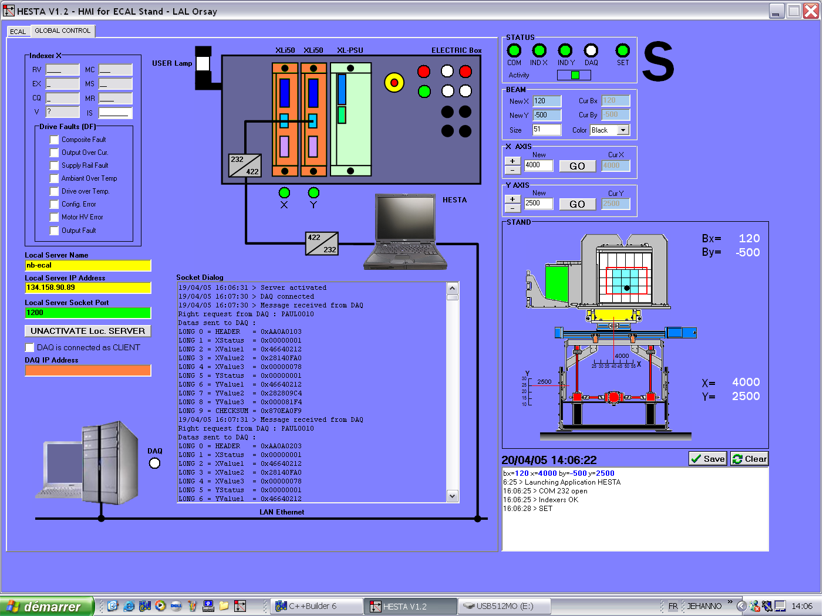
Here is a screen copy of the test end at 10H22 (20.04.05) :

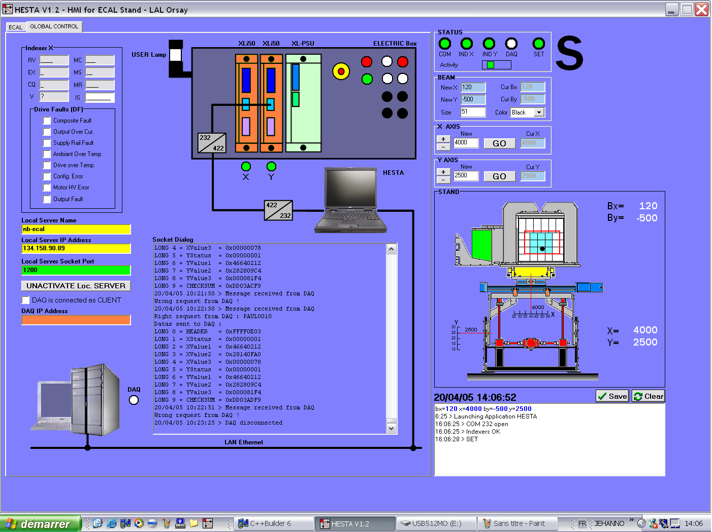
Here is the listing of all the associated messages at HESTA side :

19/04/05 16:06:31 > Server activated
19/04/05 16:07:30 > DAQ connected

First config : disconnection after each request/answer cycle

19/04/05 16:07:30 > Message received from DAQ
Right request from DAQ : PAUL0010
Datas sent to DAQ :
LONG 0 = HEADER = 0xAA0A0103
LONG 1 = XStatus = 0x00000001
LONG 2 = XValue1 = 0x46640212
LONG 3 = XValue2 = 0x28140FA0
LONG 4 = XValue3 = 0x00000078
LONG 5 = YStatus = 0x00000001
LONG 6 = YValue1 = 0x46640212
LONG 7 = YValue2 = 0x282809C4
LONG 8 = YValue3 = 0x000081F4
LONG 9 = CHECKSUM = 0x870EA0F9
19/04/05 16:07:31 > Message received from DAQ
Right request from DAQ : PAUL0010
Datas sent to DAQ :
LONG 0 = HEADER = 0xAA0A0203
LONG 1 = XStatus = 0x00000001
LONG 2 = XValue1 = 0x46640212
LONG 3 = XValue2 = 0x28140FA0
LONG 4 = XValue3 = 0x00000078
LONG 5 = YStatus = 0x00000001
LONG 6 = YValue1 = 0x46640212
LONG 7 = YValue2 = 0x282809C4
LONG 8 = YValue3 = 0x000081F4
LONG 9 = CHECKSUM = 0x870EA1F9
19/04/05 16:07:31 > Message received from DAQ
Wrong request from DAQ !
19/04/05 16:07:31 > Message received from DAQ
Wrong request from DAQ !
19/04/05 16:07:31 > Message received from DAQ
Wrong request from DAQ !
19/04/05 16:07:32 > Message received from DAQ
Right request from DAQ : PAUL0010
Datas sent to DAQ :
LONG 0 = HEADER = 0xAA0A0303
LONG 1 = XStatus = 0x00000001
LONG 2 = XValue1 = 0x46640212
LONG 3 = XValue2 = 0x28140FA0
LONG 4 = XValue3 = 0x00000078
LONG 5 = YStatus = 0x00000001
LONG 6 = YValue1 = 0x46640212
LONG 7 = YValue2 = 0x282809C4
LONG 8 = YValue3 = 0x000081F4
LONG 9 = CHECKSUM = 0x870EA2F9
19/04/05 16:07:32 > Message received from DAQ
Wrong request from DAQ !
19/04/05 16:07:32 > Message received from DAQ
Wrong request from DAQ !
19/04/05 16:07:32 > Message received from DAQ
Wrong request from DAQ !
19/04/05 16:07:33 > Message received from DAQ
Right request from DAQ : PAUL0010
Datas sent to DAQ :
LONG 0 = HEADER = 0xAA0A0403
LONG 1 = XStatus = 0x00000001
LONG 2 = XValue1 = 0x46640212
LONG 3 = XValue2 = 0x28140FA0
LONG 4 = XValue3 = 0x00000078
LONG 5 = YStatus = 0x00000001
LONG 6 = YValue1 = 0x46640212
LONG 7 = YValue2 = 0x282809C4
LONG 8 = YValue3 = 0x000081F4
LONG 9 = CHECKSUM = 0x870EA3F9
19/04/05 16:07:33 > DAQ disconnected
19/04/05 16:10:39 > DAQ connected
19/04/05 16:10:39 > Message received from DAQ
Right request from DAQ : PAUL0010
Datas sent to DAQ :
LONG 0 = HEADER = 0xAA0A0503
LONG 1 = XStatus = 0x00000001
LONG 2 = XValue1 = 0x46640212
LONG 3 = XValue2 = 0x28140FA0
LONG 4 = XValue3 = 0x00000078
LONG 5 = YStatus = 0x00000001
LONG 6 = YValue1 = 0x46640212
LONG 7 = YValue2 = 0x282809C4
LONG 8 = YValue3 = 0x000081F4
LONG 9 = CHECKSUM = 0x870EA4F9
19/04/05 16:10:47 > DAQ disconnected
19/04/05 16:28:48 > DAQ connected
19/04/05 16:28:48 > Message received from DAQ
Right request from DAQ : PAUL0010
Datas sent to DAQ :
LONG 0 = HEADER = 0xAA0A0603
LONG 1 = XStatus = 0x00000001
LONG 2 = XValue1 = 0x46640212
LONG 3 = XValue2 = 0x28140FA0
LONG 4 = XValue3 = 0x00000078
LONG 5 = YStatus = 0x00000001
LONG 6 = YValue1 = 0x46640212
LONG 7 = YValue2 = 0x282809C4
LONG 8 = YValue3 = 0x000081F4
LONG 9 = CHECKSUM = 0x870EA5F9
19/04/05 16:28:49 > Message received from DAQ
Right request from DAQ : PAUL0010
Datas sent to DAQ :
LONG 0 = HEADER = 0xAA0A0703
LONG 1 = XStatus = 0x00000001
LONG 2 = XValue1 = 0x46640212
LONG 3 = XValue2 = 0x28140FA0
LONG 4 = XValue3 = 0x00000078
LONG 5 = YStatus = 0x00000001
LONG 6 = YValue1 = 0x46640212
LONG 7 = YValue2 = 0x282809C4
LONG 8 = YValue3 = 0x000081F4
LONG 9 = CHECKSUM = 0x870EA6F9
19/04/05 16:28:49 > Message received from DAQ
Wrong request from DAQ !
19/04/05 16:28:49 > Message received from DAQ
Wrong request from DAQ !
19/04/05 16:28:49 > Message received from DAQ
Wrong request from DAQ !
19/04/05 16:29:56 > DAQ connected
19/04/05 16:29:56 > Message received from DAQ
Right request from DAQ : PAUL0010
Datas sent to DAQ :
LONG 0 = HEADER = 0xAA0A0803
LONG 1 = XStatus = 0x00000001
LONG 2 = XValue1 = 0x46640212
LONG 3 = XValue2 = 0x28140FA0
LONG 4 = XValue3 = 0x00000078
LONG 5 = YStatus = 0x00000001
LONG 6 = YValue1 = 0x46640212
LONG 7 = YValue2 = 0x282809C4
LONG 8 = YValue3 = 0x000081F4
LONG 9 = CHECKSUM = 0x870EA7F9
19/04/05 16:29:56 > DAQ disconnected
19/04/05 17:00:09 > DAQ disconnected

Final config : Continuous connection

19/04/05 17:00:11 > DAQ connected

19/04/05 17:00:11 > Message received from DAQ
Right request from DAQ : PAUL0010
Datas sent to DAQ :
LONG 0 = HEADER = 0xAA0A0903
LONG 1 = XStatus = 0x00000001
LONG 2 = XValue1 = 0x46640212
LONG 3 = XValue2 = 0x28140FA0
LONG 4 = XValue3 = 0x00000078
LONG 5 = YStatus = 0x00000001
LONG 6 = YValue1 = 0x46640212
LONG 7 = YValue2 = 0x282809C4
LONG 8 = YValue3 = 0x000081F4
LONG 9 = CHECKSUM = 0x870EA8F9
19/04/05 17:00:12 > Message received from DAQ
Wrong request from DAQ !

19/04/05 17:01:12 > Message received from DAQ
Right request from DAQ : PAUL0010
Datas sent to DAQ :
LONG 0 = HEADER = 0xAA0A0A03
LONG 1 = XStatus = 0x00000001
LONG 2 = XValue1 = 0x46640212
LONG 3 = XValue2 = 0x28140FA0
LONG 4 = XValue3 = 0x00000078
LONG 5 = YStatus = 0x00000001
LONG 6 = YValue1 = 0x46640212
LONG 7 = YValue2 = 0x282809C4
LONG 8 = YValue3 = 0x000081F4
LONG 9 = CHECKSUM = 0x870EA9F9
19/04/05 17:01:13 > Message received from DAQ
Wrong request from DAQ !

Etc…………………………

Final config : end of test

20/04/05 10:18:46 > Message received from DAQ
Right request from DAQ : PAUL0010
Datas sent to DAQ :
LONG 0 = HEADER = 0xFFFF0A03
LONG 1 = XStatus = 0x00000001
LONG 2 = XValue1 = 0x46640212
LONG 3 = XValue2 = 0x28140FA0
LONG 4 = XValue3 = 0x00000078
LONG 5 = YStatus = 0x00000001
LONG 6 = YValue1 = 0x46640212
LONG 7 = YValue2 = 0x282809C4
LONG 8 = YValue3 = 0x000081F4
LONG 9 = CHECKSUM = 0xDD03A9F9
20/04/05 10:18:47 > Message received from DAQ
Wrong request from DAQ !
20/04/05 10:19:47 > Message received from DAQ
Right request from DAQ : PAUL0010
Datas sent to DAQ :
LONG 0 = HEADER = 0xFFFF0B03
LONG 1 = XStatus = 0x00000001
LONG 2 = XValue1 = 0x46640212
LONG 3 = XValue2 = 0x28140FA0
LONG 4 = XValue3 = 0x00000078
LONG 5 = YStatus = 0x00000001
LONG 6 = YValue1 = 0x46640212
LONG 7 = YValue2 = 0x282809C4
LONG 8 = YValue3 = 0x000081F4
LONG 9 = CHECKSUM = 0xDD03AAF9
20/04/05 10:19:48 > Message received from DAQ
Wrong request from DAQ !
20/04/05 10:20:48 > Message received from DAQ
Right request from DAQ : PAUL0010
Datas sent to DAQ :
LONG 0 = HEADER = 0xFFFF0C03
LONG 1 = XStatus = 0x00000001
LONG 2 = XValue1 = 0x46640212
LONG 3 = XValue2 = 0x28140FA0
LONG 4 = XValue3 = 0x00000078
LONG 5 = YStatus = 0x00000001
LONG 6 = YValue1 = 0x46640212
LONG 7 = YValue2 = 0x282809C4
LONG 8 = YValue3 = 0x000081F4
LONG 9 = CHECKSUM = 0xDD03ABF9
20/04/05 10:20:49 > Message received from DAQ
Wrong request from DAQ !
20/04/05 10:21:49 > Message received from DAQ
Right request from DAQ : PAUL0010
Datas sent to DAQ :
LONG 0 = HEADER = 0xFFFF0D03
LONG 1 = XStatus = 0x00000001
LONG 2 = XValue1 = 0x46640212
LONG 3 = XValue2 = 0x28140FA0
LONG 4 = XValue3 = 0x00000078
LONG 5 = YStatus = 0x00000001
LONG 6 = YValue1 = 0x46640212
LONG 7 = YValue2 = 0x282809C4
LONG 8 = YValue3 = 0x000081F4
LONG 9 = CHECKSUM = 0xDD03ACF9
20/04/05 10:21:50 > Message received from DAQ
Wrong request from DAQ !
20/04/05 10:22:50 > Message received from DAQ
Right request from DAQ : PAUL0010
Datas sent to DAQ :
LONG 0 = HEADER = 0xFFFF0E03
LONG 1 = XStatus = 0x00000001
LONG 2 = XValue1 = 0x46640212
LONG 3 = XValue2 = 0x28140FA0
LONG 4 = XValue3 = 0x00000078
LONG 5 = YStatus = 0x00000001
LONG 6 = YValue1 = 0x46640212
LONG 7 = YValue2 = 0x282809C4
LONG 8 = YValue3 = 0x000081F4
LONG 9 = CHECKSUM = 0xDD03ADF9
20/04/05 10:22:51 > Message received from DAQ
Wrong request from DAQ !

Final config : end of connection

20/04/05 10:23:25 > DAQ disconnected





L-R (top row) E. Madgwick, B.N. Banerji, H.D. Smyth, N. Ahmad, W.T. Gibson, L.L. Whyte, P. Kapitza, (middle row) Y. Nishina, A.C. Chakravarti, P. Mercier, J. Crackston, H. Robinson, Miss Taylor, E.S. Bieler, J.K. Roberts, P.M.S. Blackett, E.C. Stoner, (bottom row) M.H. Belz, G. Henderson, D.A. Keys, F.W. Aston, Prof. Sir J.J. Thomson, Prof.Sir E. Rutherford, J.A. Crowther, G. Stead, E.V. Appleton, A. Muller. Cambridge University Cavendish Laboratory Department of Physics

