Problem Report Report Number: 4

Project Name: TeraPixel APS for CALICE

Item: HiPoly resistors in preShape pixel

Problem
After trial verification with the calibre LVS tool it appears the original design was manufactured with the incorrect values of hi-resistance poly resistors. The schematic and layout “pcell”, (which automatically generates the width/length of the resistor from the resistance value entered), created resistors that were physically too short. The assura rules used at the time did not report this error, but new calibre rules report the parameter mismatch, and the spice documentation lists the unit resistance for hi-poly resistors such that is agrees with the calibre result.

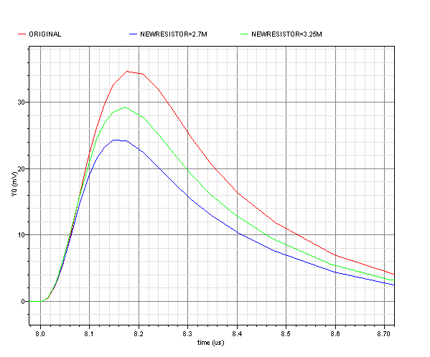
Calculating the new value for the 4MΩ feedback resistor gives a value of 2.7MΩ. Typical shaper output is shown for the original and newly calculated are shown below in red & blue respectively.

Comments from foundry also highlight the recommended rules that are not checked by DRC: “minimum width 2um to prevent sensitivity to GC CD or edge effect, especially because of No sal resistor for accurate value”. Current design is minimum width of 0.18um.
N=100
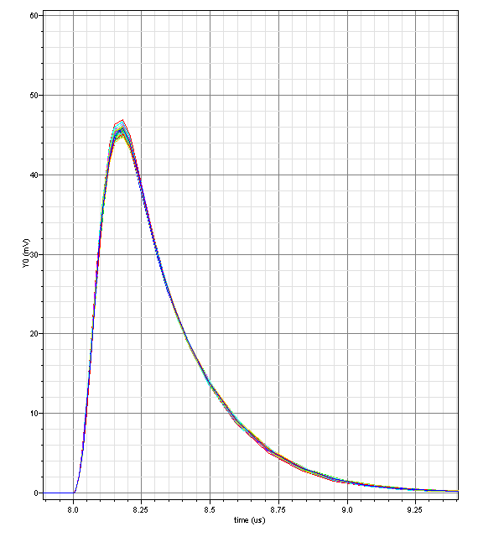
← Monte-Carlo simulations of mismatch don’t show much spread, although it is unclear whether they assume the recommended width rule was applied.

Manual simulations of resistor values ±10% show similar spread in circuit gain.

A long resistor of minimum width will be most susceptible to variation in track width

Originator (Sign/Date)
Project Manager (Sign/Date)

Remedial Action
Summary of options

Width | Length | Approx area | PCELL value | Actual value | Comment
0.18 | 486 | 343 | 3.9MΩ | 2.7MΩ | Original design
0.18 | 595 | 416 | 4.8MΩ | 3.3MΩ | Possible in new design, maximising length
2 | 5500 | 11000 | 3.9MΩ | 2.7MΩ | Recommended width, target 2.7MΩ
0.21 | 570 | 417 | 3.9 MΩ | 2.7MΩ | Maximised width for 2.7MΩ,  possible in new design

Green trace in previous plot shows the 3.3M case, which is an improvement on original design, but not full designed performance. No larger resistor can fit in the pixel with all other changes implemented.

Clearly the recommended resistor width is impractical in the pixel – in fact keeping the original 2.7M resistance value and boosting width to improve matching can only fit an additional .03um width before using the full available area in the new pixel design – hence improvement to matching from this option will be negligible so recommend increase to length as most appropriate course of action.

Actual gain mismatch have not yet been fully evaluated in sensors – if significant this is a likely cause.

Note there is no facility to trim for gain mismatch.

Project Manager (Sign/Date)

