***CALICE IV***
preliminary results

Four collecting diodes layout:
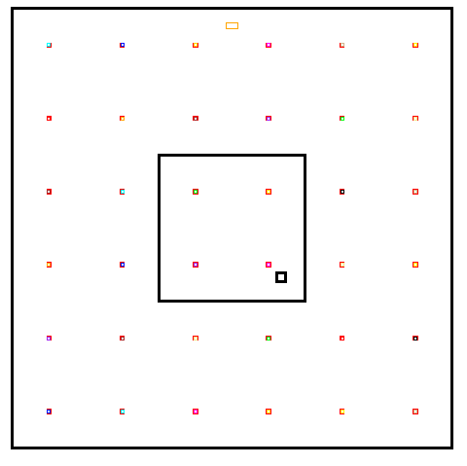
Cell size: 50 x 50 μm²

Diode size: 1.5 x 1.5 μm²

Epitaxial thickness: 10 μm

Diode location: S4

Diode bias: 2V
PWell bias: 0V
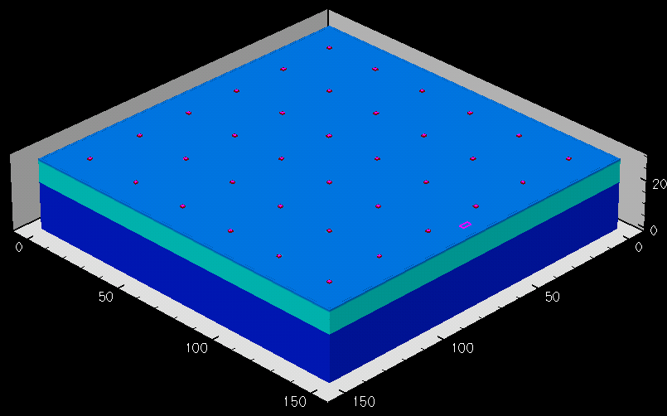
Substrate bias: floating

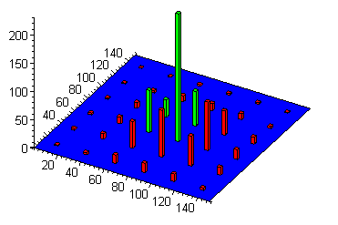
Q

Individually Collected charge hit 6

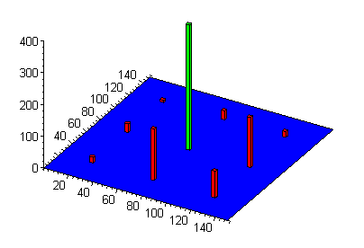

Σ Q

Four diodes Σ Collected charge hit 6

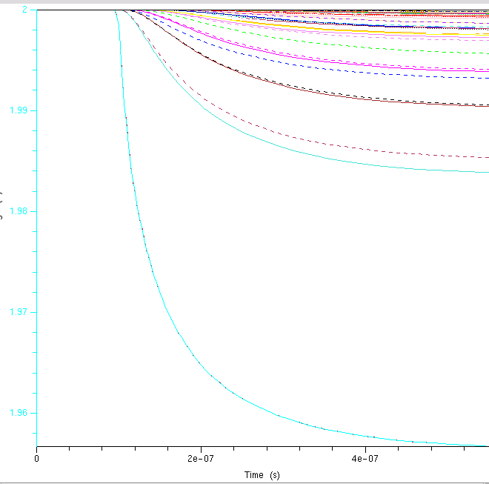
ΔV diodes hit 6: max τ_{f} ≈ 161 ns

