Simulation results for Deep P Well Calice test pixel – first submission -

Introduction

This document presents simulations results for the test pixel CMOS MAPS 0.18μm featuring DEEP P-well (INMAPS) for the CALICE ECAL detector.

DC Simulation results
The layout and corresponding 3D model of the test pixel simulated structure is shown below:

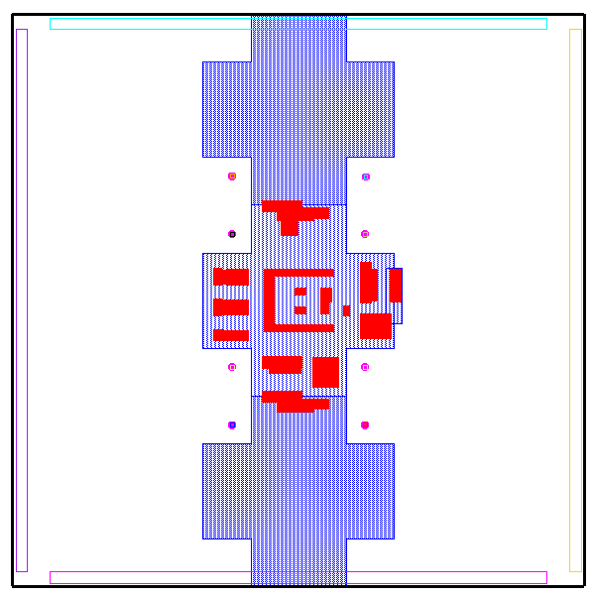
X (21)
x (25)
X (22)
X (23)
X (24)
X (1)
X (16)

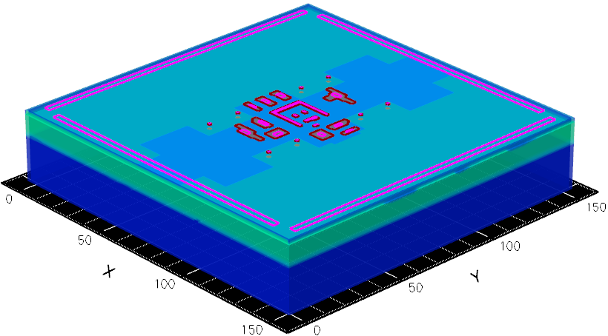

Figure1,2: Layout and 3D structure of the CALICE MAPS test
pixel. Hit locations(X) with their number are shown superimposed onto the pixel’s layout.

The simulated structures consist of a central test pixel that includes the N-wells housing the readout electronics. The remaining area of the device includes the neighboring diodes only, as per figure 2. The 21 simulated hit points are shown superimposed onto figure 1.
Both structures are biased with voltages:
Diodes: 1.0V
N-wells: 1.8V

The leakage currents for each diode of the test pixel and the ‘default’ INMAPS pixel are reported in the table below:
 | D1 | D2 | D3 | D4
Test pixel I_{lk} (fA) | 1.71 | 1.73 | 1.73 | 1.81
INMAPS I_{lk} (fA) | 1.12 | 1.12 | 1.13 | 1.14

Slightly higher DC current is predicted for the test pixel, as a result of the lack of the neighboring diodes. However, this has no practical effect.
AC Simulation results test pixel

The hits results from the 21 simulated points are used to build a surface representation Q(x,y),{ x[0,50, y[0,50]} of the collected charge by the test pixel. The interpolation function is obtained by applying an SVD algorithm.

Figure 3. Charge collected (e⁻) by test pixel vs. MIP
orthogonal hit.

The average, maximum, minimum and standard deviation value of pixel’s collected charge (in e⁻) deduced from the 21 simulated hits points are reported in the table below:
Pixel collection | Charge (e⁻)
<Q> | 436
Q_{max} | 688
Q_{min}¹ | 300
Q_{stdev} | 101

¹ minimum obtained from Hit 16, figure 1
Additional ‘low charge’ hit points (22, 23, 24 in figure 1) have been simulated and compared with the results from hit 21. The result for a straight hit on diode D2 (hit 25) is also reported in the table below.

Hit | Q (e⁻) | Hit 21 Q (e⁻) | De | %De (H_{xx}-H₂₁)/H_{xx}
22 | 354 | 353 | 1 | 0.3
23 | 358 | 353 | 5 | 1.4
24 | 357 | 353 | 4 | 1.1
25 | 828 | 353 | 527 | 57.3

As in the ‘default’ pixel, the presence of the Deep P-well helps reduce the asymmetry in charge collection to a few percent. However, the charge collected by the test pixel is expectedly higher, due to the different boundary conditions. The ‘lowest charge’ hit (21) has been taken into account to build the surface of figure 3.
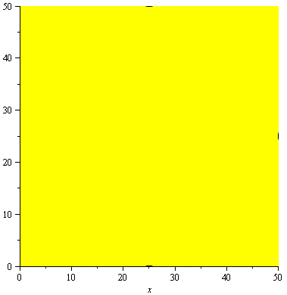
The contourplots of figure 4 show the area of the pixel interested for different values of charge threshold. Sample of Q(x,y) along direction (x,y) and (x,75) is shown in figure 5, against a plot of pixel’s boundary
300e⁻
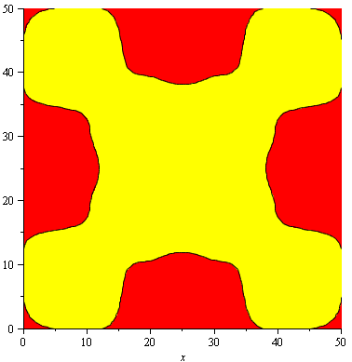
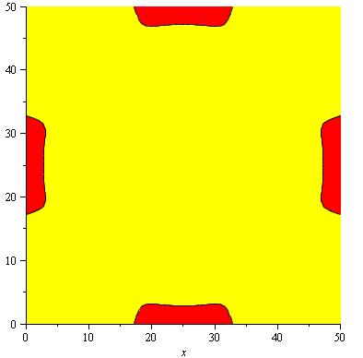
400e⁻
350e⁻

200e⁻

Figure 4. Contourplots for different Charge(e⁻)
threshold.
Q (x,y), x[0,150], y[0,150]
Q (x,75), x[0,150]
Pixel’s boundary

Figure 5. Sample of test pixel Q(x,y)

The collection time is defined as the time it takes for the charge to reach 90% of its end of simulation time value (600ns in all cases).
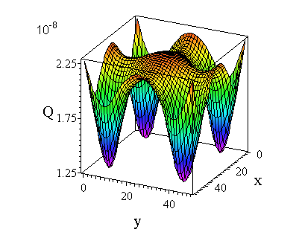

Figure 6.Ttest pixel’s Charge collection time vs. MIP
orthogonal hit.

The average, maximum, minimum and standard deviation value of test pixel’s charge collection time as deduced from the simulated hits points of figure 2 are reported in the table below:
PixelTime | Collection time (ns)
<T_{c}> | 201.1
T_{cmax} | 227.3
T_{cmin} | 140.9
T_{cstedv} | 26.2

Conclusions

The test pixel simulation results shows similar performances to the default structure, both in terms of charge collected and collection time.
Compared to the ‘default’ pixel, the test pixel collected charge is higher, due to the different boundary conditions, by an average of approximately 8.7%, or 35e⁻.
The minimum collected charge is expected to be higher by a factor of approximately 15%, or 39e⁻.
However, due to noise limitations, the test and the default pixel structure should show almost indistinguishable experimental results.
As in the default structure, a signal to noise ratio >=10 can be achieved with no considerable pixel area loss only if electron noise <= 35e⁻.

□

