Passivation Peel Strength Test for CALICE

The photo shows a test assembly based on a 20 x 20mm ceramic with 4 CALICE chips attached.

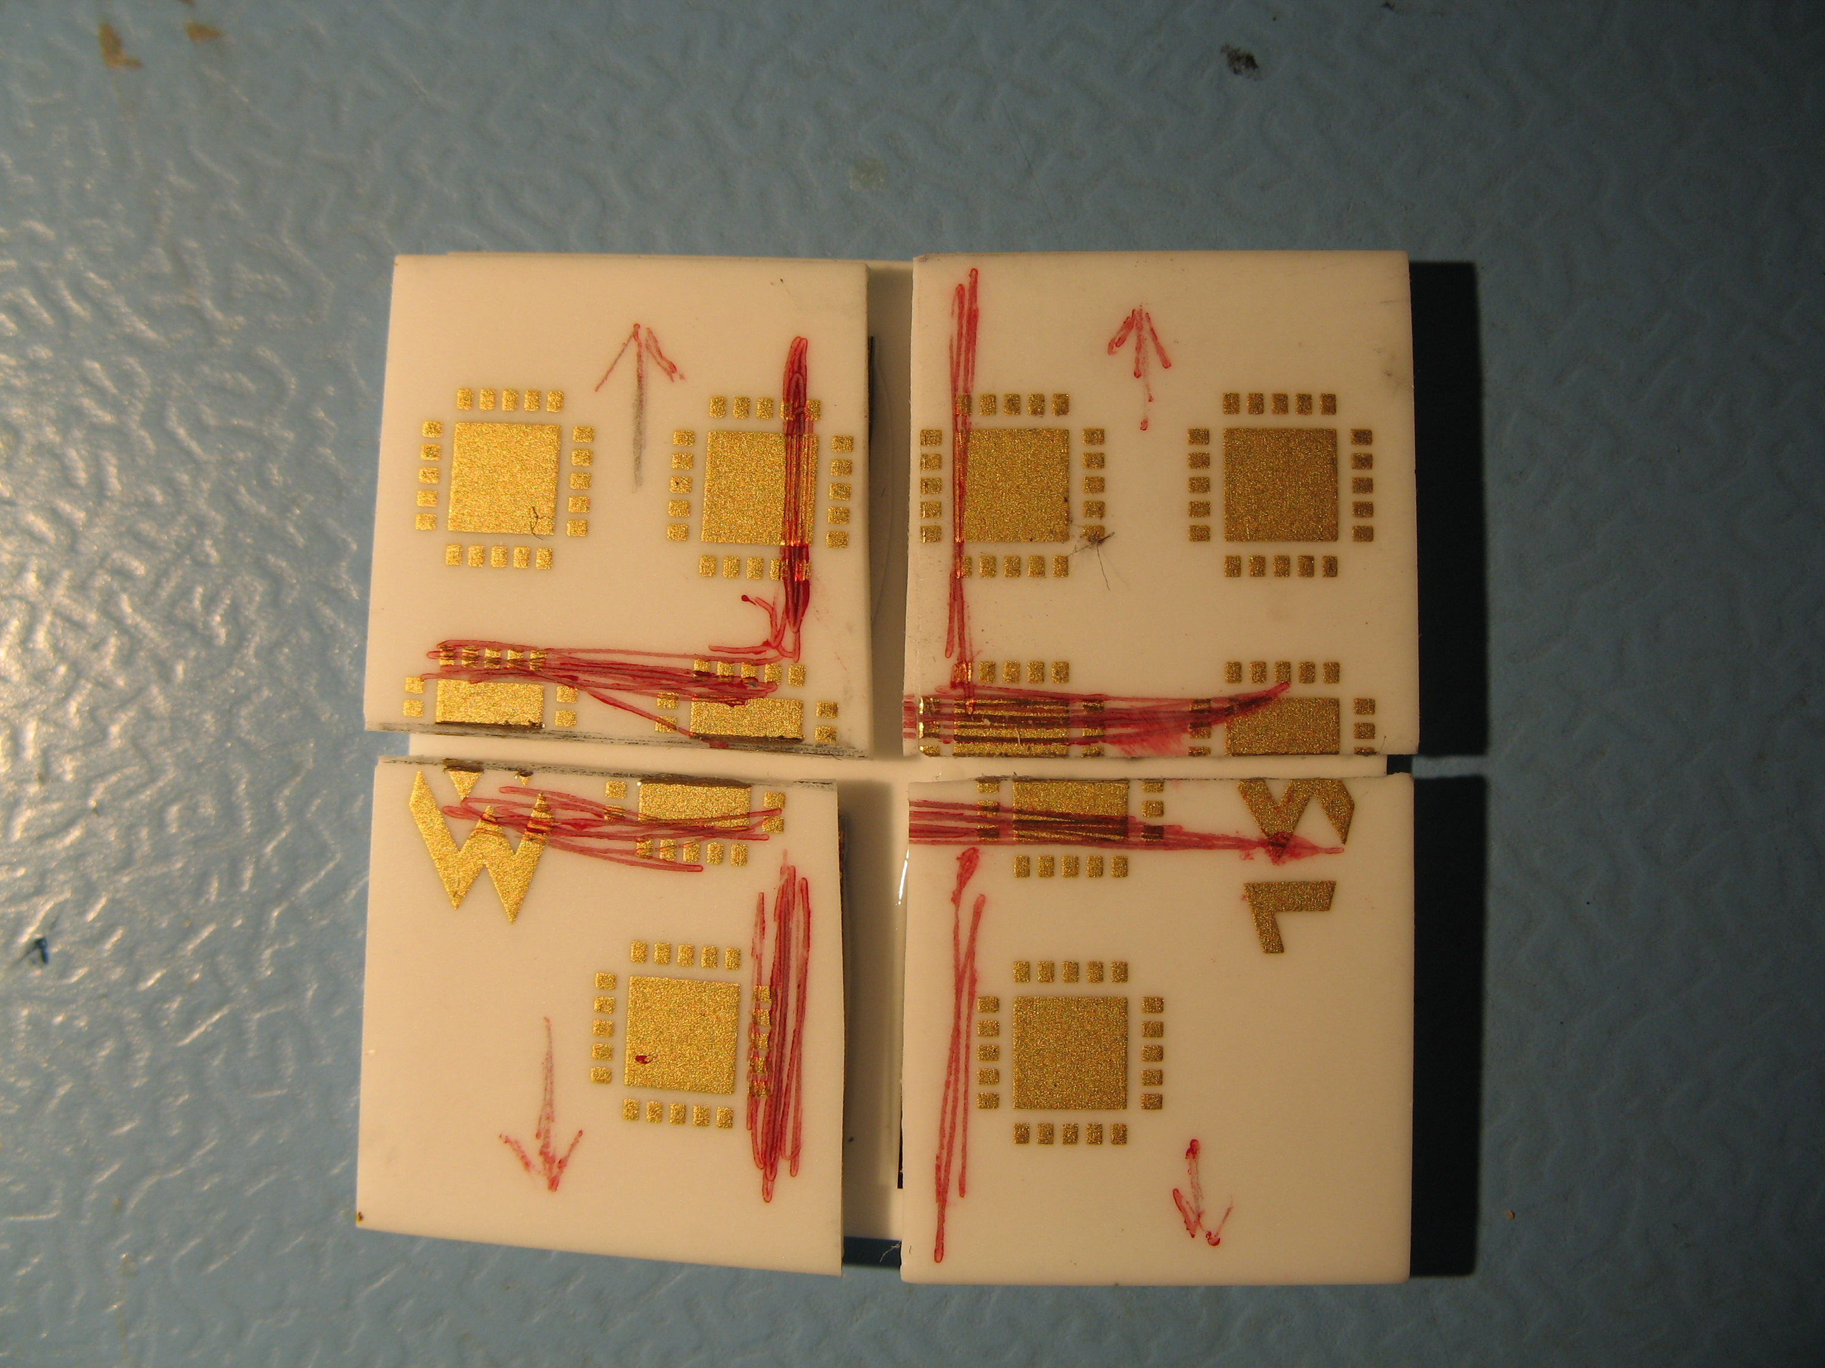

To the top of each chip a drop of epoxy was applied on one side, and a 10 x 10mm ceramic placed on top.
With the large ceramic clamped, a hook applied an upward force at the points arrowed, to establish the force required to remove the small ceramics from the chips.

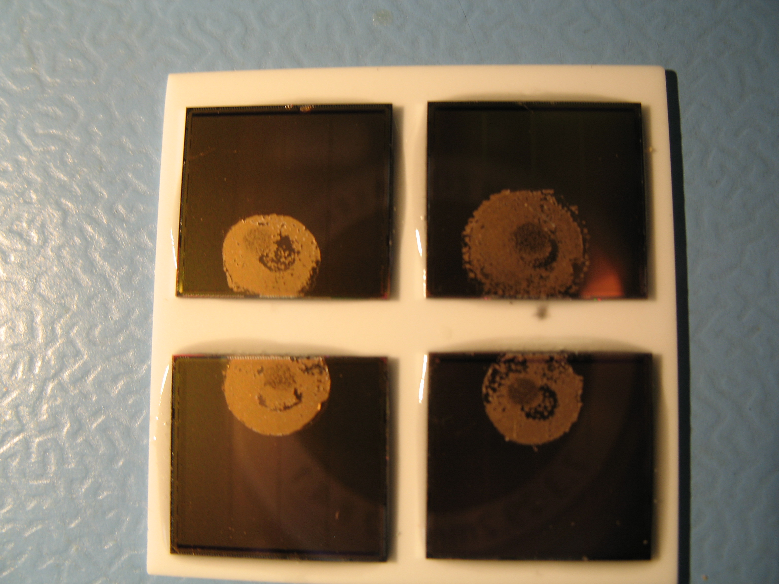

It can be seen that in every case, the glue remained on the chip, and no glue remained on the small ceramics.
The results of 1.48, 1.54, 1.56, 2.01 kgf are therefore a measure of the peel strength of the epoxy/ceramic interface, and the passivation strength has yet to be measured destructively. Pulls are typically >6mm from the glue dot, and the dot area is around 5mm².
The results are very satisfactory as far as the passivation requirements for wire-bonding are concerned, where repeated impacts at 20gf at up to 1mm* from the glued area might be experienced.

*Actual distance assumed to be half the thickness of pcb, for application under discussion.

Paul Booker: September 2008

