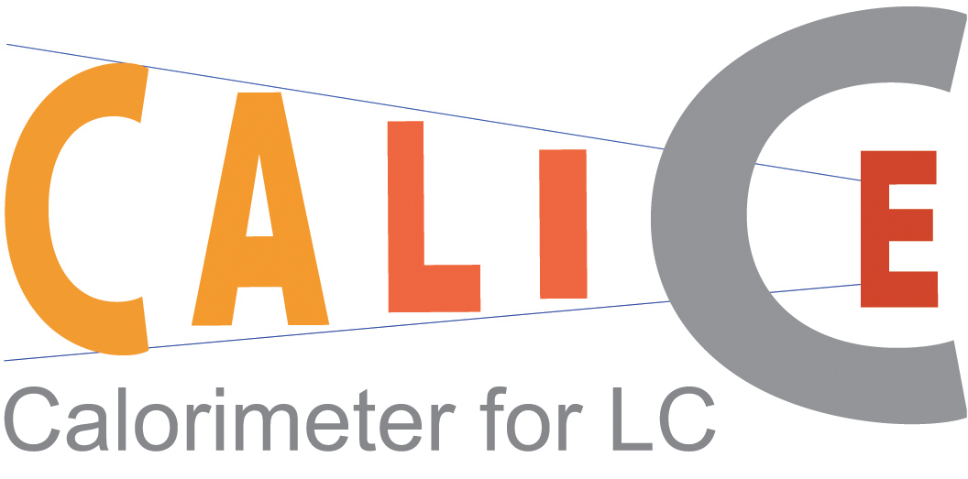

Memorandum of Agreement

between the members of the CALICE Collaboration

- Introduction
A future linear collider (LC) producing electron-positron interactions at a centre of mass energy between 90 GeV and around 1 TeV is globally recognized as the next major project of accelerator particle physics. The physics program, as well as the general environment of such a machine, requires the design of detectors based on new and technically challenging concepts.

The R&D project PRC-DESY 02-01, which emerged from studies for the TESLA TDR, was used as a starting point to build up a collaboration, called CALICE (CAlorimeter for the LInear Collider with Electrons). The aim of the collaboration is to carry through a rigorous R&D program geared towards the development of a viable design of the calorimeter for a LC detector. The goal of the collaboration is to present, in a timely manner, a well-established scientific and technical case as a basis for a proposal for calorimetry for a LC detector. The current paradigm requires a calorimeter with very fine segmentation and optimizes the design for the reconstruction of the energy and direction of all individual particles in multi-jet events; the so-called “particle flow algorithm” technique.

For scientific as well as financial reasons, this optimization process has to involve the design of all parts of the calorimeter. Hence, the electromagnetic (ECAL) and the hadronic (HCAL) calorimeters must be designed as an entity and the R&D within CALICE must cover both parts. Detector simulation programs based on GEANT and dedicated reconstruction software are used in these studies. The studies therefore depend strongly on assumptions about both the technical feasibility of the proposed detectors and the accuracy of the simulation of hadronic showers. The construction of prototypes for both the ECAL and HCAL are motivated by the need to verify these assumptions.

These studies are already under way within the CALICE collaboration, which is now relatively large with members from about 28 different institutes. The collaboration is open to new collaborators. The large size of the collaboration necessitates an organizational document concerning the management of the collaboration.

The purpose of this document is to provide such a structure and establish and organise the participation of the groups within CALICE. The internal rules and the structure of the collaboration are presented in Annex 1.

- Collaborating parties and their representatives
The following groups are involved in this project and constitute the collaboration.

Country | Laboratories | Under the authority of
Czech Republic | Institute of Physics – Academy of Science, CR  Charles University | Dean of Univ Dept,  IOP director
France | Laboratoire de Physique Corpusculaire – Clermont  Laboratoire de l’accélérateur linéaire – Orsay  Laboratoire Leprince Ringuet – Palaiseau  Physique des Interfaces et Couches Minces – Palaiseau | IN2P3/CNRS
Germany | DESY – Hamburg  Hamburg University | DESY
Korea | Kangnung National University  Seoul National University | KNU
Russia | Institute of Theoretical and Experimental Physics – Moscow  Lebedev Physics Institute – Moscow  Moscow Engineering and Physics Institute – Moscow  Institute of Nuclear Physics - Moscow State University  Institute of High Energy Physics – Protvino | Directors of Institutes
United Kingdom | School of Physics and Astronomy – University of Birmingham  Cavendish Laboratory – Cambridge University  Department of Physics – Imperial College London  Department of Physics and Astronomy – University College London  Department of Physics and Astronomy – University of Manchester  Rutherford Appleton Laboratory – Didcot | PPARC
United States of  America | Argonne National Laboratory – Argonne  Department of Physics – University of Texas at Arlington  Northern Illinois Center for Accelerator and Detector Development, North Illinois University – De Kalb | ANL – HEP director,  Deans of Univ Depts
International | Joint Institute for Nuclear Research – Dubna | JINR (Dubna) director
Table 1: Laboratories and Authorities involved in the collaboration

- Scope of this Memorandum of Agreement
This document describes the CALICE collaboration as well as its goals and plans. It lists the responsibilities taken on by the collaborating groups and so represents the intentions of these groups. However, it is not intended to be a binding agreement because of uncertainties about funding and other developments. With regard to the schedule and collaboration goals, it supersedes the PRC-DESY proposal PRC 02-01.

- Project description
The goal of the collaboration is to design and propose a fully-specified calorimeter for a LC detector. The emerging design will be based on the technology R&D and test beam results produced by the collaboration. To fulfil this goal, several different prototypes are being developed and constructed. In addition, jet reconstruction algorithms and simulation software are being developed. These will allow extrapolation from the test beam results to the full-size LC calorimeter. This will enable an estimate of the eventual calorimeter performance to be made and hence allow the design to be optimised in the light of the prototype results. The work and responsibilities of the groups, as of end 2004, are given in table 2.

ITEMS | Involved laboratories
ECAL prototype
General mechanics | LAL, LLR
Silicon wafer processing | IOP-ASCR, MSU
VFE chips | LAL
Special DAQ | LLR
Prototype DAQ | Imperial, RAL, UCL
ECAL R&D for final design
PCB, cooling, DAQ | LAL, LLR, KNU, SNU
VFE, readout | LAL, LPC
Silicon wafers and related | IOP-ASCR, LLR, PICM
Tile HCAL Prototype
General, mechanics | DESY, Hamburg, IOP-Prague, ITEP
Tile fibre and SiPM system | ITEP
Photodetectors | IOP-Prague, ITEP, MEPhI, JINR (Dubna)
Calibration | DESY, IOP-Prague
VFE | DESY, IOP-Prague, JINR(Dubna), LAL, MEPhI
DAQ | DESY, Imperial, RAL, UCL
Digital HCAL Prototype
General design | ANL, IHEP-Protvino, Texas–Arlington
RPC design | ANL, IHEP-Protvino
VFE, readout and DAQ | ANL (with help of FNAL), JINR(Dubna), Minsk
GEM development | Texas-Arlington
General
Tail catcher | DESY, NICADD-NIU
HCAL prototype mechanics | DESY
Simulation and other software services | Birmingham, Cambridge, DESY, Imperial, ITEP, LLR, NICADD-NIU, UCL
Table 2: Groups involvement in the prototype and R&D work

The ECAL is a silicon tungsten sandwich calorimeter. For the HCAL there are two competing concepts: one based on scintillating tiles with analogue or semi-digital readout (the analogue HCAL) and the other using very small pad sizes and single bit readout (the digital HCAL). For the latter both Resistive Plate Chambers and Gas Electron Multipliers are being considered as readout detectors. The mechanical structure is the same for both HCAL designs and contains 20 mm steel plates. The tail catcher will be used with both HCALs and will use the AHCAL readout electronics. The goal of the collaboration is to provide prototype calorimeter sections for the ECAL and both HCAL options by 2005. The sections will be tested in particle beams.

The funding and the manpower involved in the project for 2003 are summarized in Annex 2. It gives a representative snapshot of the level and the division of effort and investment made by the different groups.

- Test beam requirements
The requirements for a test beam program have been defined. They include testing with both electrons and hadrons, from low energy (a few GeV) to about 50 GeV. This range covers the spectrum of particle energies found in hadronic jets at a LC. The first test beam, to test the ECAL only, is foreseen for late in 2004 at DESY. The beam provides electrons of low energy (around 6 GeV). The general test beam “season” (2005-2006) will use the ECAL and both HCAL prototypes together in beams of hadrons and high energy electrons. During this general test beam period, the silicon-tungsten ECAL will be located in front of either version of the HCAL, The data will provide a real measure of the capability of the different technologies and serve as a basis for a detailed validation of the simulation of hadronic showers. Using both HCAL options will allow a comparison of their performance.

The groups involved in the R&D and construction of each subdetector have the responsibility to design, fund and build the prototypes within the timescale mentioned above. Transportation costs to the different test beam sites will be covered by the individual subdetector groups. A document outlining the test beam plans and requirements will be prepared shortly. The document is expected to be signed by the host laboratory of the test beam and by the CALICE Steering Board.

- Modifications, disagreements and effective date
This MoA will be effective up to the end of 2006, beyond the last test beam data period. If needed, an extension can be signed to extend the duration of the MoA. Any future modification or addition to the MoA shall require approval by the Steering Board and will be implemented as formal amendments to the MoA.

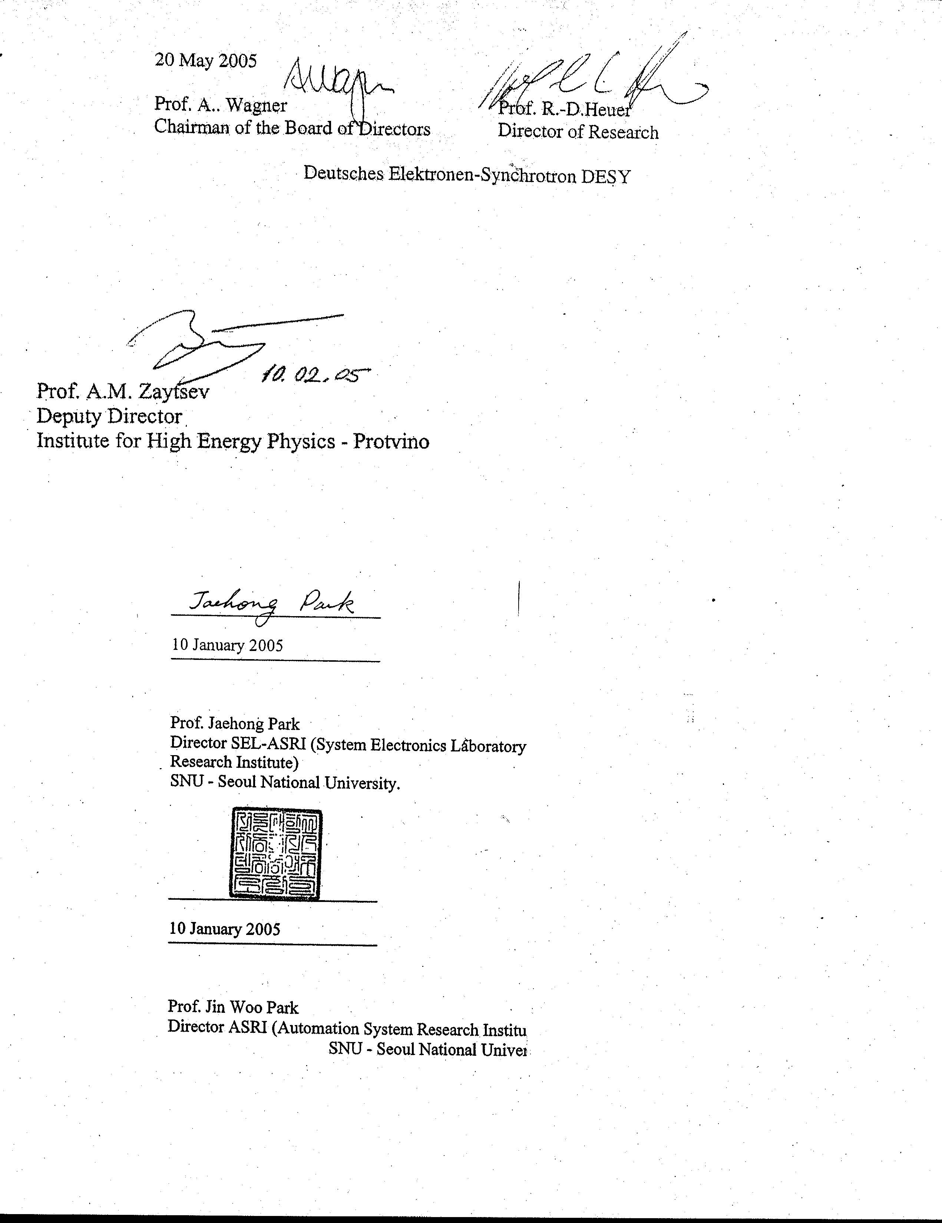
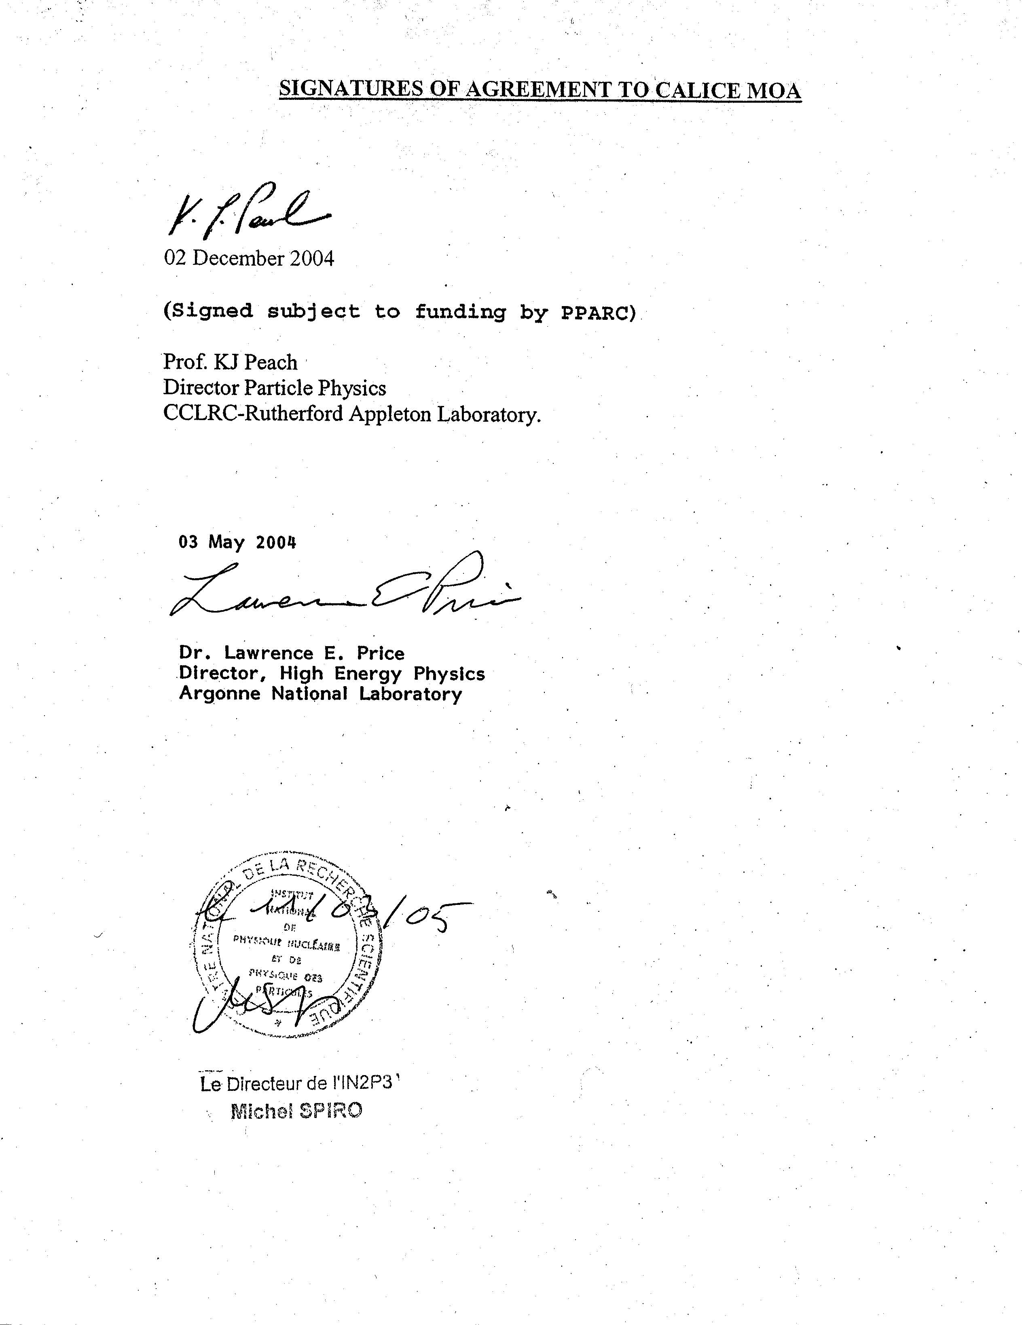
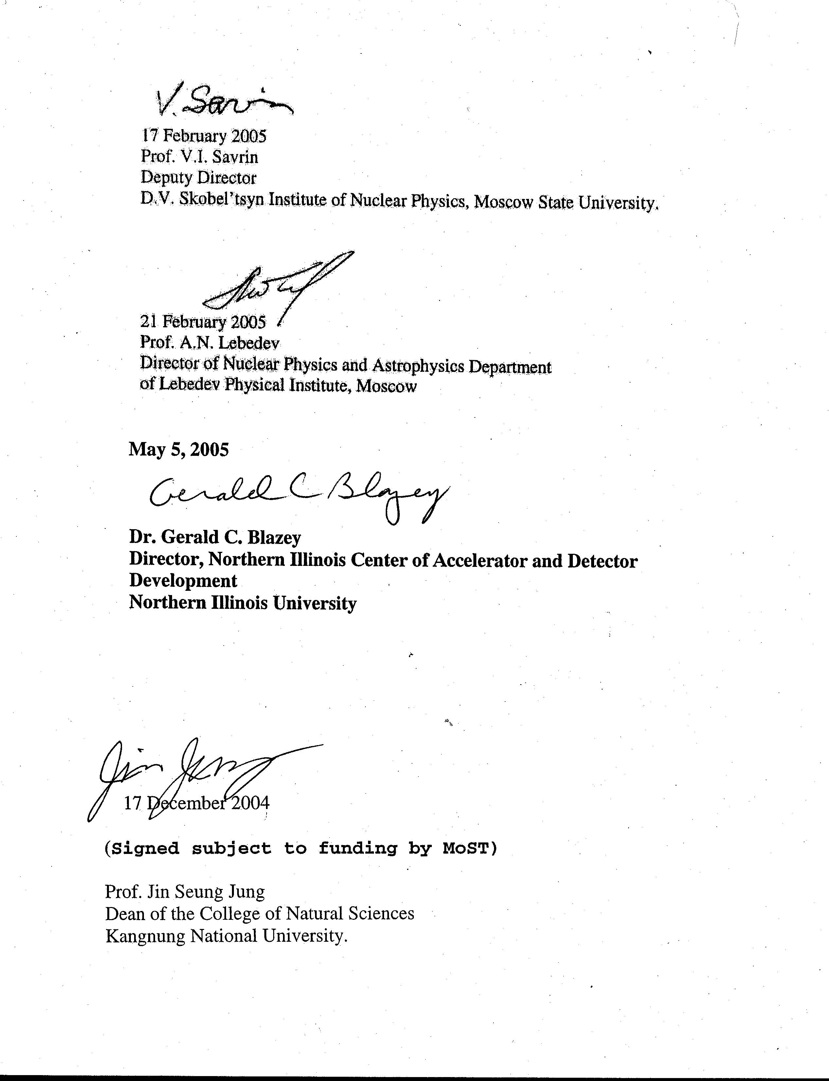
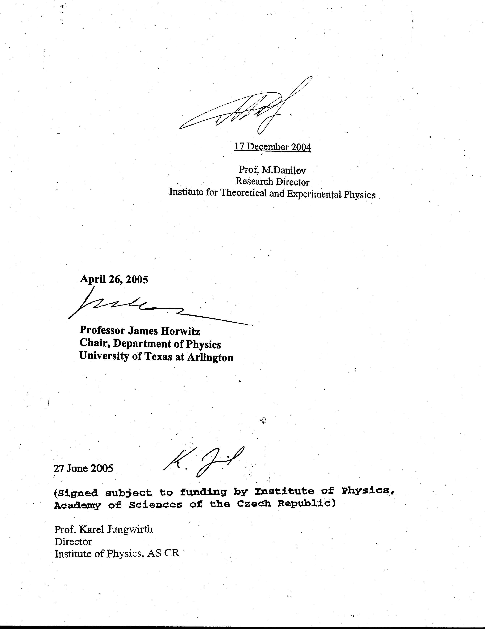
ANNEX 1

Internal rules and structure of the collaboration

The organization
The CALICE collaboration is organised around a Steering Board (SB) representing the different countries involved in the project. The SB is charged with coordinating the R&D and the construction of the prototypes. In addition, each subdetector is lead by a project leader, with the responsibility to ensure the timely construction of the subdetectors. The project leaders form the Technical Board (TB).

The Steering Board.
The SB takes the major decisions concerning the collaboration. The SB consists of the Chair of the SB and the Spokesperson (both of whom are elected by the board members) and one representative of each country (who are appointed by the members of that country). Each country can decide how they wish to appoint their representative. The Chair organizes the meetings of the board, prepares the agenda of the meetings and chairs the sessions. At each meeting, the Chair appoints a secretary to take the minutes. The minutes are accessible to all members of the collaboration. For a given meeting, with the agreement of the Chair, members can designate a substitute to represent their country.

Meetings can be scheduled at any time provided a majority of the SB requests such a meeting. The SB should meet at least four times a year.

The SB is responsible for defining the scientific goals, resolving issues concerning the funding, and considering suggestions for modifications of the MoA. Decisions are taken by general consensus as far as possible. At the first SB meeting, J.-C. Brient was elected Spokesperson of the collaboration. The current (end 2004) members of the SB are:

J. Repond (ANL), Chair,
J.-C. Brient (LLR), Spokesperson,
M. Danilov (ITEP), representing the Russian groups,
P. Dauncey (Imperial), representing the United Kingdom groups,
D.W. Kim (KNU), representing Korea groups,
A. White (UTA), representing the United States of America groups,
F. Richard (LAL), representing the France groups,
F. Sefkow (DESY), representing the German groups,
V. Vrba (IOP-ASCR), representing the Czech groups.

The term for the Spokesperson will be for the length of the current project. The term for the Chair is for two years.

The Technical Board
The TB is chaired by a Technical Coordinator appointed by the SB. In addition, the TB consists of a deputy coordinator, the project leaders of the subprojects within CALICE and other experts as appointed by the SB or TB. The project leaders of the subdetectors are responsible for all aspects of that project.
The TB should meet frequently, around once a month. As of the end of 2004, the coordinator of the technical board is Jaehoon Yu and the deputy is still to be appointed. The other members of the technical board are (end 2004):

J.-C. Vanel (LLR) for the ECAL project,
V. Korbel (DESY) and F. Sefkow (DESY) for the tile HCAL project,
J. Repond (ANL) for the digital HCAL project,
P. Dauncey (Imperial) for DAQ,
D.Ward (Cambridge) for the software project.

New collaborators
New collaborators asking to join the collaboration must produce a Letter of Intent (LoI) describing the proposed R&D project, the responsibilities they plan to take, and the projected funding and effort. The LoI must be signed by the group leader and the relevant funding agencies or authority (e.g. the head of the physics department for a university). It will be sent to the SB members, who will then decide on the proposal. The new group is expected to fund its entire proposed R&D. If a need occurs for support by common funds, the SB will negotiate an agreement with the new group concerning their contribution to this fund.

If the new group is from a country not yet present in the collaboration, one person will be appointed to the SB as the representative of this country.

Editorial and publication policy
The editorial policy applies to publications, major conference presentations and the resulting proceedings. The policy applicable to these public presentations depends on the nature of the material being published and the importance of the conference, if applicable.

- For presentations of basic R&D work performed within the CALICE framework, the people directly involved with the project should determine the author list. In addition, reference to CALICE is strongly recommended.
- The author list for results from early beam tests (e.g. the Minical or ECAL-only tests) should be restricted to the groups involved in the tests; for example, the tile HCAL groups for the Minical results. The SB will decide on special cases, such as people working on common aspects like electronics, simulation, software, etc.
- The test beam results involving both the ECAL and either of the HCALs will be treated as the collective property of the collaboration. The author list will therefore be the official collaboration list, as established by the SB.

A Speakers Bureau will be established to coordinate abstract submissions to conferences, decide on speakers, and organise approval of results, to be shown. The Bureau will consist of four members; the Chair, the Deputy Chair, the Collaboration Spokesperson and the Steering Board Chair.

Each member of the collaboration has the right to comment on the drafts of journal publications and major conference talks (and their resulting proceedings). In case of irreconcilable disagreements between members of the collaboration, the SB will decide on the final wording.

For minor conferences, consultation with other members of the collaboration is strongly encouraged, but the final responsibility for the presentation and proceedings lies with the person giving the talk.

ANNEX 2

Funding and effort investment in 2003

During calendar year 2003, the projects made significant progress based on funding from a variety of sources. The following table displays the actual effort and funds.

 | Equipment funds (k€) | Travel funds  (k€) | Effort (FTE)

ECAL
ASCR – Czech republic  IOP, Charles Uni. | 10 | 15 | 3
IN2P3/CNRS – France  LAL, LLR, LPC, PICM | 100 | 30 | 12
MOST – Korea  KNU, SNU | 16 | 7 | 4
RUSSIAN groups  INP-MSU, ITEP | 10 | 2 | 5
PPARC – United Kingdom  Birmingham, Cambridge, Imperial, Manchester, RAL,  UCL | 90 | 20 | 8

Tile HCAL
ASCR – Czech republic  IOP, Charles Uni. | 10 | 15 | 4
DESY – Germany  DESY Hamburg, Hamburg Uni. | 120 | 70 | 9
RUSSIAN groups  ITEP, LPI, MEPHI | 20 | 35 | 14
JINR (Dubna) | 8 | 4 | 3

Digital HCAL
DOE and NSF – USA  ANL, UTA, NIU | 30 | 20 | 7
RUSSIAN groups  IHEP | 7 | 2 | 4
JINR (Dubna) | 5 | 1 | 2

