Wafer Probing Manual

General Information

Wafer Probing Software

Use administrator account on SICHOPC

LabView test software:
\\Sichopc\System Disk\LabVIEW

Recent data:
\\Sichopc\System Disk\APV25S1_TestData\Latest Data

Local data archive:
\\Sichopc\Data Storage\APV25 DATA ARCHIVE\APV25s1_TestData

Backup data archive:
\\Sideburnspc\System Disk\APV25 Wafer Probing\APV25 Data Archive

Shortcuts can be found in Explorer Favourites and on the desktop, including:
– Resource Manager
– Test APV25 Wafer VI
– APV25 Wafer Probing Website

Wafer Probing Hardware Schematic

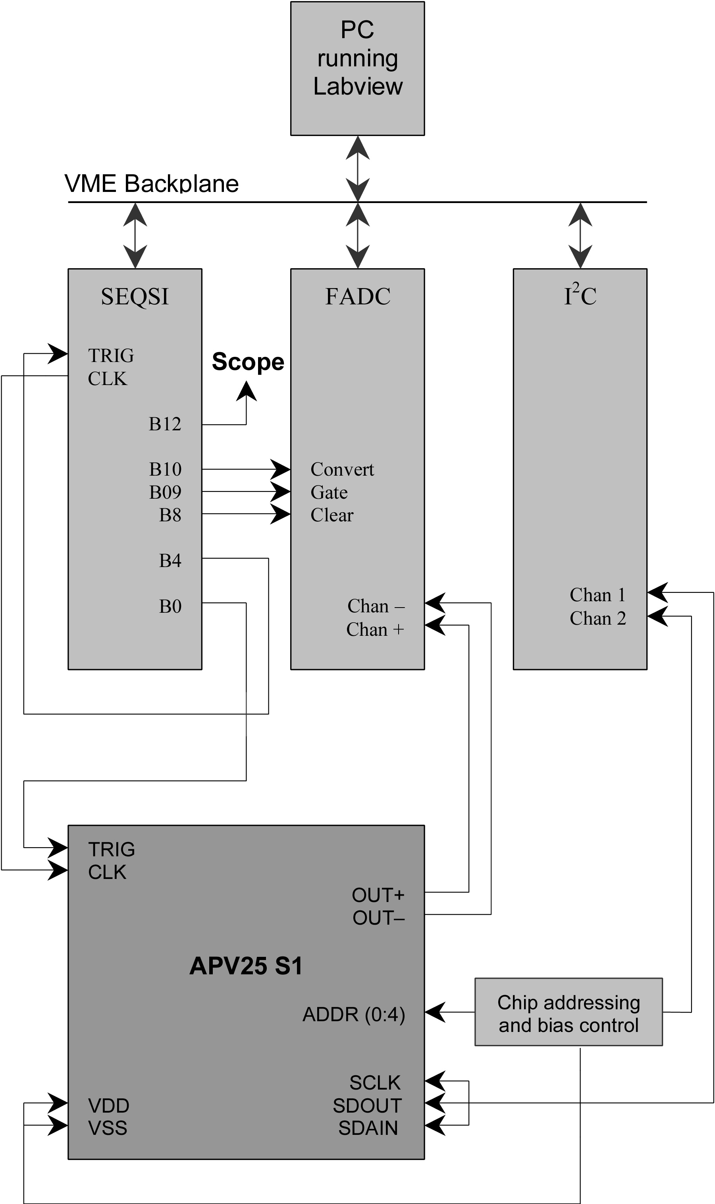
Figure 1. Hardware schematic.

Wafer Probing Procedure

Initialisation

- Switch on the prober, crate, power supply, scope and vacuum pump.
- Run Resource Manager (Resman via Start Menu or desktop) to initialise crate.
- Create folder with name as identifier of wafer to be probed, in:
\\Sichopc\System Disk\APV25S1_TestData\Latest Data.

Wafer Loading and Alignment

- Load wafer on chuck with the wafer flat located at “3 o’clock” and switch on vacuum.
- Manually align pads of an APV chip to the probe needles of the probe card. The joystick should be used to control stage movement and alignment is adjusted using the theta adjust arm (see probe station manual).
- Ensure alignment is achieved for chips both at the centre of the wafer and at the periphery.

Probing Modes

- Open the wafer probing software via the “Test APV25 Wafer.vi” shortcut on the desktop.

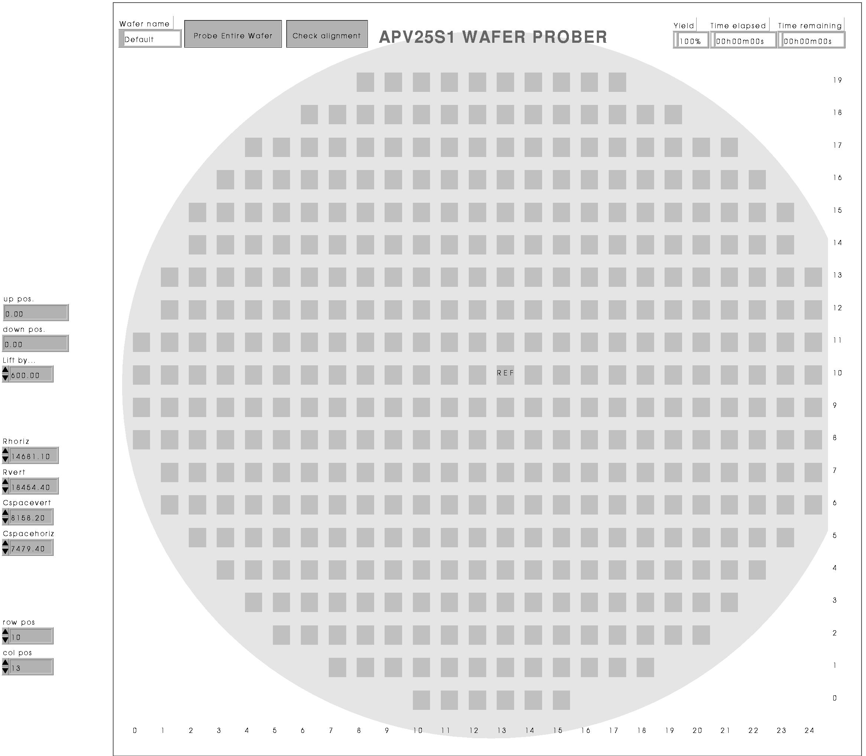
Figure 2. Front panel display for “Test APV25 Wafer.vi”.

- The wafer identifier must be entered in the wafer name field on the front panel.
(Every chip is uniquely labelled through combining the wafer identifier and a 4-digit number, which is indicative of its position on the wafer. This label is used to name the files in which data are archived.)
- The correct probing mode must be selected by toggling the probing mode button (next to wafer name field):
“Probe Entire Wafer”: all APV25 sites are probed (default mode)
“Probe Specific Sites”: only selected sites are probed.
- If “Probe Specific Sites” is selected, one can choose to probe individual sites or all sites from a specified start position, by toggling the button labelled “Select individual sites / Start from specific site”. Individual die are selected for probing by clicking over the appropriate site on the front panel. This must be done before running the VI.
- One can choose if chips failing a digital test are reprobed, by toggling the “Allow reprobing / No reprobing” button.
- Alignment checking between the probe card and the pads of a particular APV site can be performed at any time during probing by toggling the “Check alignment” button. If selected, the next site to be tested is illuminated and the user is prompted for confirmation of good alignment before probing is allowed to continue. Deselecting this button inhibits this checking routine.
(It is advisable to select the “Check alignment” feature before running the VI and use the feature for the first two or three sites tested.)
- An indicator string shows the estimated remaining testing time.

Running the software

- After running the Test APV25 Wafer VI, the user is initially prompted to check if the wafer name and probing modes are correct and if alignment between the probe card and wafer has been performed.
- After all the sites of a wafer have been tested, the platen is raised by 1000 μm.

Wafer Orientation

- The user is then asked if the wafer orientation with respect to the prober coordinate system should be calculated (usually required).
(This operation allows the prober to compensate for the angular orientation of the wafer with respect to the prober co-ordinate system and consists of calculating the wafer orientation from two position measurements made at opposite edges of the wafer.)
- The user is prompted to manoeuvre the wafer (using the joystick) until the eyepiece crosshair coincides with some identifiable feature near to the wafer edge at “6 o’clock”.
- The user should ‘enter’ this position and repeat the procedure with the corresponding feature at the “12 o’clock” edge of the wafer.
- The highest-magnification lens should be used during this operation.
(The platen should not be raised whilst using this lens as the lens may damage the probe card.)

Alignment with the Reference Site

- The user is then prompted to align the probe card with the input pads of the APV25 site labelled “REF” on the VI front panel and lower the probes into contact with the pads.
- The user is then prompted for confirmation to begin probing.

Alignment Checking

- In the rare case when the probe card is not correctly aligned with the first site (situated at the outermost site at approximately “10 o’clock”), then the stage should be “sent home” and the prober switched off/on. Note that the wafer need not be removed during the homing of the stage and so the manual alignment between probe card and wafer need not be repeated.

Book-Keeping

Data Archiving

- Folders containing complete wafer data should be moved from:
\\Sichopc\System Disk\APV25S1_TestData\Latest Data
to the directory:
\\Sideburnspc\System Disk\APV25 Wafer Probing\APV25 Data Archive\Lot 0\Wafer Data , where “Lot 0” should be replaced by the appropriate lot number
- A backup also exists on \\Sichopc\Data Storage\APV25 DATA ARCHIVE
- Regular backups should be made on DVD

Data Analysis

- Data analysis software found in:
\\Sideburnspc\System Disk\APV25 Wafer Probing\ANALYSIS SOFTWARE\LabView
- Postscript and ascii wafer maps are generated using the VI:
“CreateWaferMapWithPostTestAnalysis.vi”
- Postscript and ascii wafer maps should be placed in:
\\Sideburnspc\System Disk\APV25 Wafer Probing\APV25 DATA ARCHIVE\Lot <N>\Wafer Maps (+ \ps or \map)

Logbook and Website

- Information on probed wafers should be recorded in the paper logbook, including:
lot number, wafer identifier, date probed, wafer yield, location, other comments.
- Information is available on the website http://www.hep.ph.ic.ac.uk/~silicon/
- The user should upload all new wafer maps to the website and update the appropriate wafer lot spreadsheet
- “Start Menu → Programs → SSH Secure Shell → Secure File Transfer Client”
- Profile is called “WAFER PROBING WEBSITE”
- Postscript wafer maps found in: ~/public_html/WaferMaps/Ps/Lot<N>
- Ascii wafer maps found in: ~/public_html/WaferMaps/Map/Lot<N>
- Wafer lot spreadsheets found in: ~/public_html/WaferMaps/Info

